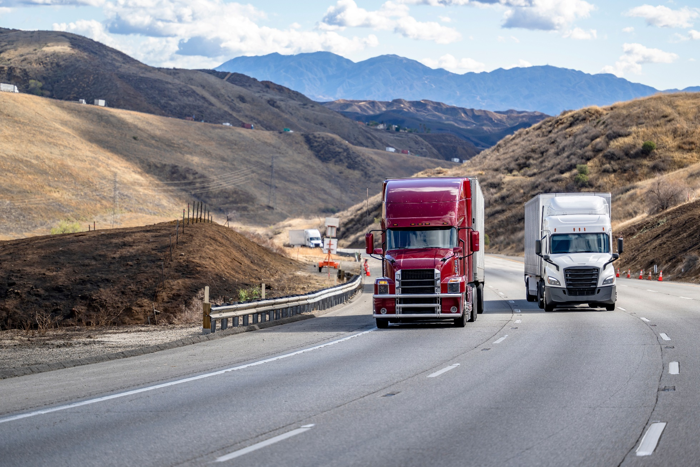

[Project Title Name Goes Here] (Style: Heading 1)
  - Trade Corridor Enhancement Program (TCEP)
CALIFORNIA DEPARTMENT OF TRANSPORTATION & [NOMINATING AGENCY]
[MONTH 20XX]


[Project Title Name Goes Here] (Style: Heading 1)
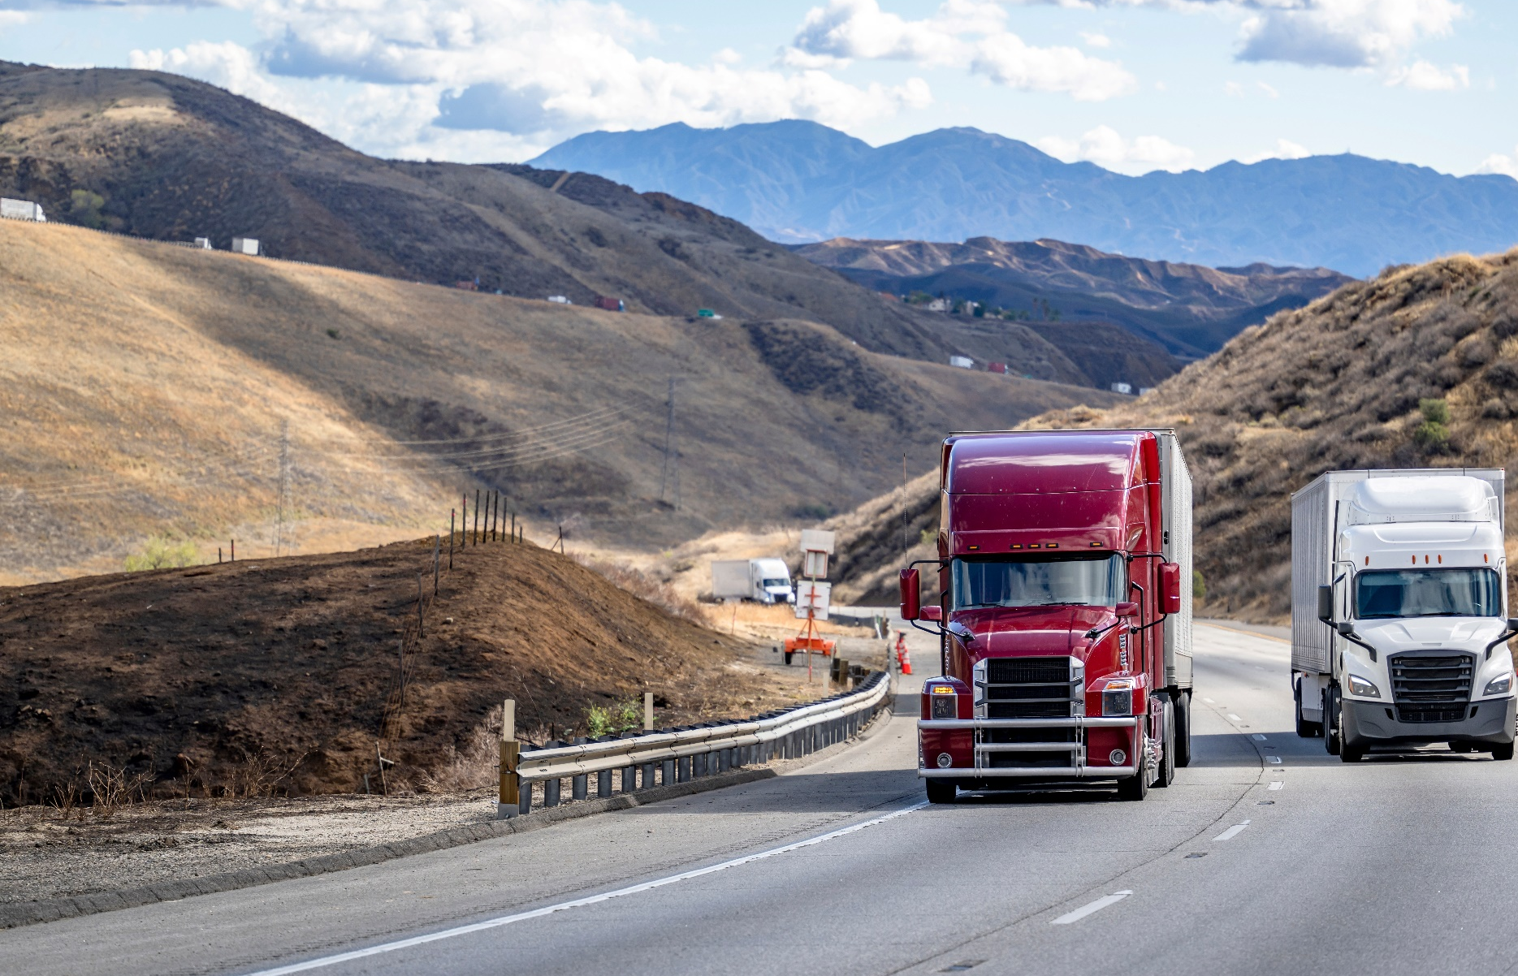

  - Trade Corridor Enhancement Program (TCEP)
CALIFORNIA DEPARTMENT OF TRANSPORTATION & [NOMINATING AGENCY]
[MONTH 20XX]

[Project Title Name Goes Here] (Style: Heading 1)
  - Trade Corridor Enhancement Program (TCEP)
CALIFORNIA DEPARTMENT OF TRANSPORTATION & [NOMINATING AGENCY]

[MONTH 20XX]

[Project Title Name Goes Here] (Style: Heading 1)

  - Trade Corridor Enhancement Program (TCEP)
CALIFORNIA DEPARTMENT OF TRANSPORTATION & [NOMINATING AGENCY]
[MONTH 20XX]

Table of Contents
Table of Contents 1
A. Cover Letter 3
B. Fact Sheet 4
Project Scope 4
Background 4
Project Location 4
Project Cost 5
Project Schedule 5
Project Benefits 5
C. General Information 6
1. Overview 6
2. Project Location 6
3. Priority 6
4. Scope 6
5. Independent Utility 6
6. Nominating Agency/Implementing Agency Agreement 6
7. Letters of Support 6
D. Screening Criteria 7
1. Eligible Projects 7
2. Consistency with the RTP/SCS 8
3. Environmental Clearance 8
4. Committed Funds 8
5. Required Funding Match 8
E. Project Delivery 9
1. Delivery Method – [Identify Type] 9
2. Contracts 9
3. Schedule Risks 9
4. Rail Company Coordination 9
5. California Environmental Quality Act (CEQA) / National Environmental Policy Act (NEPA) Status 10
F. Evaluation Criteria 11
1. Freight System Factors 11
2. Transportation System Factors 11
3. Community Impact Factors 12
4. Other Factors 12
5. Zero-Emission Freight Infrastructure Sub-Criteria 13
G. Other Project Information Areas 14
1. Accessibility 14
2. Climate Change Resilience and Adaptation 14
3. Protection of Natural and Working Lands, and Enhancement of the Built Environment 14
4. Public Health 14
H. Funding and Deliverability 15
1. Funding Table 15
2. Total Project Cost 15
3. Cost Overruns 15
4. Contracts 15
5. Pre-Construction Requests 16
6. Federal Discretionary Funds 16
7. Ineligible Elements 16
I. Other 17
1. Public/Private Benefits 17
2. Interagency Cooperation 17
3. Bulk Coal 17
4. Reversible Lanes 17
Appendices 18
Appendix I: Electronic Project Programming Request 18
Appendix II: Performance Indicators and Measures 20

Cover Letter
Insert the Cover Letter PDF

Cover letter should meet the following criteria:
- Addressed to the CTC Executive Director
- Clearly identify nominating agency or agencies
- Signed by Director of Transportation or person authorized by the director to submit the nomination.
- Signed by Chief Executive Officer or another authorized officer of the regional agency when applicable.
- Jointly nominated project must have a duly authorized signature of all agencies.
- When project is implemented by an agency or multiple agencies other than the nominating agency, signature(s) from the Chief Executive Officer or other authorized officers are required for the implementing agency or agencies

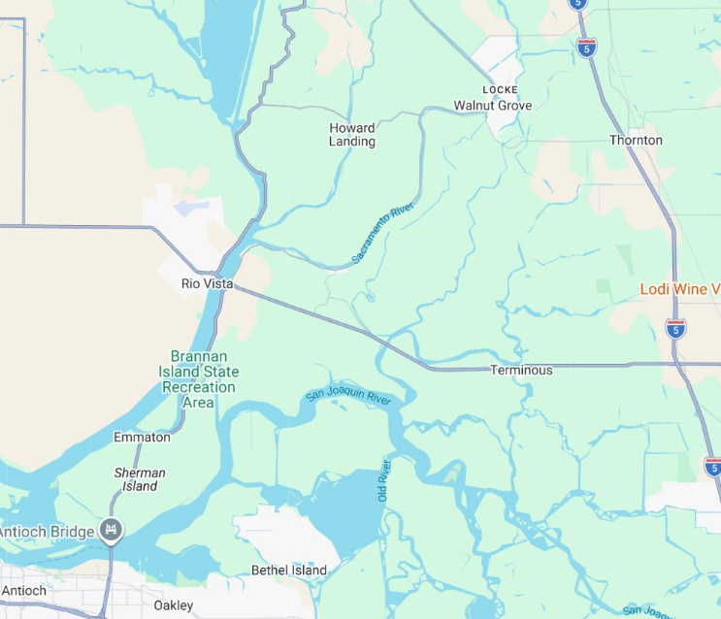
Fact Sheet (Style: Heading 2)
Photo 2: Add caption for photo here. Right-click the photo and select View Alt-Text to add alternative text.
Fact sheet should be one or two pages in length. If images are included, the images should meet the following requirements:
- High-quality picture or rendering – at least 300 Dots per Inch (DPI)
- High-quality picture or rendering of nominating agency’s logo If there are multiple nominating agencies, each agency’s logo must be included.

Project Scope (Style: Heading 3)
Describes the project scope.

Background (Style: Heading 3)
Includes a brief narrative on how the project: (1) Impacts Greenhouse Gas Emissions; (2) Considers Transportation Equity; (3) Mitigated or avoided negative community impacts that resulted in better outcomes. Narrative should be understood by a non-technical audience.

Project Location (Style: Heading 3)
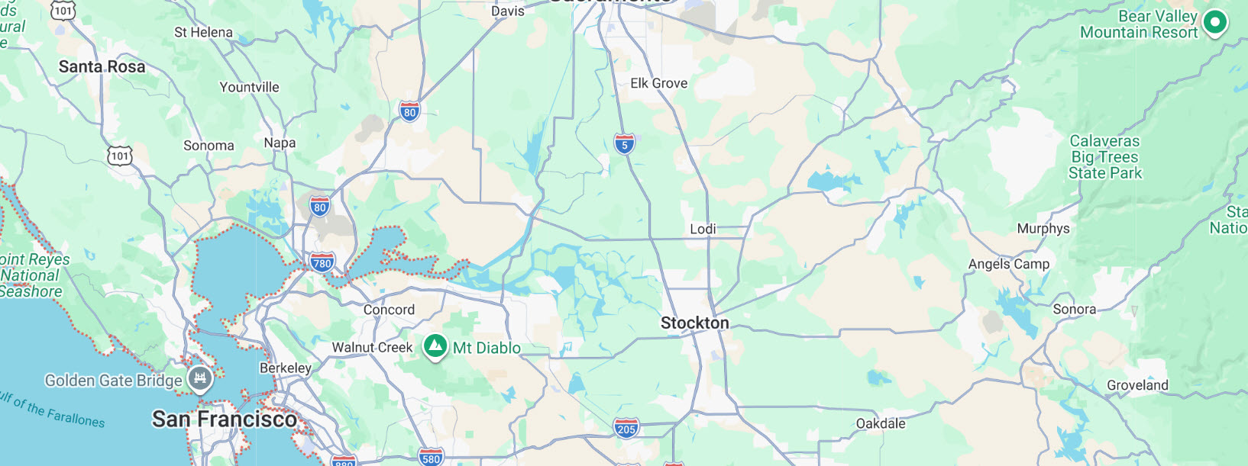
Describes the project location.
Photo 3: Add caption for photo here. Right-click the photo and select View Alt-Text to add alternative text.

Project Cost (Style: Heading 3)
Describes the project cost.
Total Project Cost | Total Grant Request
$00,000,000.00 | $00,000,000.00

Project Schedule (Style: Heading 3)
Describes the project schedule. May include a table, if helpful.

Project Benefits (Style: Heading 3)
Describes project benefits (outputs and outcomes).
• Benefit 1
• Benefit 2
• Benefit 3
• Benefit 4
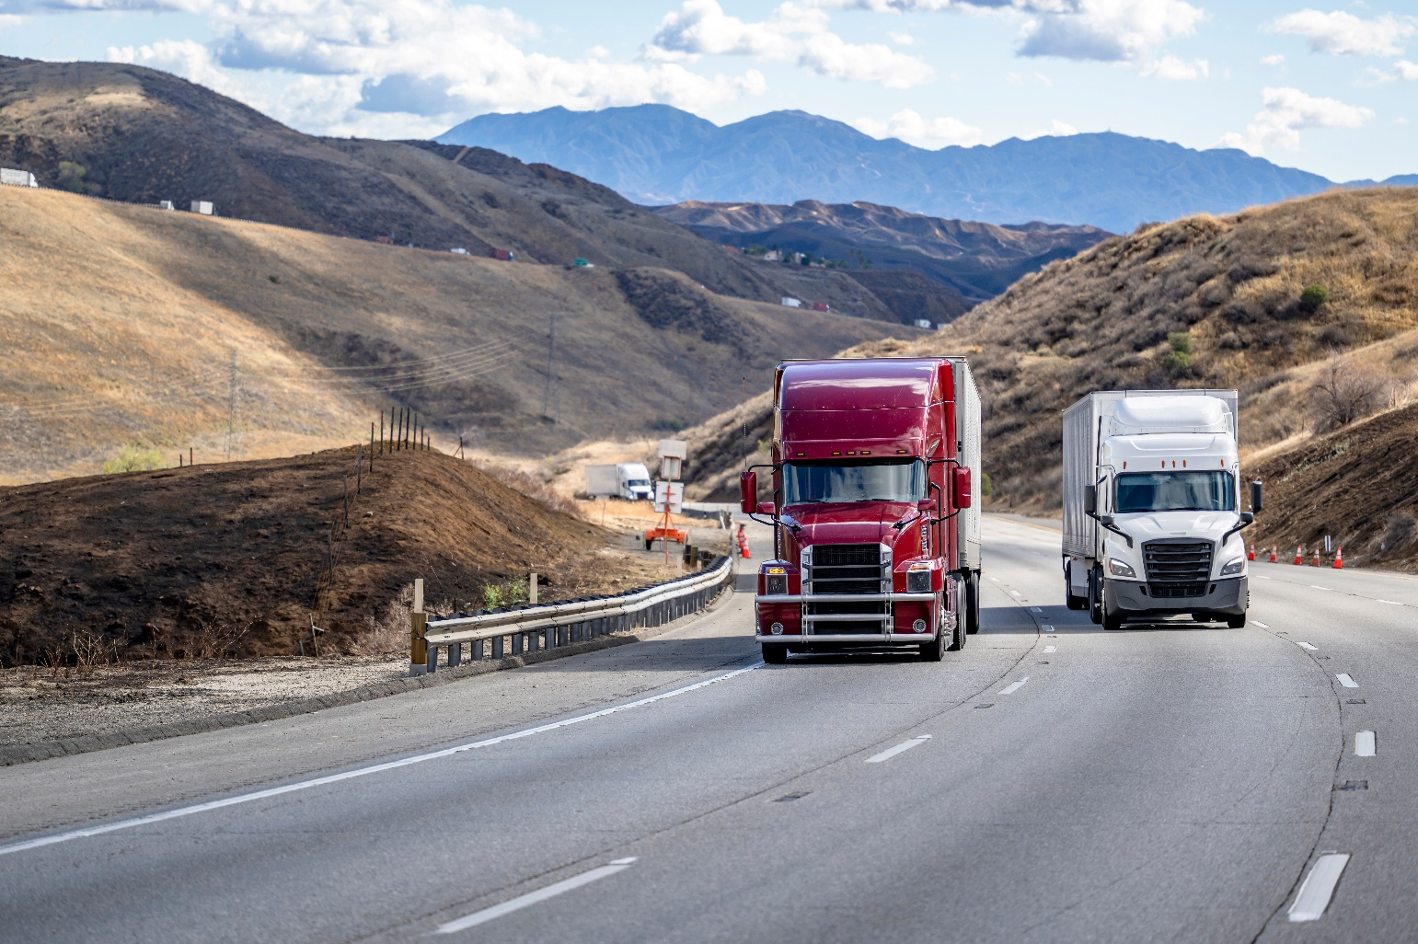
• Benefit 5
Photo 4: Add caption for photo here. Right-click the photo and select View Alt-Text to add alternative text.

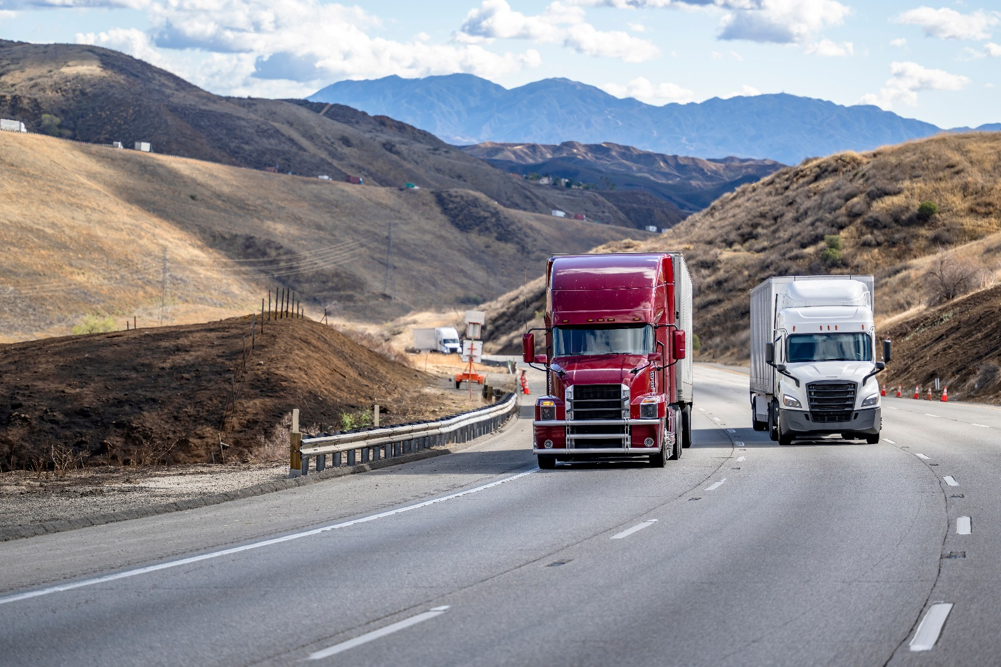
General Information (Style: Heading 2)
Photo 2: Add caption for photo here. Right-click the photo and select View Alt-Text to add alternative text.

Overview (Style: Heading 3)

Project Title Goes Here (Style: Heading 4)
Include a brief one-to-three paragraph non-technical description of the project, focusing on why the project is a good freight project. Includes brief project background, purpose and need for the project.

Project Location (Style: H3)
Provides a description and map(s) of the project location.

Priority (Style: Heading 3)
If the applicant is submitting multiple applications, specify the project priority.

Scope (Style: Heading 3)
Provides a brief description of the project scope (no longer than two paragraphs), and a list of outputs for the project. Outputs listed match the outputs submitted in the PPR.
Occuptat ommos as et lab in con elesequi int hicid quiaerum ipsuntion por ad unt dentorum si de dis autae pro bero excest mo cus. Ignam idias ducid magnatur sitata poratem pernatem as ex excerum aliquos eicit erum faccull animus.

Independent Utility (Style: Heading 3)
A project requesting construction funds must have independent utility. If the project nomination is requesting funds for construction and proposing a project segment, then in no more than two paragraphs, explain why the project is being segmented, and why the proposed segment has independent utility.

Nominating Agency/Implementing Agency Agreement (Style: Heading 3)
Provides confirmation that there is or will be a written agreement in place between the project nominator and implementing agency, if the project will be implemented by an agency other than the nominator.

Letters of Support (Style: Heading 3)
Any letters of support included as attachments must be preceded by a cover sheet which numerically lists all letters in the order they are attached. For congressional and legislative letters, include the member(s) names and district numbers on the cover sheet.

Screening Criteria (Style: Heading 2)

Eligible Projects (Style: Heading 3)
Identifies the project as one or more of the following project types:
- Highway Improvements
- Freight Rail System Improvements
- Border Improvements
- Port Enhancement & Improvements
- Truck Corridor Improvements
- Surface Transportation
- Local Roads
- Connector Road Improvements to effectively facilitate goods movement
- Freight Infrastructure Improvements (excluding vehicles) that enables zero-emission or near-zero emission goods movement
- Environmental or Community Mitigation that occurs as part of a freight infrastructure project
Freight Infrastructure related to advance technology (include the installation of broadband such as, conduit and fiber, and where appropriate and feasible along a strategic corridor. Provides an explanation of how the project fits under the category/categories selected – limited to one to two paragraphs or presented in the form of a short table. Provides an explanation on how the project is meets the following conditions:
- A freight infrastructure improvement with public benefits and meets screening and evaluation criteria.
- Compliant with Streets and Highway Code Section 2192.
- Consistent with Article XIX of the California Constitution.
Meet objectives of the program and support goals of the National Highway Freight Program, California Freight Mobility Plan, and California’s Sustainable Freight Action Plan.
TCEP Eligible Project Conditions | [Project Name Goes Here]
Project condition description | Description of how the project meets conditions
Project condition description | Description of how the project meets conditions
Project condition description | Description of how the project meets conditions
Project condition description | Description of how the project meets conditions

Consistency with the RTP/SCS (Style: Heading 3)
Confirm that the proposed nomination is included in the current approved Regional Transportation Plan and, if applicable, Sustainable Communities Strategy. Applicants must provide:
- Publicly accessible links to the approved Regional Transportation Plan/Sustainable Communities Strategy. Applicants must include the project identification number(s) for reference.
- For projects located within the boundaries of a metropolitan planning organization, a signed letter from the applicant’s metropolitan planning organization stating that the project’s cost, scope, and schedule is consistent with that metropolitan planning organization’s regional transportation plan and Sustainable Communities Strategy.
- For projects located outside the boundaries of a metropolitan planning organization, a signed letter from the applicable regional transportation planning agency stating that the project’s cost, scope, and schedule are consistent with the regional transportation planning agency’s regional transportation plan.

Environmental Clearance (Style: Heading 3)
Confirm that the project has achieved (or will achieve) environmental clearance at the time of program adoption.
If not, the project must achieve environmental clearance within six months of program adoption. In detail, explain how this will be accomplished and include an anticipated process timeline to ensure the project will meet this deadline.

Committed Funds (Style: Heading 3)
Confirm that the project has complete funding commitments that align with the requirements in Part V, Section 23 of the Trade Corridor Enhancement Program Guidelines. Uncommitted funds may only be from the Local Partnership Competitive Program, the Solutions for Congested Corridors Program, or a federal discretionary grant program.

Required Funding Match (Style: Heading 3)
If applicable, confirm that the funding plan includes the required 30 percent funding match, as described in Part II, Section 6 of these guidelines. The applicant should include the total match amount, and the source of the matching funds.

Project Delivery (Style: Heading 2)

Delivery Method – [Identify Type] (Style: Heading 3)
In less than one paragraph, discuss what specific delivery method is being used for the project. For delivery methods other than design-bid-build, identify the delivery method.

Contracts (Style: Heading 3)
Note if more than one contract will be needed for the same phase.

Schedule Risks (Style: Heading 3)
Provides discussion or identifies in a table any potential schedule risk and proposed mitigation strategies to keep the project on schedule. This can include geotechnical analysis needs/concerns, complicated utility relocations, or land acquisitions needs.
Risk | Proposed Mitigation Strategy
Description of potential risk | Description of a proposed mitigation strategy
Description of potential risk | Description of a proposed mitigation strategy
Description of potential risk | Description of a proposed mitigation strategy
Description of potential risk | Description of a proposed mitigation strategy
Description of potential risk | Description of a proposed mitigation strategy
If the project requests allocation in the final fiscal year of the program, provides justification that the project will be ready to allocate on time.

Rail Company Coordination (Style: Heading 3)
Provides a timeline for any necessary coordination with rail companies (Union Pacific Railroad/Burlington Northern Santa Fe). Below are examples of rail company involvement:
- The project requires a construction and maintenance agreement.
- The implementing agency needs permission from a rail company to use, make changes to, acquire, or work on their land.
- A rail company must review and approve the project design.
- Any other kid of significant involvement.

Timeline (Style: Heading 4)
If the project requires coordination with a rail company, includes a timeline with the following information:
- When the project team begins and ends engagement with rail company
- Average review and approval timeframe from the rail company
- Dates when the project team will secure any necessary approvals
- Any other major milestones

California Environmental Quality Act (CEQA) / National Environmental Policy Act (NEPA) Status (Style: Heading 3)
For applicants request design, right-of-way, or construction funding, the following information should be provided:
- One to two-paragraph description of where the applicant is at in the process of securing approvals for CEQA and NEPA if necessary.
- One to two-paragraph description or table containing information regarding the environmental and community impacts as identified in the environmental document and if applicable the proposed mitigations.
- Link to the final environmental document(s), or the draft environmental document(s) of the project including all project segments, if applicable.
- If environmental documents are not completed, includes one to two-paragraph explanation on how the project will ensure the completion of CEQA and NEPA within 6 months of program adoption.

Evaluation Criteria (Style: Heading 2)
Provide a completed Performance Indicators and Measure Table that aligns or matches with qualitative description provided. These Performance Indicators/Measures should be tabulated in Appendix B, and provide the quantitative information for those evaluation criteria that are also performance measures.
Projects Inducing Passenger Vehicle Miles Traveled: Applicants should discuss the benefits of any passenger vehicle miles traveled mitigation strategies under the evaluation criteria that align with the specific mitigation approach.

Freight System Factors (Style: Heading 3)

Throughput (Style: Heading 4)

Describes how the project provides for increased volume of freight traffic through capacity expansion or operational efficiency to improve the interregional transportation network and move goods through and from ports.

Velocity (Style: Heading 4)

Describes how the project increases the speed of freight traffic moving through the distribution system (critical freight corridors and ports)

Reliability (Style: Heading 4)

Describes how the project reduces the variability and unpredictability of travel time.

Transportation System Factors (Style: Heading 3)

Safety (Style: Heading 4)
Describes how the project increases the safety of the public, industry workers, and traffic.

Congestion Reduction/Mitigation (Style: Heading 4)
Describes how the project reduces daily hours of delay on the system and improves access to freight facilities.

Key Transportation Bottleneck Relief (Style: Heading 4)
Describes how the project relieves key freight system bottlenecks where forecasts of freight traffic growth rates indicate infrastructure or system needs are inadequate to met demand (bottlenecks on critical freight corridors and near state’s borders).

Multi-Modal Strategy (Style: Heading 4)
Describes how the project employs or supports multi-modal strategies to increase port and transportation system throughput while reducing truck vehicle miles/ hour traveled or truck idling times.

Interregional Benefits (Style: Heading 4)
Describes how the project links regions or corridors to serve statewide or national trade corridor needs and to improve the interregional transportation network.

Advanced Technology (Style: Heading 4)
Describes how the project employs advanced and innovative technology and integrates transformative ideas to increase benefits for the state’s people, economy, and environment, and those that include installation of broadband (conduit and or fiber).

Zero-Emission Infrastructure (Style: Heading 4)
Describe how the project supports zero-emission freight infrastructure. Actions that support the transition to zero-emission freight infrastructure include, but may not be limited to, the following:
- Building zero-emission infrastructure that supports freight.
- Improving access to freight charging or hydrogen fueling infrastructure to refuel battery electric and fuel cell powered trucks.
- As a part of a larger port freight infrastructure project, buying zero-emission or near-zero-emission human-operated equipment.
Applicants proposing zero-emission freight infrastructure must also address the sub-criteria listed under “Zero-Emission Freight Infrastructure Sub-Criteria” below, including traditional projects with zero-emission freight infrastructure elements.

Community Impact Factors (Style: Heading 3)

Air Quality Impact (Style: Heading 4)
Describes how the project reduces local and regional emissions of diesel particulate, carbon monoxide, nitrogen oxides, greenhouse gases, and other pollutants.

Community Engagement (Style: Heading 4)
Demonstrates how the project provides meaningful and effective public participation in the decision-making process, particularly for disadvantaged or historically impacted and marginalized communities. Review the application guidelines for additional required responses and questions to respond to.

Economic Impact (Style: Heading 4)
Describes how the project stimulates local economic activity, enhances trade value, preserves, or creates jobs, enhances California freight competitiveness, improves the economy, and when looking at the overall need, benefits and cost, the project provides more benefits than cost. Review the application guidelines for additional prompts that require a response.

Other Factors (Style: Heading 3)

Urgent Freight Need (Style: Heading 4)
Describes how well the project addresses the state’s most urgent freight needs.

Project Readiness (Style: Heading 4)
Provides description on the project’s readiness and reasonableness of the schedule for project implementation. Implementation includes but is not limited to:
- Progress towards achieving environmental protection requirements. If this information has already been provided in the California Environmental Quality Act/National Environmental Policy Act Status section above, the nomination may reference that section of the application.
- The comprehensiveness and sufficiency of agreements with key partners that will be involved in implementing the project. For rail information, if it has already been provided in the Rail Company Coordination section above, the nomination may reference that section.

Leveraging and Coordination of Funds (Style: Heading 4)
Describes the leveraging and coordination of funding from other private, federal, state, local, or regional sources, with consideration of those sources that are discretionary compared to those that are nondiscretionary.

Joint Nomination or Joint Funding (Style: Heading 4)
The comprehensiveness and sufficiency of agreements with key partners (particularly infrastructure owning railroads) involved in implementing the project. For rail information, if already provided in “Rail Company Coordination”, refers to said section. Describes the commitment of multiple partners in the delivery of the project, as evidenced by join nomination and or joint funding of a project.

Other Factors (Style: Heading 4)
Describes any other factors considered relevant at the time of application.

Zero-Emission Freight Infrastructure Sub-Criteria (Style: Heading 3)
These sub-criteria only apply to zero-emission freight infrastructure projects. Refer to pages 61-63 in the TCEP Guidelines for the required responses.

Other Project Information Areas (Style: Heading 2)

Accessibility (Style: Heading 3)
Describes how the project improves access to jobs or key destinations, improves access for specific populations, or improves transportation options.

Climate Change Resilience and Adaptation (Style: Heading 3)
Describes how the project identifies and includes project features or strategies to mitigate the impact of climate change.

Protection of Natural and Working Lands, and Enhancement of the Built Environment (Style: Heading 3)
Describes how the project minimizes the impact on natural working lands (e.g., forest, rangelands, farms, urban green spaces, wetlands, and soils) or incorporate natural and green infrastructure.

Public Health (Style: Heading 3)
Describes how the project removes or alleviates conflicts between freight vehicles and other travel modes.

Funding and Deliverability (Style: Heading 2)

Funding Table (Style: Heading 3)
Provides a completed funding table for all phases of the project that aligns with the PPR. Provides an escalated cost to the year of proposed implementation and be approved by the Chief Executive Officer or other authorized officer of the implementing agency. Joint applications clearly identify the required 30% funding match for each programed component. NOTE: Match funds are calculated based on the total amount of regional TCEP funds being requested.
Match funds only include funds not allocated by the Commission on a project specific basis, except for State Transportation Improvement Program. Match funds are expended concurrently and proportionally on the project programmed with TCEP funds unless Commission has approved non-proportional spending at the time of programming or allocation. Funds programmed in prior program cycles do not count toward match requirement. If receiving Federal National Highway Freight Program funds, non-proportional spending must be approved by the Federal Highway Administration prior to allocation. Costs incurred prior to allocation are not counted toward the match. Explains why local funds can be reasonably assumed to be available and why state funds will not result in stranded investments.
Phase | Fiscal Year Allocation | Amount (in Millions) | Funding Source | Committed or Uncommitted
Content | Content | Content | Content | Content
Content | Content | Content | Content | Content
Content | Content | Content | Content | Content
Content | Content | Content | Content | Content
Content | Content | Content | Content | Content
Content | Content | Content | Content | Content

Total Project Cost (Style: Heading 3)
Provides the total project cost at the end of the funding table or in a separate sentence which matches the Project Programming Request.

Cost Overruns (Style: Heading 3)
The nomination should describe the ability of the nominating or implementing agency or agencies to absorb any cost overruns and deliver the proposed project without additional Trade Corridor Enhancement Program funding, except as noted in Part II, Section 8 of the guidelines.

Contracts (Style: Heading 3)
Notes if more than one contract (and two separate allocations) will be needed for the same phase.

Pre-Construction Requests (Style: Heading 3)
Explains how future construction will be funded if proposing to fund only preconstruction project components.

Federal Discretionary Funds (Style: Heading 3)
Identifies any discretionary federal funds that have been committed as of the application due date and provides proof of the commitment in the form of a letter or public announcement issued by the authorized federal agency.

Ineligible Elements (Style: Heading 3)
Identifies any ineligible elements of a project and confirms that those ineligible elements will not be funded with TCEP funds.

Other (Style: Heading 2)

Public/Private Benefits (Style: Heading 3)
Provides the following analysis if the project includes significant benefits to private infrastructure or private company:
- Provides a list of specific public benefits and a list of specific private benefits.
- Provides an estimate of what percent of funds will directly benefit private infrastructure or private company, and what percent of funds will directly benefit the public, based on the total project cost.
- Explains who will own the asset once the project is completed.
- Explains why the public benefit of the project warrants the investment of public funding and why the share of public benefit is commensurate with the share of public funding if the project results in private benefits.

Interagency Cooperation (Style: Heading 3)
Provides evidence and explains the cooperation between the nominating agency and Caltrans, for projects on the State Highway System.

Bulk Coal (Style: Heading 3)
Confirms that any new terminals projects will not have significant environmental impacts as described in related environmental document resulting from the storage, handling, or transport of coal in bulk pursuant to Government Code Section 14525.3. Evaluation of each new terminal if related environment documents are not completed, a written confirmation is provided to the Commission.

Reversible Lanes (Style: Heading 3)
Confirms that any capacity-increasing project or major street or highway lane realignment project was considered for reversible lanes pursuant to Streets and Highway Code Section 100.15

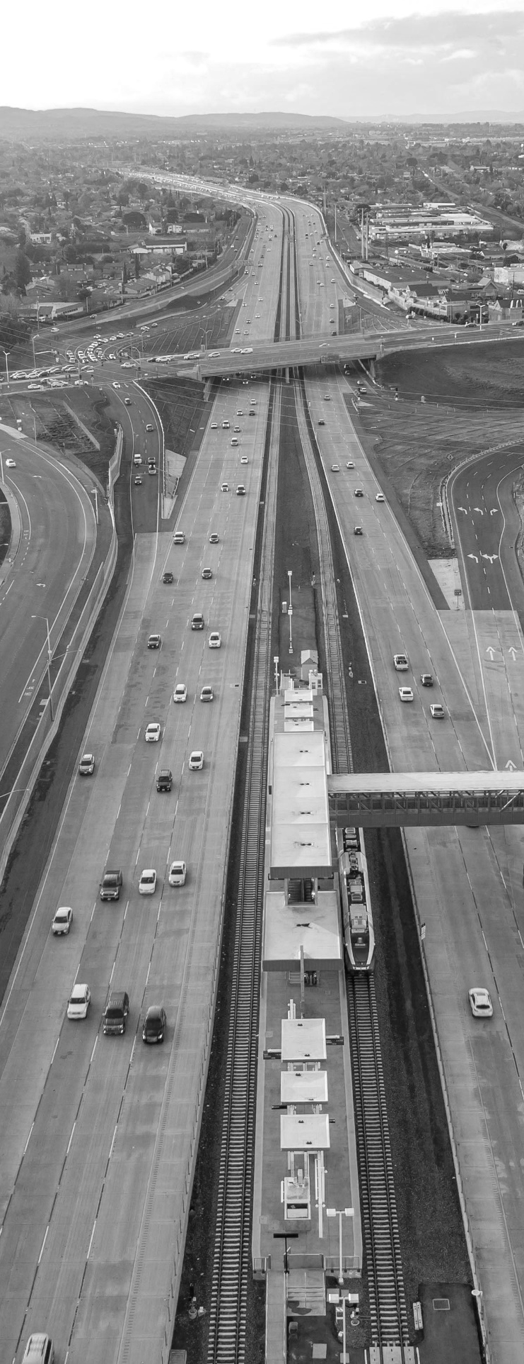
Appendices

Appendix I: Electronic Project Programming Request

Insert the Electronic Project Programming Request PDF

Appendix II: Performance Indicators and Measures
Existing Average Annual Vehicle Volume on Project Segment | Content
Existing Average Annual Truck Percent on Project Segment | Content
Estimated Year 20 Average Annual Vehicle Volume on Project Segment with Project | Content
Estimated Year 20 Average Annual Truck Percent on Project Segment with Project | Content

Measure | Metric | Project Type | Build | Future No Build | Change | Increase / Decrease
Congestion Reduction (Freight) | Change in Daily Vehicle Hours of Delay | All
Congestion Reduction (Freight) | Change in Daily Truck Hours of Delay | All (except Rail)
Congestion Reduction (Freight) | (Optional) Person Hours of Travel Time Saved | All
Congestion Reduction (Freight) | (Optional) Daily Truck Trips Due to Mode Shift | Rail, Sea Port
Congestion Reduction (Freight) | (Optional) Daily Truck Miles Traveled Due to Mode Shift | Rail, Sea Port
Congestion Reduction (Freight) | (Optional) Other Information | All
Throughput (Freight) | Change in Truck Volume | Highway, Road, and Port Projects Only
Throughput (Freight) | Change in Rail Volume | Rail
Throughput (Freight) | (Optional) Change in Cargo Volume | Sea Port, Airport
Throughput (Freight) | (Optional) Other Information | All
System Reliability (Freight) | (Optional) Truck Travel Time Reliability Index (“No Build” Only) | National and State Highway System Only
System Reliability (Freight) | (Optional) Other Information | All
Velocity (Freight) | Travel time or total cargo transport time | All
Velocity (Freight) | (Optional) Change in Average Peak Period Weekday Speed for Road Facility | Road
Velocity (Freight) | (Optional) Average Peak Period Weekday Speed for Rail Facility | Rail
Velocity (Freight) | (Optional) Other Information | All
Air Quality | Particulate Matter (PM 10) | All
Air Quality | Particulate Matter (PM 2.5) | All
Air Quality | Carbon Dioxide (CO2) | All
Air Quality | Volatile Organic Compounds (VOC) | All
Air Quality | Sulphur Oxides (SOx) | All
Air Quality | Carbon Monoxide (CO) | All
Air Quality | Nitrogen Oxides (NOx) | All
Safety | Number of Fatalities
Safety | Rate of Fatalities per 100 Million VMT
Safety | Number of Serious Injuries
Safety | Number of Serious Injuries per 100 Million VMT
Safety | (Optional) Number of Non-Motorized Fatalities and Non-Motorized Serious Injuries
Safety | Optional (Other Information) | All
Cost Effectiveness | Cost Benefit Ratio | All
Cost Effectiveness | Optional (Other Information) | All
Economic Development | Jobs Created | All
Economic Development | Optional (Other Information) | All

