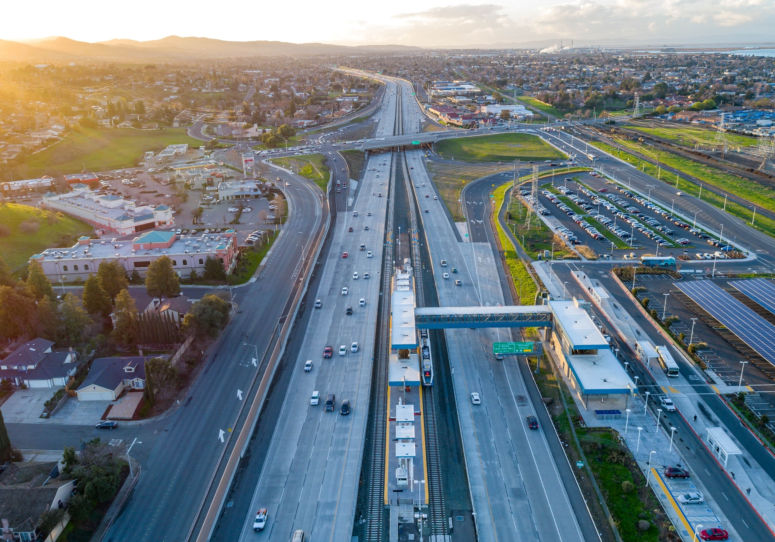

[Project Title Name Goes Here] (Style: Heading 1)
  - Solutions for Congested Corridors Program (SCCP)
CALIFORNIA DEPARTMENT OF TRANSPORTATION & [NOMINATING AGENCY]
[MONTH 20XX]


[Project Title Name Goes Here] (Style: Heading 1)
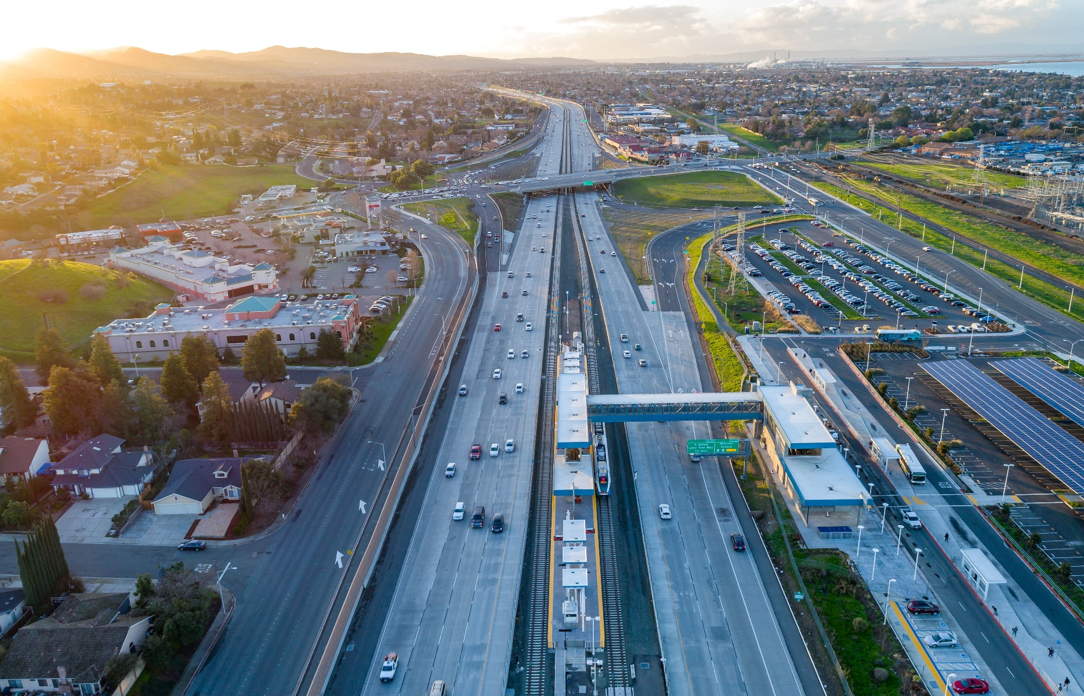

  - Solutions for Congested Corridors Programs (SCCP)
CALIFORNIA DEPARTMENT OF TRANSPORTATION & [NOMINATING AGENCY]
[MONTH 20XX]

[Project Title Name Goes Here] (Style: Heading 1)
  - Solutions for Congested Corridors Program (SCCP)
CALIFORNIA DEPARTMENT OF TRANSPORTATION & [NOMINATING AGENCY]
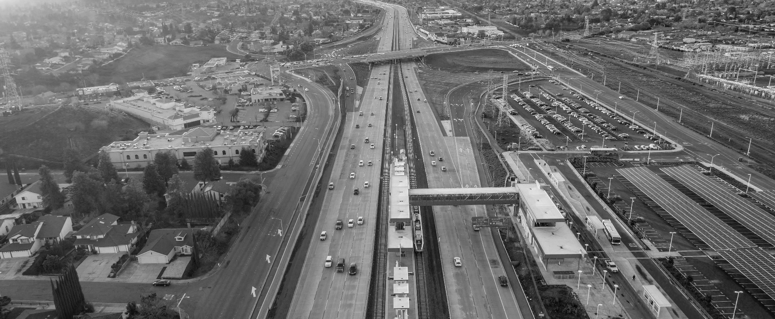
[MONTH 20XX]

[Project Title Name Goes Here] (Style: Heading 1)
  - Solutions for Congested Corridors Program (SCCP)
CALIFORNIA DEPARTMENT OF TRANSPORTATION & [NOMINATING AGENCY]
[MONTH 20XX]
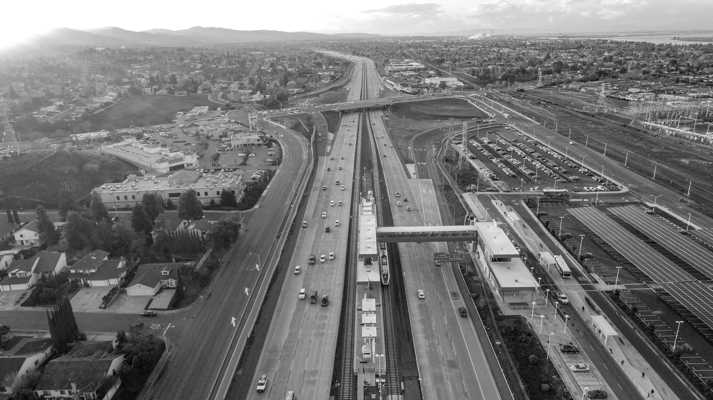

Table of Contents
Table of Contents 1
A. Cover Letter 2
B. Fact Sheet 3
Project Overview/Scope 3
Project Location 3
Project Cost 4
Project Schedule 4
Project Benefits 4
C. Screening Criteria 5
1. Project Location Map(s) 5
2. Reversible Lanes 5
3. Regional Transportation Plan (RTP) and Sustainable Communities Strategy (SCS) 5
4. Comprehensive Multimodal Corridor Plan (CMCP) 6
5. Environmental and Community Impacts 6
6. Construction Ready 6
7. Funding Commitments 6
D. Evaluation Criteria 7
1. Congestion Evaluation Criteria 7
2. Additional Evaluation Criteria 7
E. Additional Information 9
1. Private Infrastructure 9
2. Rail Infrastructure 9
F. Other Optional Project Information Areas 10
1. Climate Change Resilience and Adaptation 10
2. Protection of Natural and Working Lands, and Enhancement of the Built Environment 10
3. Public Health 10
G. CMCP Self-Certification Form 11
H. Electronic Project Programming Request 13
I. Performance Measures 15
J. Letters of Support 18
K. Appendices / Additional Attachments 20
Appendix I: [Name of Appendix Section] 20
Appendix II: [Name of Appendix Section] 22

Cover Letter
Insert the Cover Letter PDF

The cover letter must include a brief non-technical description of the project scope, cost, schedule, benefits (outputs and outcomes), and requested funding amount. If the project includes multiple project modes, each project mode must be described. Specifically include a “project purpose and need” section to describe how the project meets the primary purpose of the Solutions for Congested Corridors Program as specified in Part I, Section 1 of the Solutions for Congested Corridors Guidelines. If multiple nominations are submitted, identify each nominated project and its priority.
If proposing a segment of a corridor, the applicant should discuss the entire corridor and why the project is being segmented. The project must demonstrate the segment proposed for funding has independent utility and include a narrative of the plan to complete the remaining improvements of the corridor.
If proposing the last segment of the corridor, the nomination should discuss the benefits that have been achieved through the completion of all other segments and the overall benefits of completing the corridor. The cover letter should address the impacts of not completing the segment(s). The analysis should be coordinated with other jurisdictions if the corridor crosses multiple jurisdictions.
The cover letter should meet the following criteria:
- Addressed to the CTC Executive Director
- Clearly identify nominating agency or agencies on a formal letterhead
- Signed by Director of Transportation or person authorized by the director to submit the nomination.
- Signed by Chief Executive Officer or another authorized officer of the regional agency when applicable.
- Jointly nominated project must have a duly authorized signature of all agencies.
- If a project will be implemented by an agency or multiple agencies other than the nominating agency, the nomination must include the signature(s) of the Chief Executive Officer or other authorized officer(s) of the implementing agency or agencies, and documentation of the agreement between the project nominator and implementing agency.

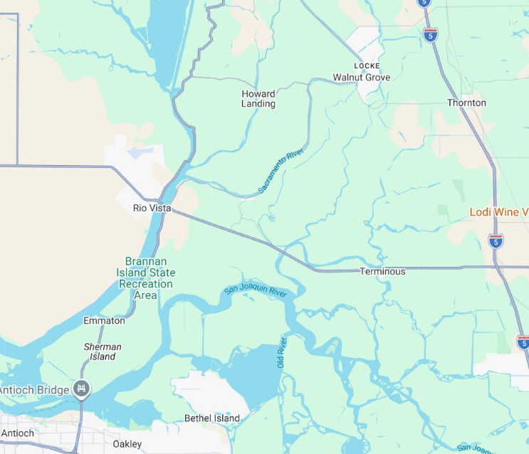
Fact Sheet (Style: Heading 2)
Photo 2: Add caption for photo here. Right-click the photo and select View Alt-Text to add alternative text.
Fact sheet should be one or two pages in length. If images are included, the images should meet the following requirements:
- High-quality picture or rendering – at least 300 Dots per Inch (DPI)
- High-quality picture or rendering of nominating agency’s logo If there are multiple nominating agencies, each agency’s logo must be included.

Project Overview/Scope (Style: Heading 3)
Includes a brief narrative on how the project: (1) Impacts Greenhouse Gas Emissions; (2) Considers Transportation Equity; (3) Mitigated or avoided negative community impacts that resulted in better outcomes. Narrative should be understood by a non-technical audience.

Project Location (Style: Heading 3)
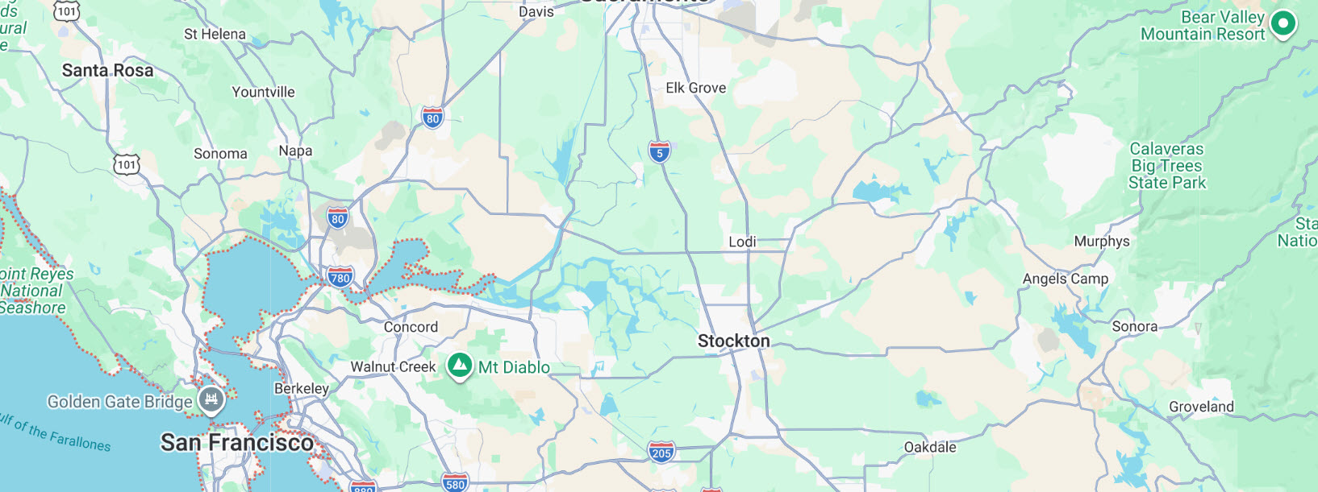
Describes the project location.
Photo 3: Add caption for photo here. Right-click the photo and select View Alt-Text to add alternative text.

Project Cost (Style: Heading 3)
Describes the project cost.
Total Project Cost | Total Grant Request
$00,000,000.00 | $00,000,000.00

Project Schedule (Style: Heading 3)
Describes the project schedule. May include a table, if helpful.

Project Benefits (Style: Heading 3)
Describes project benefits (outputs and outcomes).
• Benefit 1
• Benefit 2
• Benefit 3
• Benefit 4
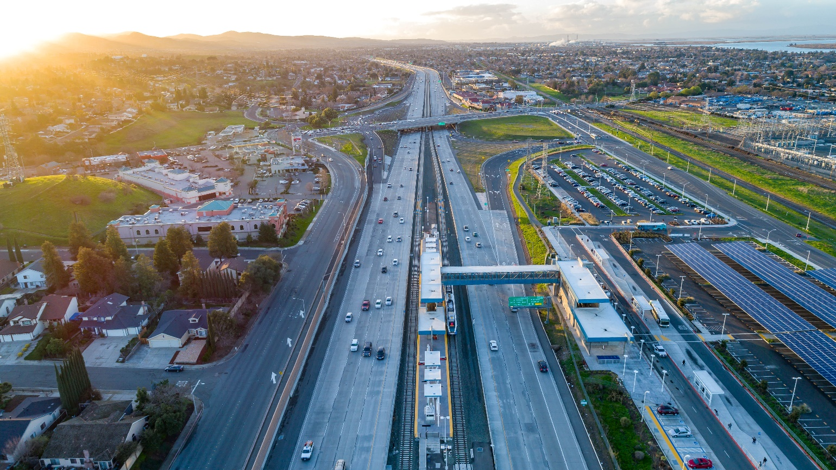
• Benefit 5
Photo 4: Add caption for photo here. Right-click the photo and select View Alt-Text to add alternative text.

Screening Criteria (Style: Heading 2)
SCCP Eligibility Requirement | Eligible (Y/N) | How This Project Qualifies
Content | Y | Content
Content | Y | Content
Content | Y | Content
Content | Y | Content

Project Location Map(s) (Style: Heading 3)
Include at least one high-resolution project location map which includes a map legend.
Photo 3: Add caption for photo here. Right-click the photo and select View Alt-Text to add alternative text.

Reversible Lanes (Style: Heading 3)
Confirm consideration [explain].

Regional Transportation Plan (RTP) and Sustainable Communities Strategy (SCS) (Style: Heading 3)
- Confirm project is included in an adopted RTP/SCS.
- Description: [Project is consistent with RTP/SCS goals and objectives]
- RTP Link:
- Page Number
- Project ID Number
- SCS Link:
- Page Number
- Project ID Number
Signed letter from metropolitan planning organization included in Section L, page [number].

Comprehensive Multimodal Corridor Plan (CMCP) (Style: Heading 3)
- Confirm project is included in a CMCP.
- Description: [Project is consistent with CMCP objectives]
- CMCP Link:
  - Page #
  - Project ID Number
- Completed CMCP Self-Certification Form included in Section G, page [number].

Environmental and Community Impacts (Style: Heading 3)
Confirm project has achieved environmental clearance at the time of program adoption or will achieve environmental clearance within six months of program adoption.

California Environmental Quality Act (CEQA) - specify for each project segment (Style: Heading 4)
- Current Status and (Expected) Clearance Date
- Final (or Draft) Environmental Document Link

National Environmental Policy Act (NEPA) - if applicable (Style: Heading 4)
- Current Status and (Expected) Clearance Date
- Final (or Draft) Environmental Document Link

Construction Ready (Style: Heading 3)
Confirm project is (or will be) ready for construction by December 31, 2027.

Funding Commitments (Style: Heading 3)
Confirm project has complete funding commitments in alignment with program guidelines.

Evaluation Criteria (Style: Heading 2)
Photo 2: Add caption for photo here. Right-click the photo and select View Alt-Text to add alternative text.

Congestion Evaluation Criteria (Style: Heading 3)

Extent of Congestion (Style: Heading 4)
Describe the extent of the congestion. Use subsections (Style: H5) if needed. Some example subsections include: (1) Current Conditions; (2) No-Build Environment; (3) Completed or Ongoing Improvements; and (4) Other Issues.

Proposed Solution (Style: Heading 4)
Describe the proposed solution. Use subsections (Style: H5) if needed. Some example subsections include: (1) Reducing Congestion; (2) Incorporating Multiple Modes; (3) Increasing Throughput and Reducing Vehicle Miles Traveled; (4) Balanced Solution; (5) Solution Benefits; and (6) Induced Demand.

Additional Evaluation Criteria (Style: Heading 3)

Safety (Style: Heading 4)
Describe the safety considerations. Use subsections (Style: H5) if needed. Some example subsections include: (1) Current Conditions; (2) Increasing Safety; (3) Health Impacts; and (4) Other Safety Measures.

Accessibility (Style: Heading 4)
Describe the accessibility considerations. Use subsections (Style: H5) if needed. Some example subsections include: (1) Multimodal Choices; (2) Gap Closure; (3) Connectivity; and (4) Other Accessibility Measures.

Community Engagement (Style: Heading 4)
Describe the community engagement considerations. Use subsections (Style: H5) if needed. Some example subsections include: (1) Identification; (2) Engagement; (3) Outcomes; (4) Impacts; and (5) Pre-existing Plans and Activities

Economic Development and Job Creation and Retention (Style: Heading 4)
Describe the economic development and job creation and retention considerations. Use subsections (Style: H5) if needed. Some example subsections include: (1) Stimulating Economic Activity; (2) Increasing Access and Retaining Opportunities; (3) Creating Jobs; (4) Workforce Development; (5) Movement of Goods and Services; and (6) Other Economic Impacts

Air Quality and Greenhouse Gases (Style: Heading 4)
Describe the air quality and greenhouse gas considerations. Use subsections (Style: H5) if needed. Some example subsections include: (1) Reducing Emissions and Pollutants; (2) Advancing State Climate Goals; (3) Zero Emission Infrastructure, Equipment, and Vehicles; and (4) Other Environmental Benefits

Efficient Land Use and Housing (Style: Heading 4)
Describe the efficient land use and housing considerations. Use subsections (Style: H5) if needed. Some example subsections include: (1) Local Land Use Policies and Patterns; (2) Prohousing; (3) Existing or Developing Housing Issues; and (4) Residential, Mixed-Use, Infill Development and Multimodal Choices

Matching Funds and Deliverability (Style: Heading 4)
Describe the matching funds and deliverability considerations. Use subsections (Style: H5) if needed. Some example subsections include: (1) Cost Estimate and Fund Sources; (2) Uncommitted Funds; (3) Cost Overruns; (4) Delivery Plan and Timeline; and (5) Risks and Contingencies

Collaboration (Style: Heading 4)
Describe the collaboration considerations. Use subsections (Style: H5) if needed. Some example subsections include: (1) Partner Agencies and (2) Combined Resources

Cost Effectiveness (Style: Heading 4)
Describe the cost effectiveness considerations. Use subsections (Style: H5) if needed. Some example subsections include: (1) Methodology and (2) Benefit-Cost Ratio

Additional Information (Style: Heading 2)

Private Infrastructure (Style: Heading 3)
Describe the private infrastructure considerations. Use subsections (Style: H5) if needed. Some example subsections include: (1) Public and Private Benefit-Cost Analysis and (2) Asset Ownership

Rail Infrastructure (Style: Heading 3)
Describe the rail infrastructure considerations. Use subsections (Style: H5) if needed. Some example subsections include: (1) Public and Private Benefit-Cost Analysis and (2) Investment Levels

Other Optional Project Information Areas (Style: Heading 2)

Climate Change Resilience and Adaptation (Style: Heading 3)
Describe the climate change resilience and adaptation considerations. Use subsections (Style: H5) if needed. Some example subsections include: (1) Mitigating Climate Change Impacts and (2) Utilized Strategies

Protection of Natural and Working Lands, and Enhancement of the Built Environment (Style: Heading 3)
Describe the protection of natural and working lands, and enhancement of the built environment. Use subsections (Style: H5) if needed. Some example subsections include: (1) Employing Land Conservation Measures and (2) Natural or Green Infrastructure Solutions

Public Health (Style: Heading 3)
Describe the public health considerations. Use subsections (Style: H5) if needed. An example subsection is: Physical Activity and Mental Health Impacts

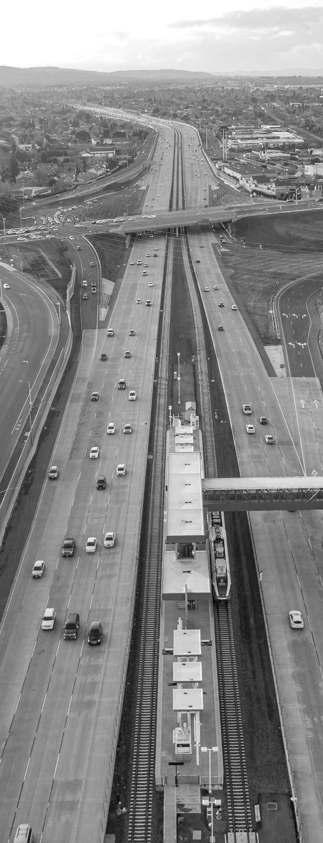
CMCP Self-Certification Form

Insert the CMCP Self-Certification Form

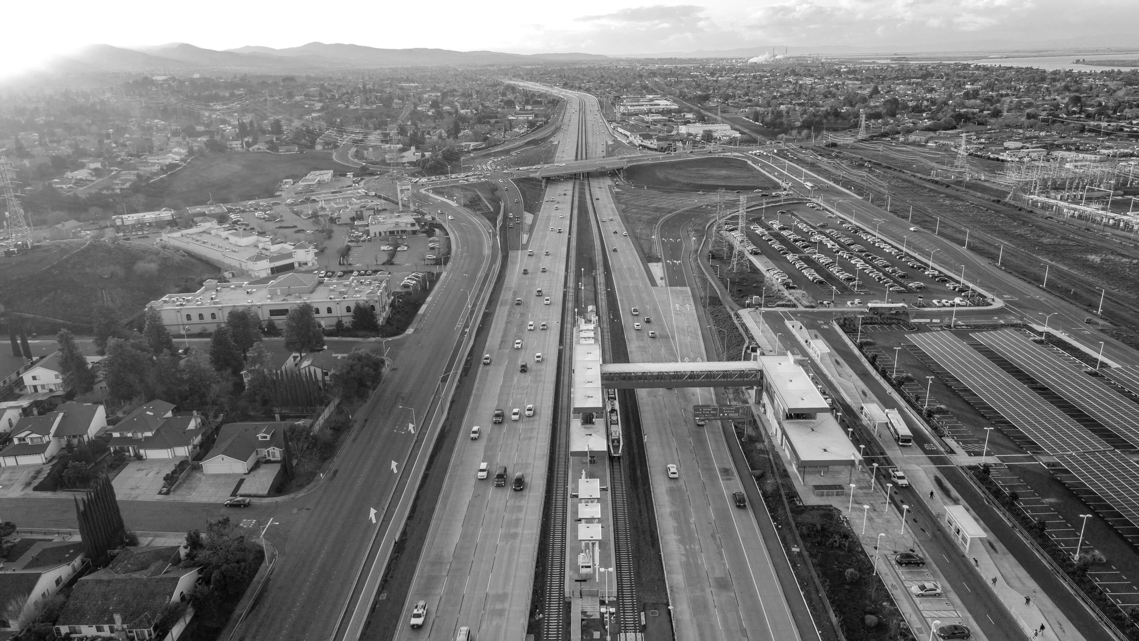
Electronic Project Programming Request

Insert the Electronic Project Programming Request

Performance Measures

Existing Average Annual Vehicle Volume on Project Segment | Content
Estimated Year 20 Average Annual Vehicle Volume on Project Segment with Project | Content

Measure | Metric | Project Type | Build | Future No Build | Change | Increase / Decrease
Congestion Reduction (Freight) | Change in Daily Vehicle Miles Traveled (VMT) | All
Congestion Reduction (Freight) | Person Hours of Travel Time Saved | All
Congestion Reduction (Freight) | (Optional) Change in Daily Vehicle Hours of Delay | Highway
Congestion Reduction (Freight) | (Optional) Percent Change in Non-Single Occupancy Vehicle Travel | Local Road, Highway
Congestion Reduction (Freight) | (Optional) Per Capita and Total Person Hours of Delay per Year | Local Road, Highway
Congestion Reduction (Freight) | (Optional) Other Information | All
Throughput | (Optional) Peak Period Person Throughput – by applicable mode | All
Throughput | (Optional) Passengers Per Vehicle Service Hour | Transit Rail and Transit Bus
Throughput | (Optional) Other Information | All
System Reliability (Freight) | Peak Period Travel Time Reliability Index (“No Build” Number Only) | National and State Highway System Only
System Reliability (Freight) | Level of Transit Delay | Transit Rail and Transit Bus
System Reliability (Freight) | (Optional) Other Information | All
Safety | Number of Fatalities | All
Safety | Rate of Fatalities per 100 million VMT | All
Safety | Number of Serious Injuries | All
Safety | Rate of Serious Injuries per 100 million VMT | All
Safety | (Optional) Number of Non-Motorized Fatalities and Non-Motorized Serious Injuries | All
Safety | (Optional) Other Information | All
Safety | (Optional) Number or Rate of Property Damage Only Collisions | Local Road, Highway
Safety | (Optional) Number or Rate of Non-Serious Injury Collisions | Local Road, Highway
Safety | (Optional) Accident Cost Savings | Local Road, Highway
Economic Development | Jobs Created | All
Economic Development | (Optional) Other Information | All
Air Quality and Greenhouse Gases | Particulate Matter (PM 10) | All
Air Quality and Greenhouse Gases | Particulate Matter (PM 2.5) | All
Air Quality and Greenhouse Gases | Carbon Dioxide (CO2) | All
Air Quality and Greenhouse Gases | Volatile Organic Compounds (VOC) | All
Air Quality and Greenhouse Gases | Sulphur Oxides (SOx) | All
Air Quality and Greenhouse Gases | Carbon Monoxide (CO) | All
Air Quality and Greenhouse Gases | Nitrogen Oxides (NOx) | All
Accessibility | (Optional) Number of Jobs Accessible by Mode | All
Accessibility | (Optional) Access to Key Destinations by Mode | All
Accessibility | (Optional) Percentage of Population Defined as Low Income or Disadvantaged within ½ mile of a rail station, ferry terminal, or high-frequency bus stop | Transit Rail and Transit Bus
Accessibility | Optional (Other Information) | All
Cost Effectiveness | Cost Benefit Ratio | All
Cost Effectiveness | Optional (Other Information) | All

Letters of Support

Insert the Letters of Support PDFs

Appendices / Additional Attachments

Appendix I: [Name of Appendix Section]

Appendix II: [Name of Appendix Section]

