RED COLORED TRANSIT-ONLY LANES

REQUEST TO CONTINUE AND EXPAND EXPERIMENT

Submitted to:
California Traffic Control Devices Committee
Federal Highway Administration, Office of Traffic Operations

Submitted by:
City of Los Angeles Department of Transportation

April 18, 2022

BACKGROUND
The City of Los Angeles Department of Transportation (LADOT) manages and regulates traffic control devices within the City of Los Angeles. This includes roadways used by several regional transit systems, including the Los Angeles County Metropolitan Transportation Authority (LACMTA). The roadway network within the city of Los Angeles includes 29.1 lane miles of transit-only lanes. As part of ongoing initiatives to improve service on our regional bus network, LADOT is seeking improvements to the operation of transit-only lanes. LADOT is also evaluating the addition of new transit-only lanes throughout the city. This request for experimentation is for the use of red colored pavement within existing transit-only lanes.

NATURE OF THE PROBLEM
Transit-only lanes can reduce transit travel times and improve transit service reliability by allowing transit vehicles to bypass traffic congestion and avoid conflicts with other vehicles in mixed travel lanes. Non-transit vehicles are typically permitted to enter transit-only lanes to access curbside parking or to complete a turn, unless specifically prohibited. However, non-transit vehicles frequently violate transit-only lane restrictions by traveling through within transit-only lanes, or parking in transit-only lanes during times when both are prohibited. Transit-only lane violations can cause transit vehicles to slow down to merge into adjacent lanes or stop to wait for the transit-only lane to clear, contributing to longer transit travel times, reduced service reliability and reduced customer safety and comfort. Given limited enforcement resources, LADOT seeks to reduce violations of transit-only lane restrictions by making existing and future transit-only lanes more self-enforcing. Appendix A includes photos of various transit-only lane configurations in Los Angeles.

PROPOSAL
LADOT proposes expanding its experiment with red colored transit-only lanes to determine if they continue to reduce violations of transit-only lane restrictions and reduce delays to transit vehicles.

Transit-only lanes in Los Angeles generally include pavement messages indicating the class of vehicles permitted to use the lanes (examples include “BUS LANE”) and signs indicating when the transit-only regulation is effective. The California Manual on Uniform Traffic Control Devices, 2014 Edition (CA MUTCD) provides guidance for preferential lane word, symbol and longitudinal markings, but does not provide specific guidance for the use of colored preferential lanes. Section 3G.01 of the CA MUTCD states:

“If colored pavement is used within the traveled way, on flush or raised islands, or on shoulders to regulate, warn, or guide traffic or if retroreflective colored pavement is used, the colored pavement is considered to be a traffic control device and shall be limited to the following colors and applications:
A. Yellow pavement color shall be used only for flush or raised median islands separating traffic flows in opposite directions or for left-hand shoulders of roadways of divided highways or one-way streets or ramps.
B. White pavement color shall be used for flush or raised channelizing islands where traffic passes on both sides in the same general direction or for right-hand shoulders.
Colored pavements shall not be used as a traffic control device, unless the device is applicable at all times.”

This request for experimentation is for the use of red colored transit-only lanes as a new traffic control device, including both full-time transit-only lanes and part-time transit-only lanes. LADOT anticipates that adding red colored treatments to transit-only lanes will improve compliance with existing restrictions and reduce delays to transit vehicles.

SUPPORTING DATA
Preliminary data, comparing driver compliance in the locations identified in the original experiment demonstrated favorable results due to the installation of red colored pavement. The data is summarized in the tables below.

 | Figueroa St & Washington Blvd (NB)
 | 3/30/2021 |  |  | 7/20/2021
 | Total Vol. | # Violations | % Violating | Total Vol. | # Violations | % Violating
7:00 AM | 198 | 6 | 3.0% | 229 | 4 | 1.7%
7:15 AM | 215 | 12 | 5.6% | 280 | 3 | 1.1%
7:30 AM | 220 | 7 | 3.2% | 281 | 6 | 2.1%
7:45 AM | 250 | 9 | 3.6% | 315 | 3 | 1.0%
8:00 AM | 210 | 8 | 3.8% | 269 | 3 | 1.1%
8:15 AM | 193 | 4 | 2.1% | 277 | 2 | 0.7%
8:30 AM | 188 | 5 | 2.7% | 221 | 6 | 2.7%
8:45 AM | 190 | 11 | 5.8% | 235 | 3 | 1.3%
AM Totals | 1664 | 62 | 3.7% | 2107 | 30 | 1.5%
4:00 PM | 256 | 15 | 5.9% | 209 | 4 | 1.9%
4:15 PM | 211 | 16 | 7.6% | 272 | 2 | 0.7%
4:30 PM | 225 | 15 | 6.7% | 253 | 8 | 3.2%
4:45 PM | 225 | 25 | 11.1% | 272 | 0 | 0.0%
5:00 PM | 216 | 15 | 6.9% | 217 | 9 | 4.1%
5:15 PM | 193 | 7 | 3.6% | 253 | 2 | 0.8%
5:30 PM | 202 | 13 | 6.4% | 251 | 14 | 5.6%
5:45 PM | 179 | 18 | 10.1% | 284 | 4 | 1.4%
PM Totals | 1707 | 124 | 7.3% | 2011 | 43 | 2.2%
AM/PM Totals | 3371 | 186 | 5.5% | 4118 | 73 | 1.8%
 |  |  |  |  | Percent decrease | -66.5%
 | Wilshire Blvd & Bundy Dr (EB)
 | 3/30/2021 |  |  | 7/20/2021
 | Total Vol. | # Violations | % Violating | Total Vol. | # Violations | % Violating
7:00 AM | 19 | 0 | 0% | 35 | 1 | 3%
7:15 AM | 19 | 1 | 5% | 25 | 1 | 4%
7:30 AM | 33 | 1 | 3% | 51 | 1 | 2%
7:45 AM | 61 | 1 | 2% | 43 | 0 | 0%
8:00 AM | 51 | 0 | 0% | 64 | 2 | 3%
8:15 AM | 48 | 2 | 4% | 72 | 0 | 0%
8:30 AM | 66 | 0 | 0% | 73 | 0 | 0%
8:45 AM | 67 | 2 | 3% | 86 | 1 | 1%
AM Totals | 364 | 7 | 2.1% | 449 | 6 | 1.6%
4:00 PM | 117 | 2 | 2% | 143 | 3 | 2%
4:15 PM | 126 | 5 | 4% | 160 | 1 | 1%
4:30 PM | 119 | 6 | 5% | 159 | 1 | 1%
4:45 PM | 113 | 3 | 3% | 133 | 0 | 0%
5:00 PM | 104 | 4 | 4% | 128 | 2 | 2%
5:15 PM | 101 | 0 | 0% | 112 | 2 | 2%
5:30 PM | 95 | 2 | 2% | 97 | 2 | 2%
5:45 PM | 75 | 7 | 9% | 110 | 4 | 4%
PM Totals | 850 | 29 | 3.6% | 1042 | 15 | 1.5%
AM/PM Totals | 1214 | 36 | 2.9% | 1491 | 21 | 1.6%
 |  |  |  |  | Percent decrease | -44.2%

 | Wilshire Blvd & Bundy Dr (WB)
 | 3/30/2021 |  |  | 7/20/2021
 | Total Vol. | # Violations | % Violating | Total Vol. | # Violations | % Violating
7:00 AM | 64 | 1 | 2% | 92 | 0 | 0%
7:15 AM | 92 | 3 | 3% | 103 | 1 | 1%
7:30 AM | 87 | 1 | 1% | 105 | 1 | 1%
7:45 AM | 106 | 4 | 4% | 122 | 3 | 2%
8:00 AM | 84 | 0 | 0% | 117 | 0 | 0%
8:15 AM | 96 | 4 | 4% | 114 | 2 | 2%
8:30 AM | 98 | 2 | 2% | 109 | 1 | 1%
8:45 AM | 122 | 4 | 3% | 102 | 1 | 1%
AM Totals | 749 | 19 | 2.4% | 864 | 9 | 1.0%
4:00 PM | 125 | 0 | 0% | 144 | 1 | 1%
4:15 PM | 92 | 2 | 2% | 142 | 2 | 1%
4:30 PM | 106 | 2 | 2% | 135 | 2 | 1%
4:45 PM | 106 | 3 | 3% | 142 | 2 | 1%
5:00 PM | 96 | 1 | 1% | 134 | 1 | 1%
5:15 PM | 82 | 1 | 1% | 146 | 0 | 0%
5:30 PM | 108 | 2 | 2% | 156 | 4 | 3%
5:45 PM | 92 | 2 | 2% | 150 | 5 | 3%
PM Totals | 807 | 13 | 1.6% | 1149 | 17 | 1.5%
AM/PM Totals | 1556 | 32 | 2.0% | 2013 | 26 | 1.2%
 |  |  |  |  | Percent decrease | -39.3%

 | Figueroa St & Venice Blvd (NB)
 | 3/30/2021 |  |  | 7/20/2021
 | Total Vol. | # Violations | % Violating | Total Vol. | # Violations | % Violating
7:00 AM | 141 | 0 | 0.0% | 173 | 0 | 0.0%
7:15 AM | 165 | 2 | 1.2% | 212 | 0 | 0.0%
7:30 AM | 138 | 1 | 0.7% | 235 | 3 | 1.3%
7:45 AM | 180 | 2 | 1.1% | 229 | 0 | 0.0%
8:00 AM | 143 | 2 | 1.4% | 224 | 0 | 0.0%
8:15 AM | 130 | 2 | 1.5% | 193 | 0 | 0.0%
8:30 AM | 128 | 1 | 0.8% | 185 | 0 | 0.0%
8:45 AM | 115 | 1 | 0.9% | 173 | 0 | 0.0%
AM Totals | 1140 | 11 | 1.0% | 1624 | 3 | 0.2%
4:00 PM | 188 | 2 | 1.1% | 175 | 0 | 0.0%
4:15 PM | 160 | 3 | 1.9% | 188 | 2 | 1.1%
4:30 PM | 159 | 7 | 4.4% | 213 | 0 | 0.0%
4:45 PM | 160 | 5 | 3.1% | 220 | 0 | 0.0%
5:00 PM | 165 | 4 | 2.4% | 211 | 2 | 0.9%
5:15 PM | 146 | 2 | 1.4% | 200 | 1 | 0.5%
5:30 PM | 141 | 3 | 2.1% | 218 | 5 | 2.3%
5:45 PM | 162 | 6 | 3.7% | 219 | 2 | 0.9%
PM Totals | 1281 | 32 | 2.5% | 1644 | 12 | 0.7%
AM/PM Totals | 2421 | 43 | 1.7% | 3268 | 15 | 0.4%
 |  |  |  |  | Percent decrease | -74.8%

 | Wilshire Blvd & Barrington Ave (EB)
 | 3/30/2021 |  |  | 7/20/2021
 | Total Vol. | # Violations | % Violating | Total Vol. | # Violations | % Violating
7:00 AM | 8 | 8 | 100% | 18 | 4 | 22%
7:15 AM | 12 | 7 | 58% | 23 | 5 | 22%
7:30 AM | 21 | 9 | 43% | 36 | 3 | 8%
7:45 AM | 35 | 10 | 29% | 45 | 5 | 11%
8:00 AM | 36 | 13 | 36% | 35 | 4 | 11%
8:15 AM | 38 | 11 | 29% | 41 | 2 | 5%
8:30 AM | 33 | 10 | 30% | 45 | 5 | 11%
8:45 AM | 31 | 10 | 32% | 48 | 8 | 17%
AM Totals | 214 | 78 | 44.7% | 291 | 36 | 13.4%
4:00 PM | 80 | 20 | 25% | 68 | 12 | 18%
4:15 PM | 63 | 8 | 13% | 85 | 12 | 14%
4:30 PM | 68 | 26 | 38% | 89 | 13 | 15%
4:45 PM | 65 | 15 | 23% | 69 | 8 | 12%
5:00 PM | 75 | 19 | 25% | 91 | 13 | 14%
5:15 PM | 80 | 17 | 21% | 81 | 16 | 20%
5:30 PM | 58 | 16 | 28% | 88 | 9 | 10%
5:45 PM | 70 | 13 | 19% | 60 | 8 | 13%
PM Totals | 559 | 134 | 24.0% | 631 | 91 | 14.4%
AM/PM Totals | 773 | 212 | 34.3% | 922 | 127 | 13.9%
 |  |  |  |  | Percent decrease | -59.4%

 | Wilshire Blvd & Barrington Ave (WB)
 | 3/30/2021 |  |  | 7/20/2021
 | Total Vol. | # Violations | % Violating | Total Vol. | # Violations | % Violating
7:00 AM | 25 | 12 | 48% | 18 | 4 | 22%
7:15 AM | 27 | 8 | 30% | 45 | 5 | 11%
7:30 AM | 30 | 14 | 47% | 41 | 6 | 15%
7:45 AM | 50 | 18 | 36% | 54 | 17 | 31%
8:00 AM | 45 | 6 | 13% | 56 | 8 | 14%
8:15 AM | 47 | 9 | 19% | 58 | 6 | 10%
8:30 AM | 47 | 28 | 60% | 53 | 9 | 17%
8:45 AM | 53 | 23 | 43% | 61 | 28 | 46%
AM Totals | 324 | 118 | 37.0% | 386 | 83 | 20.9%
4:00 PM | 62 | 9 | 15% | 71 | 7 | 10%
4:15 PM | 60 | 7 | 12% | 77 | 10 | 13%
4:30 PM | 43 | 13 | 30% | 81 | 3 | 4%
4:45 PM | 62 | 15 | 24% | 55 | 11 | 20%
5:00 PM | 45 | 6 | 13% | 75 | 7 | 9%
5:15 PM | 57 | 13 | 23% | 75 | 9 | 12%
5:30 PM | 60 | 10 | 17% | 85 | 8 | 9%
5:45 PM | 53 | 8 | 15% | 74 | 13 | 18%
PM Totals | 442 | 81 | 18.6% | 593 | 68 | 11.9%
AM/PM Totals | 766 | 199 | 27.8% | 979 | 151 | 16.4%
 |  |  |  |  | Percent decrease | -41.1%

Additionally, transit operator surveys were conducted which yielded the following summarized feedback:

Interviews were conducted with Line 720 and Silver Line operators on 7/20 and 7/21 at their respective terminals. A total of 15 operators for each line were interviewed, for a total of 30 interviews. The operators interviewed regularly drive during the AM/PM weekday peak. Overall, operators really liked the red treatment. They thought the red treatments were very visible and noticeable, and discouraged drivers from driving and stopping in the bus lanes. Three quarters of operators observed an improvement in bus lane compliance as a result of the red treatments. Zero operators saw a decrease in bus lane compliance as a result of the red lane treatments.

RELATED STUDIES
The New York City Department of Transportation completed a Federal Highway Administration (FHWA) sponsored study of red colored bus lanes in 2011. The FHWA experiment title is “3-198(Ex) - Colored Pavement for Bus Lanes - NY City." The NYCDOT study evaluated the effect of red treatments on bus travel times, illegal bus lane occupancy by non-bus vehicles, legal parking behavior in red bus lanes during non-bus lane hours and non-bus vehicle right-turning behavior. Highlights from the NYCDOT study include:

- Reduced illegal driving in bus lanes after installation of red treatment.
- Reduced illegal standing (under 30 minutes) in bus lanes after installation of red treatment.
- Increased illegal parking (over 30 minutes) in bus lanes after installation of red treatment.
- No significant change in bus travel times after installation of red treatment
- No impact on legal parking behavior when the bus lane is not in effect.
- No impact on legal right-turn behavior.
- Easier enforcement of bus lane violations after installation of red treatment.

The NYCDOT study showed positive results but was based on relatively small samples. Subsequently, the San Francisco Municipal Transportation Agency (SFMTA) completed a FHWA and California Traffic Control Devices Committee (CTCDC) sponsored study of red colored bus lanes in 2017 (CTCDC Experiment 12-18, FHWA Experiment 9(03)-18 (E)). The SFMTA study also evaluated the effect of red treatments on bus travel times, illegal bus lane occupancy by non-bus vehicles, Highlights from the SFMTA study include:

- Reduced transit-only lane violations by non-bus vehicles (average 51% reduction) even though traffic volumes increased by 8%.
- Increased overall compliance of transit-only lanes
- Decreased overall compliance as congestion increases above a V/C ratio of 0.6.
- Decreased ratio of transit travel time to traffic travel time for all study corridors, indicating that the treatments were effective at insulating transit travel times from the effects of increased traffic congestion.
- A decreased in injury collisions along the three study corridors (overall 24% reduction) while citywide collision trends were nearly unchanged during the same analysis periods.
- No change in parking occupancy

MATERIAL DETAILS
Prior studies indicate that surface preparation along with epoxy-based paints, epoxy/aggregate treatments, and asphalt concrete micro-surface treatments provide the best durability. LADOT has determined that a thermoplastic-based material provides superior performance and is the only material being used as part of this experiment.

COLOR SPECIFICATIONS
Since the CA MUTCD does not yet provide guidance for the use of the color red as a pavement marking functioning as a traffic control device, LADOT is evaluating different color values within the range of what are typically considered shades of red. The “off-the-shelf” shade of red typically offered by manufacturers of material types under consideration has RGB values of 181, 48, and 48, respectively. LADOT will consider these values as well as other variations within a reasonable range that would still provide adequate conspicuity while remaining conscientious of potential adverse impacts to the film industry.

LAYOUT
Under the experiment conducted by SFMTA, red color treatments were implemented as a solid continuous fill of the transit-only lane from the start of block until the point at which the solid line delineating the transit-only lane from the adjacent mixed-flow lane converts to a broken line, approaching a cross street where right turns are permitted. At this point, the solid fill becomes broken with blocks of red the width of the transit-only lane and mirroring the breaks of the adjacent broken white line. Under this experiment, LADOT proposes to minimize application of the red fill in an effort to control costs while evaluating whether such an approach can still provide improvements to compliance. The application would remain the same where the white line delineating the transit-only lane is broken, but instead of a continuous fill for the remaining portion of the block, only the beginning of the block where the “BUS LANE” pavement marking is located would feature red fill. The rendering below illustrates an example block layout as proposed.
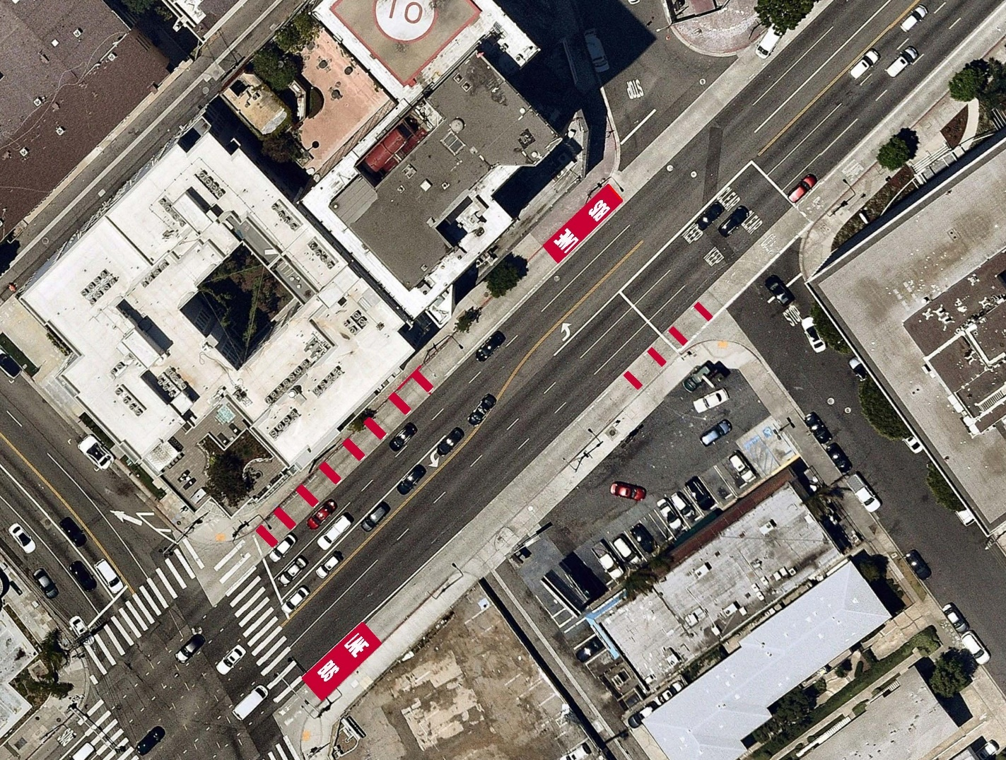

EVALUATION PLAN
LADOT proposes evaluating red colored transit-only lanes by collecting before and after observational data of transit-only lane violations and before and after data of LACMTA bus vehicle travel times.

DATA COLLECTION
LADOT proposes manually observing the operations of transit-only lanes before and after installation of red treatments. Each experimental location will be observed multiple times during peak activity periods (typically on weekdays during the hours of approximately 7AM – 9AM and 4PM – 7 PM). User surveys of motorists, transit vehicle operators, and transit customers may also be utilized to collect information on user perceptions of the meaning and effectiveness of the red treatments. Before and after data to be collected includes:
- Traffic counts
- Illegal motor vehicle travel within transit-only lanes
-Parking occupancy adjacent to transit-only lanes
- Vehicle turning behavior
- Collisions

In addition to manual data collection, LADOT proposes to measure before and after transit travel times in coordination with LACMTA.

SCHEDULE
The following timeline assumes that permission to continue and expand this experiment is granted by the CTCDC and FHWA by June, 2022:

- July, 2022: Material procurement
- July, 2022: Before data collection
- September, 2022: Install red treatments
- January, 2023: After data collection
- August, 2023: Submit final report to CTCDC and FHWA

LOCATIONS
The Map below shows the locations of existing and future transit-only lanes in Los Angeles where red treatments may be applied.

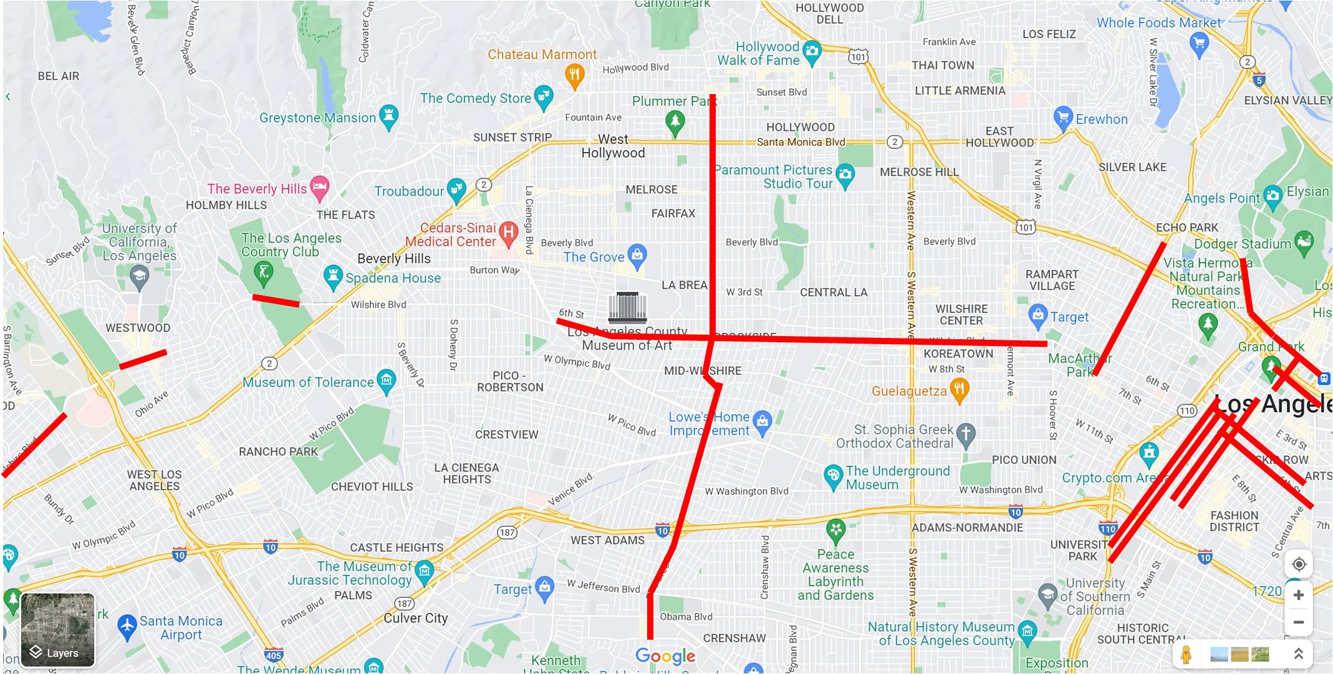

The table below provides details for existing transit-only lanes in Los Angeles where red treatments may be applied.

Transit-Only Lane Location | Hours of Operation | Typical configuration
Wilshire Boulevard from Centinela Avenue to Federal Avenue; Veteran Avenue to Selby Avenue; Comstock Avenue to Beverly Hills City Limit; Beverly Hills City Limit to Park View Street | 7AM – 9AM, 4PM – 7PM, M-F | Transit-only lane in both directions adjacent to curb (on-street parking permitted in lane when inactive)
Figueroa Street from 23rd Street to 5th Street | All times | Transit-only northbound lane adjacent to curb (on-street parking permitted in parking lane to the right of transit-only lane during non-peak hours).
North Spring Street from 1st Street to Cesar E. Chavez Avenue | All times | Contraflow northbound dual transit-only lanes
Cesar E. Chavez Avenue/Sunset Boulevard from Union Station Driveway to Innes Avenue | All times/7AM-9AM/4PM-7PM, M-F | Transit-only lanes in both directions adjacent to curb (on-street parking permitted in lane during non-peak hours west of Broadway).
Flower Street from 8th Street to 27th Street | 3PM-7PM, M-F | Transit-only southbound lane adjacent to curb (on-street parking permitted in lane during non-peak hours)
Aliso Street from Spring Street to Alameda Street | All times | Right-side transit-only eastbound lane adjacent to curb
5th Street from Central Avenue to Flower Street | 7AM-7PM M-F | Transit-only westbound lane adjacent to curb (on-street parking permitted in lane during non-peak hours)
6th Street from Hope Street to Central Avenue | 7AM-7PM M-F | Transit-only eastbound lane adjacent to curb (on-street parking permitted in lane during non-peak hours)
Alvarado Street from Sunset Boulevard to 7th Street | 7AM-10AM/3PM-7PM, M-F | Transit-only lanes in both directions adjacent to curb (on-street parking permitted in lane during non-peak hours)
98th Street from Bellanca Avenue to Vicksburg Avenue | All times | Transit-only lanes in both directions adjacent to curb
Olive Street from Pico Boulevard to 2nd Street | 7AM-7PM, M-F | Transit-only northbound lane adjacent to curb (on-street parking permitted in parking lane to the right of transit-only lane during non-peak hours).
Grand Avenue from Hope Place to Pico Boulevard | 7AM-7PM, M-F | Transit-only southbound (on-street parking permitted in parking lane to the right of transit-only lane during non-peak hours).
La Brea Avenue from Coliseum Street to Sunset Boulevard* | 7AM-10AM/3PM-7PM, M-F | Transit-only lanes in both directions adjacent to curb (on-street parking permitted in lane during non-peak hours)
*Future transit-only lanes to be installed in the second half of 2022

REPORTING
LADOT will submit semiannual progress reports to the CTCDC and FHWA’s Office of Transportation Operations for the duration of the experiment and will submit a final report within three months following completion of the experiment.

ADMINISTRATION
LADOT will be the sponsoring agency and consultant services may be used as needed. The concept of red colored transit-only lanes is not protected by patent or copyright.

REMOVAL OF EXPERIMENTAL INSTALLATIONS
LADOT will remove experimental installations within three months of a determination by the CTCDC and FHWA that changes to the MUTCD or CA MUTCD are not warranted. Additionally, LADOT will terminate the experiment if significant safety concerns are found to be attributable to the experiment.

APPENDIX A

EXAMPLES OF TRANSIT-ONLY LANES IN LOS ANGELES
(All images from maps.google.com)

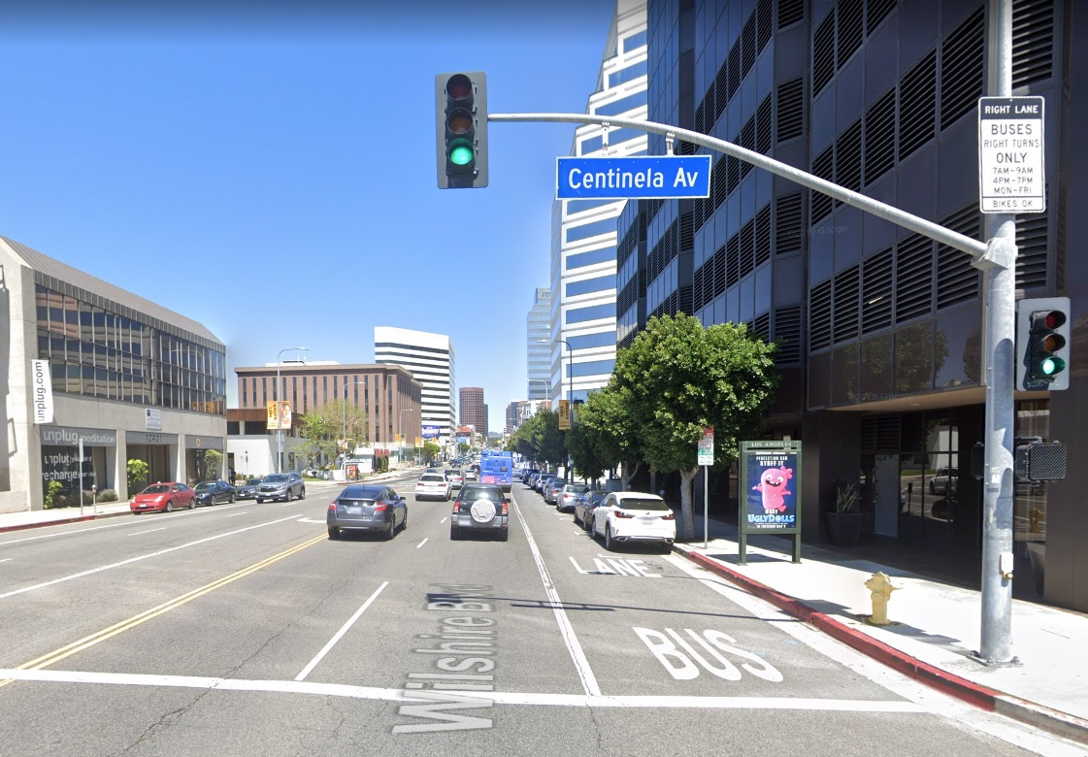
East Wilshire Boulevard @ Centinela Avenue – Transit-Only Lane 7-9AM and 4-7PM M-F

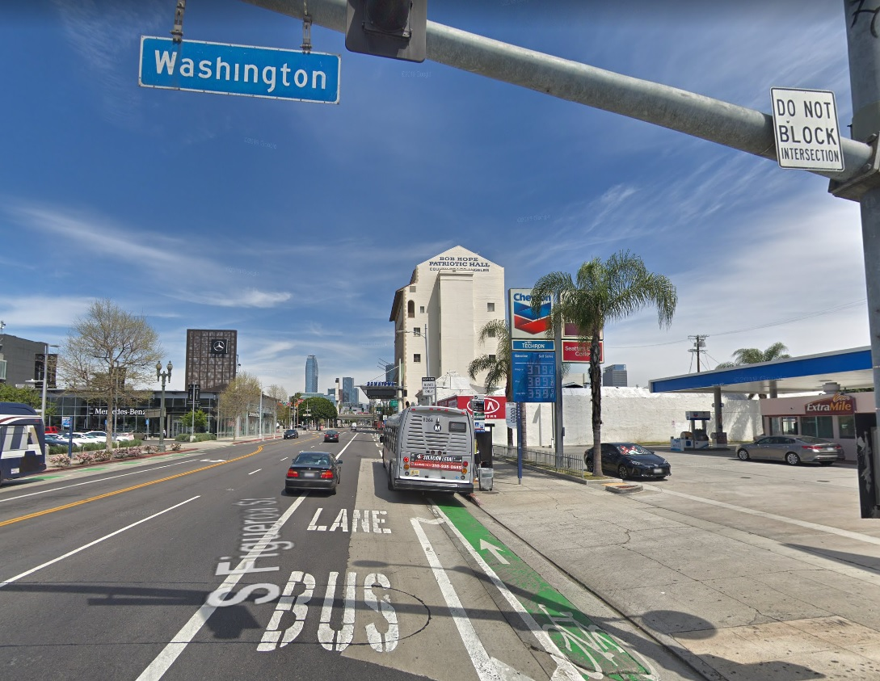
North Figueroa Street @ Washington Boulevard – Transit-Only lane All Times

