# Introduction

This example project will go through the entire Life-Cycle Cost Analysis (LCCA) process to determine the most cost-effective pavement type. It will follow step by step procedures found in the 2013 LCCA Procedures Manual.

This example project proposes to construct High Occupancy Vehicle (HOV) lanes, in the median of Interstate 80 (I-80) and in both directions, from PM 0.3 to PM 10.4 in Sacramento County as shown in Figure 1. The existing I-80 is a six-lane separated PCC freeway. Since this project has pavement work and is not eligible for an exemption, a LCCA must be performed. Figure 2 shows the typical cross section of the roadway.

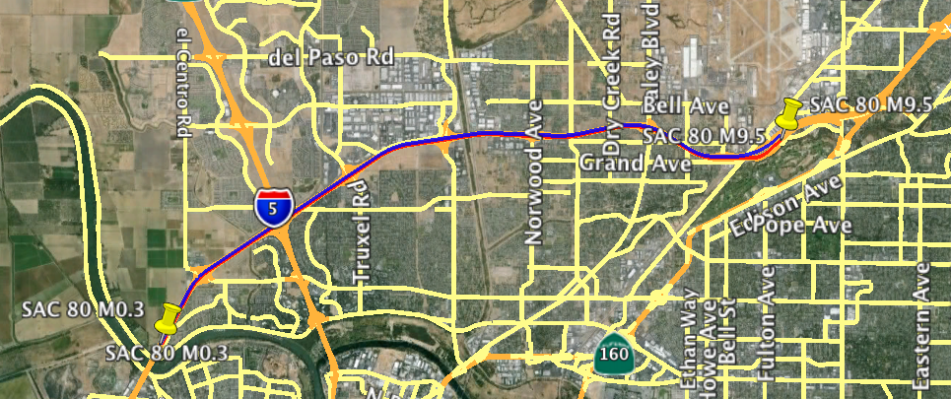

End of Project

Beginning of Project

Figure 1: Project Location Map

Median Widening Work

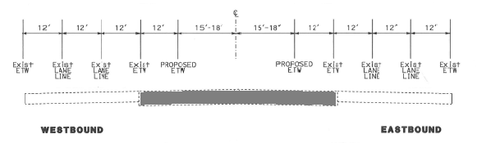

Figure 2. Typical Cross Section

**Step 1**

Determine pavement alternatives to analyze.

Since the project type is new construction, use Figure 3 LCCA Lane Widening Flowchart to determine the pavement alternatives to analyze.

From the flowchart shown in Figure 3, it is recommended to perform LCCA for the following pavement alternatives:

1. 20-yr Flexible HMA
2. 40-yr Rigid Concrete Pavement, Jointed Plain Concrete Pavement (JPCP)

The pavement alternatives must meet the LCCA requirements (See Chapter 2, section 2.3 of the 2013 LCCA Procedures Manual):

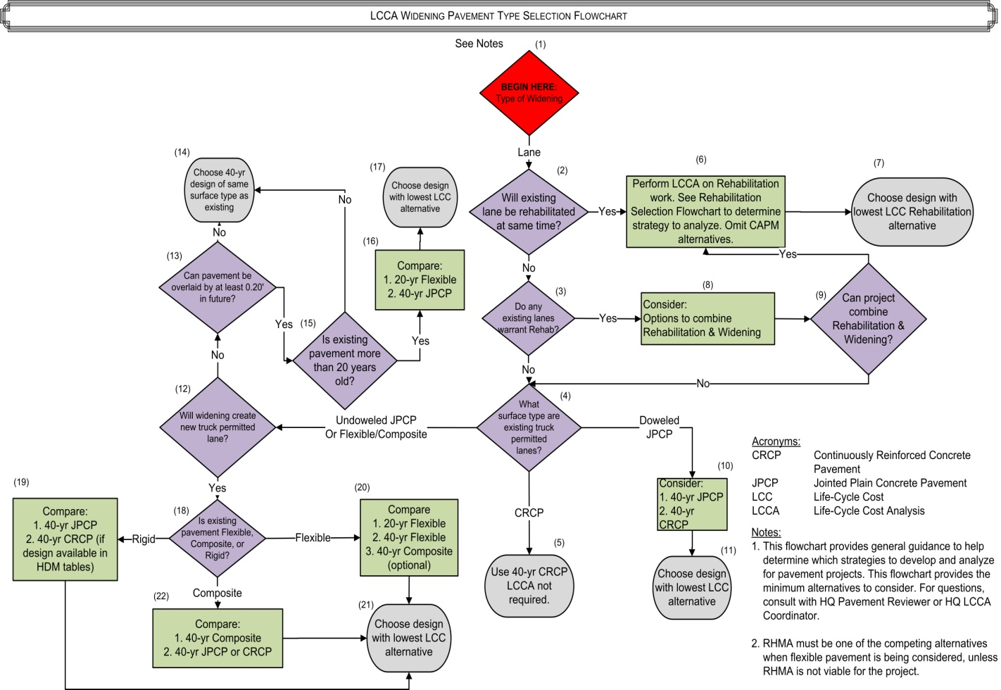

Figure 3. LCCA Lane Widening Flowchart

**Step 2**

As early as possible, submit requests to various Functional Units as this information will be needed to perform LCCA.

**Step 2A (Alternative method to gather traffic information)**

There may be times, due to accelerated schedules, when there is not sufficient time to submit request to Functional Units and receive information to perform LCCA. If this is the case, follow this alternate method to gather project information. This preliminary information is for LCCA purposes only and not to be used for design purposes.

Preliminary traffic information can be found at the Traffic Operation website: [*https://dot.ca.gov/programs/traffic-operations/census*](https://dot.ca.gov/programs/traffic-operations/census)

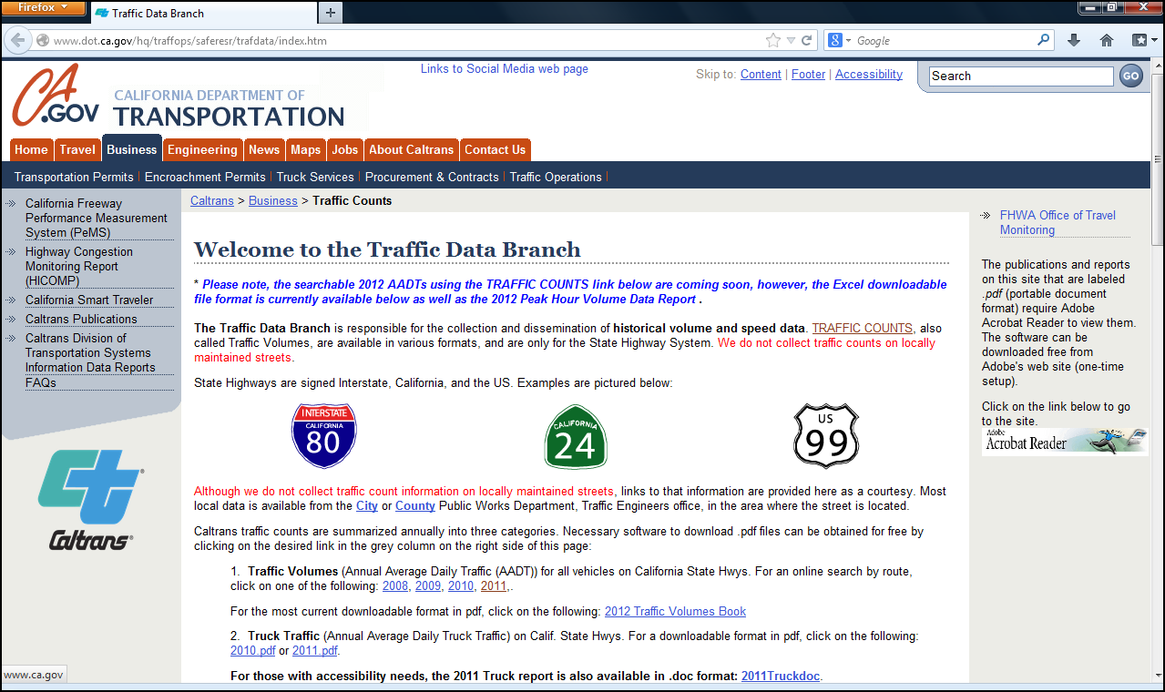**Figure 4. Caltrans Traffic Data Branch**

Select the most current Truck Traffic year

The report is sorted by Route, District, County, and Post Mile. Gather information that pertains to your project. Choose information that best represent the overall project. An alternative is use average or weighted average.

**Step 2B**

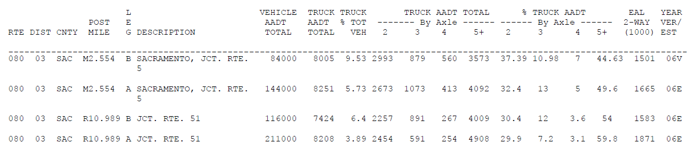

**3**

**2**

**1**

Figure 5. 2011 Truck Traffic Publication

* Determine construction year vehicle AADT:

$$Contruction year vehicle AADT= \frac{84,000+144,000}{2}=114,000$$

(This value will be input in *RealCost*)

(See bullet #1 from Figure 5. Average was taken.)

* Combination truck can be calculated with the following equations:

Single Unit Trucks (SUT):

$$SUT=T X \frac{TA}{100}$$

$$T=Total Truck \%= \frac{9.53+5.73}{2}=7.63 \%$$

(See bullet #2 from Figure 5. Average was taken.)

$$TA=2 axle \% Truck AADT= \frac{37.39+32.4}{2}=34.90 \%$$

(See bullet #3 from Figure 5. Average was taken.)

$$SUT=7.63 X \frac{34.90}{100}$$

$=2.66 \%$ (This value will be an input in *RealCost*)

Combination Truck (CT) as Percentage of AADT:

$$CT=T-SUT$$

$$=7.63-2.66$$

$=4.97\%$ (This value will be an input in *RealCost*)

* Annual Growth Rate of Traffic Estimate (A) = 2.47% (If information is not provided, use calculation from LCCA Procedures Manual)

Use equation 1 to calculate annual growth rate of traffic.

$A={[\left(\frac{FT}{MT}\right)}^{(\frac{1}{FY-MY})}-1] x 100---$ Equation 1 (Equation 3-3 in LCCA Procedures Manual)

**A** = Annual Growth Rate of Traffic (%)

**FT** = Future Year AADT (total for both directions) 🡪 200,000

**MT** = Most Current Year AADT (total for both directions) 🡪 114,000

**FY** = Future Year in which AADT is available 🡪 2034

**MY** = Most Current Year in which AA DT is available 🡪 2011

The Annual Growth Rate of Traffic is:

$A=\left[{\left(\frac{200,000}{114,000}\right)}^{\left(\frac{1}{2034-2011}\right)}-1\right]x 100=2.47$%

**Step 3**

Table 1 shows the initial construction cost estimate for the two pavement alternatives. The initial construction cost estimate (developed by the engineer) does not include the following:

* Add on costs such as minor items, supplemental work, mobilization, and contingencies.
* Structure and right of way costs.
* Project support costs for design, environmental, project management, construction administration and inspection costs, etc.
* Common cost between pavement alternatives.

These assumptions may need to be modified if there are differences between the alternatives’ cost estimates.

Table 1. Initial Costruction Cost

|  |  |  |  |  |  |
| --- | --- | --- | --- | --- | --- |
| Pavement Alternative 1:HMA |  |  |  |  |  |
| Section | Quantity | Unit | Unit Price | Item Cost | Total Cost |
| Roadway Excavation | 140,000 | CY | $40 | $5,600,000.00 |  |
| HMA-A | 150,000 | TON | $95 | $14,250,000.00 |  |
| Aggregate Base | 110,000 | CY | $50 | $5,500,000.00 |  |
| Pavement Initial Construction Cost = | | | | | $25,350,000.00 |

|  |  |  |  |  |  |  |
| --- | --- | --- | --- | --- | --- | --- |
| Pavement Alternative 2: Jointed Plain Concrete Pavement (JPCP) | | | | | |  |
| Section | Quantity | Unit | Unit Price | Item Cost | Total Cost |  |
| Roadway Excavation | 140,000 | CY | $40 | $5,600,000.00 |  |  |
| JPCP | 110,000 | TON | $200 | $22,000,000.00 |  |  |
| Lean Concrete Base (LCB) | 46,000 | CY | $175 | $8,050,000.00 |  |  |
| Aggregate Subbase | 65,000 | SF | $45 | $2,925,000.00 |  |  |
| Pavement Initial Construction Cost = | | | | | $38,575,000.00 |  |

**Step 4**

Use the most current *RealCost v2.5CA* (see LCCA Procedures Manual for installation instructions). Save your work often in the program by clicking on “Save LCCA Workbook As…” as shown in Figure 6.

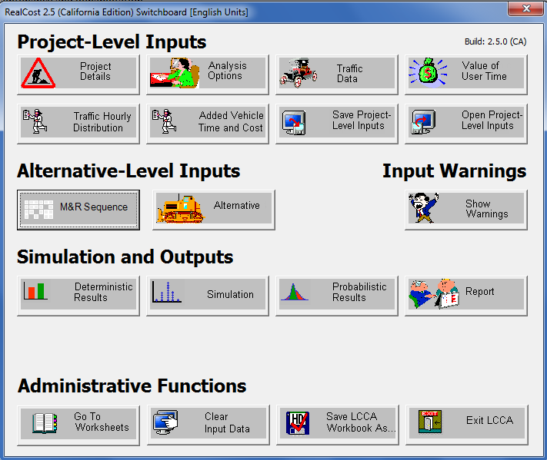

Save often.

Figure 6. *RealCost v2.5* Switchboard Window

Project Details

Input project information.

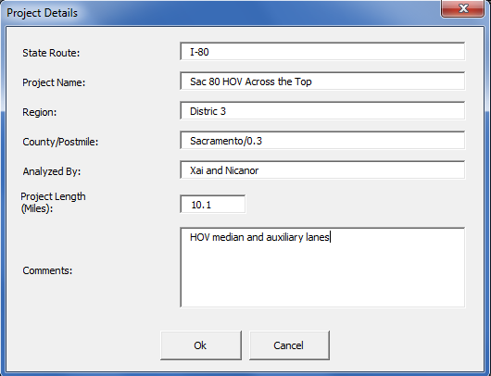

Enter project length in miles.

Figure 7. Project Details Window

Analysis Options

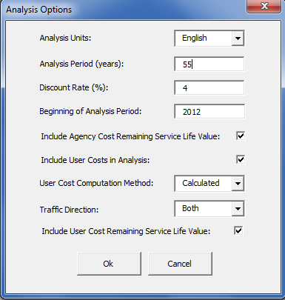

Caltrans uses English units.

See Table 2

Default value = **4%**

Begin Construction Year = **2016**

Default selection

Select **Both** if constructing in both directions

Default selection

Figure 8. Analysis Option Window

Comparing 20-yr Flexible and 40-yr concrete pavement.

Table 2. LCCA Anaysis Periods (Table 2-1 in LCCA Procedure Manual)

|  |  |  |  |
| --- | --- | --- | --- |
| **Alternative Life** | **CAPM** | **20-Yr** | **More than 20 years** |
| **CAPM** | 20 years | 35 years | 55 years |
| **20-Yr** | 35 years | 35 years | 55 years |
| **More than 20 years** | 55 years | 55 years | 55 years |

Traffic Data

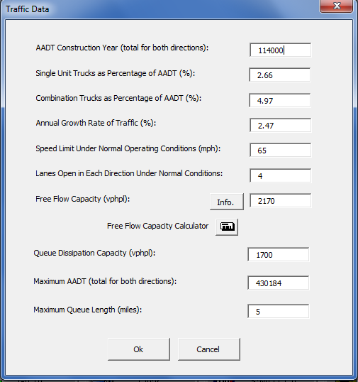

3 Existing Lanes plus 1 lane widening

From Traffic Unit or Step 2B

Posted Speed Limit

See Table 3 Traffic Input Values

Note: Max AADT = (2 direction) x (4 lanes) x 53,773 = 430,184 Maximum AADT (total for both directions)

Figure 9. Traffic Data Window

The project is a multi-lane highway located on level terrain in an urban area. With the known information, use Table 3 to get traffic input values.

Table 3. Traffic Input Values (1,2,3) (Tabel 3-1 in LCCA Procedure Manual)

Screen Shot of Traffic Input Values table from LCCA Manual.

Value of User Time

Use default values. Value of User Time is updated annually. Visit the [LCCA website](https://dot.ca.gov/-/media/dot-media/programs/maintenance/documents/office-of-concrete-pavement/life-cycle-cost-analysis/value-of-user-time-2013-a11y.pdf) for the most current value.

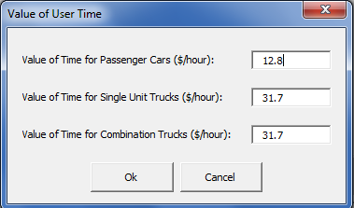

Default values

Figure 10. Values of User Time

Traffic Hourly Distribution

This project has weekday single peak.

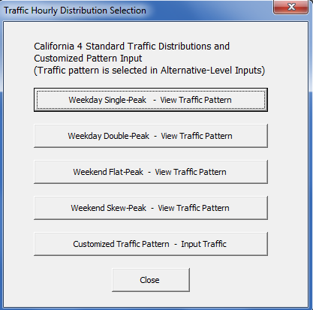

Traffic pattern for this project.

Figure 11. Traffic Hourly Distribution Selection Window

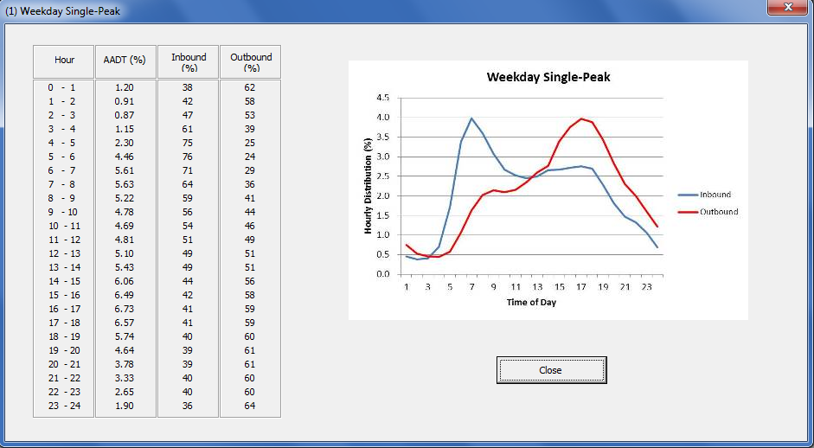

Figure 12. Weekday Single-Peak Window

Added Vehicle Time and Costs

Table 3 shows the transportation Consumer Price Index (CPI), which is updated annually. For the latest CPI value, visit the [LCCA website](https://dot.ca.gov/-/media/dot-media/programs/maintenance/documents/office-of-concrete-pavement/life-cycle-cost-analysis/cpi-value-2013-a11y.pdf).

Table 4. Transportation Component Consumer Price Indexes

(Table 3-2 in LCCA Procedure Manual)

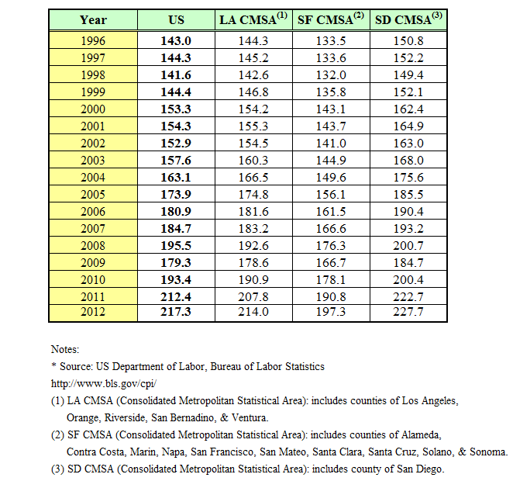

Use 217.3 for Current CPI for escalation.

Values shown in Figure 13 are after escalation to construction year 2016.

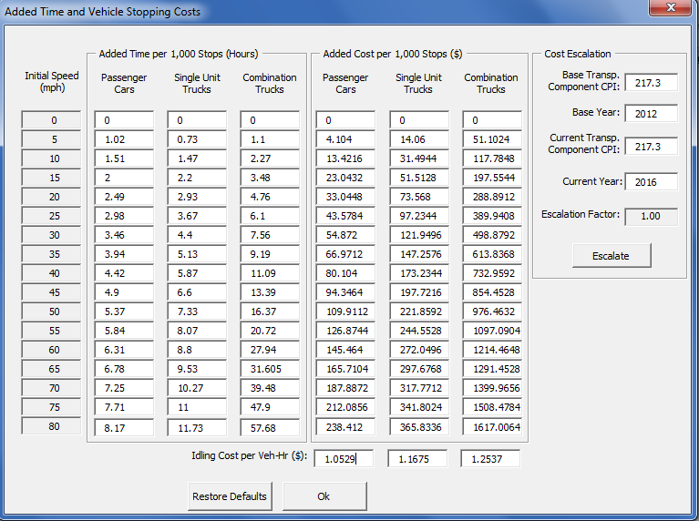

Click Escalate

Year of end construction

Current CPI value. See Table 5

Figure 13. Added Time and Vehicle Stopping Cost after Escalating Window

Note: Escalation factor shows “1.00” after escalation.

M&R Sequence Selection

Maintenance Service Level: 1

Climate Region: Inland Valley

Project Type: Widening

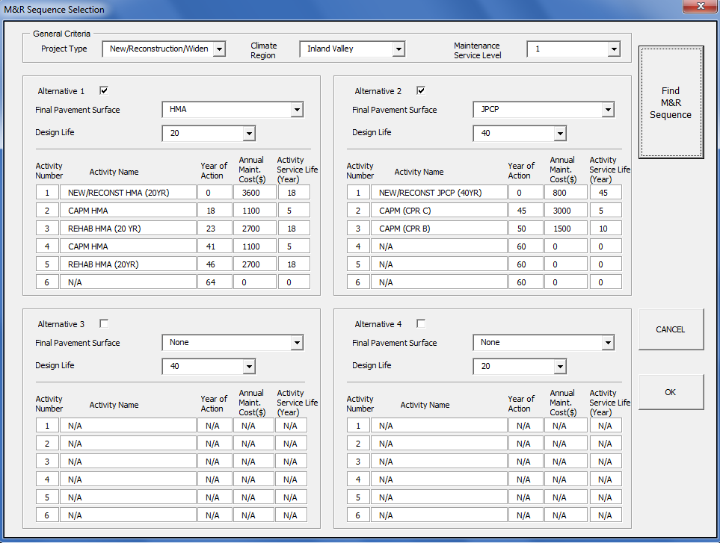

Figure 14. M&R Sequence Selection Window

Note: For each alternative to be evaluated for comparison, a check mark must be clicked by the “Alternative “box.

Specify the final pavement surface in (Figure 15) given the two pavement alternatives:

1. 20-yr Flexible HMA
2. 40-yr Rigid Concrete Pavement JPCP

**Alternative 1**

Alternative 1, Activity 1: New/Recons HMA (20yr)

Some information is imported from M&R Sequence window.

Initial construction cost estimate in $1000’s. See the pavement cost estimate in Table 1.

Input Alternative Description

Imported from M&R Tables

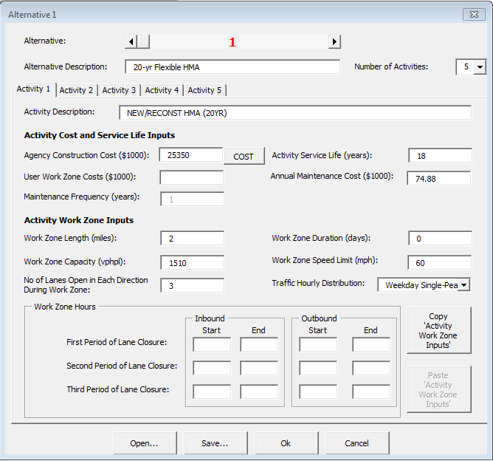

Assume no lane closure is needed for widening.

Manually calculate/input for widening projects.

Project length x # lanes in a direction x # of direction x Annual maintenance cost

10.1mi/lane x1 lane x 2 dir. x 3.6 = 74.88

Work Zone Duration is zero for Widening. Initial Users Cots are not calculated for Widening projects since lane does not exist yet.

Typically, 5 mph less than posted speed limit.

Pick the closest that match your traffic conditions

Default blank. *RealCost* to calculate

Typically, 2 miles  
Typi

See Table 3  
Typi

Three lanes open during construction.

Figure 15. Alternative 1, Activity 1 Window

Agency Construction Cost

Input the initial cost estimate, from Table 1, of paving items in this version of *RealCost Version 2.5CA.*

See Figure 16 for the completed window.



Figure 16. Completed Window of Alternative 1, Activity 1

After Alternative 1, Activity 1 inputs are completed; select the Alternative 1, Activity 2. All Activities after Activity 1 need to use the cost estimate calculator in the software to calculate initial construction cost.

Alternative 1, Activity 2: CAPM (FLEX OVERLAY)

Click on the “COST” button shown in Figure 17 and Figure 18 will appear.

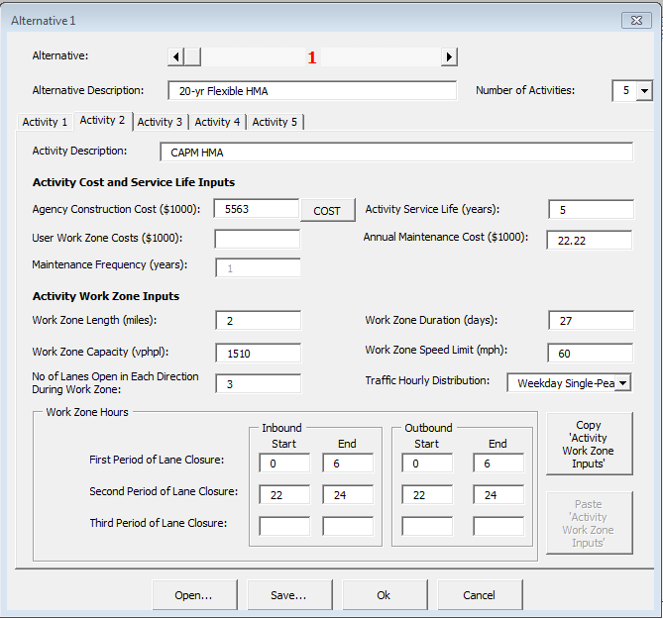

Construction cost estimate in $1000. Use cost estimate button. See below.

Figure 17. Alternative 1, Activity 2 Window

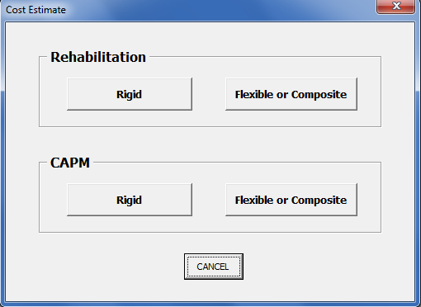

Figure 18. Cost Estimate Window

Since this activity is CAPM on Flexible pavement, use the CAPM, Flexible or Composite button in Figure 18. Then the “CAPM Flexible or Composite Pavement” window is activated as shown Figure 19. The items that are shown in black font can be selected or inputted, and the items shown in gray font are either a program default value or the item is calculated by *RealCost Version 2.5CA*.

Specify Pavement area and Milling Area. See calculations below.

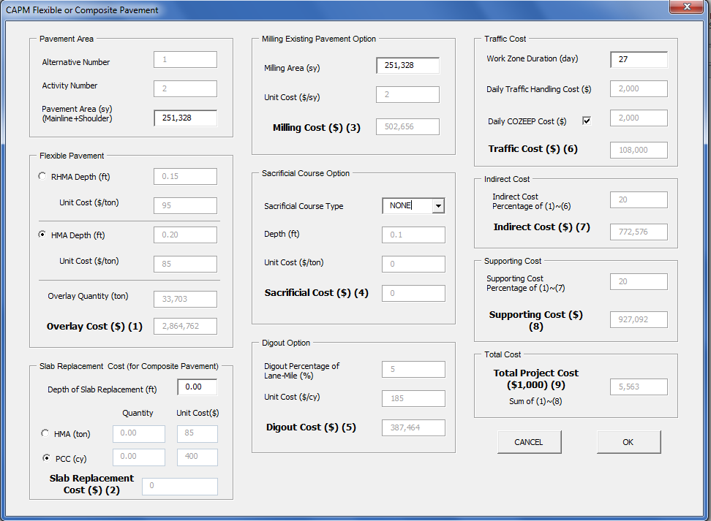

Specify Flex. Pave. Type. Also, select sacrificial course. This activity does not include slab replacement, so depth of slab replacement is 0.

Input Work Zone Duration. If applicable, select Daily COZEEP Cost.

Figure 19. CAPM Flexible Or Composite Pavement Window

Work Zone Duration (day) Example:

Work Zone Duration = Lane-miles/ Productivity Rate

Where:

**WZD** = Work Zone Duration in days

**PR** = Productivity Rate in lane-miles per day

Lane-miles = 1 lanes/ dir. x 10.1miles x 2 dir. = 20.2 lane-miles

$$∴Work Zone Duration \left(days\right)=\frac{20.2 Lane-mile}{0.75}=26.96→27 days$$

Since the existing pavement is HMA (Flexible pavement), use Table 5 to determine productivity rate. Since the project type is CAPM with a final surface type of Flexible, go to CAPM section and Flexible/Composite subsection; then Mill & Overlay as the future M&R sequence. Subsequently, choose 5+yr for the pavement design life because the future M&R alternative’s design life is 20 years. Then choose Maintenance Service Level 1 since I-80 is an arterial freeway. Since the implementation of the M&R alternative requires 8 hour closure daily, choose the productivity rate corresponding to the 8 to 12 hour closure column. The productivity rate is 0.75.

The logic for selecting productivity rate is shown below.

Existing Flexible🡪 Table 5**.** 🡪Project Type: CAPM🡪Final Surface Type: Flexible/Composite🡪Mill & Overlay in future M&R🡪5+yr. design life🡪MSL=1🡪8 hr. closure 🡪 PR = 0.75

Table 5. Productivity Estimates of Typical Future Rehabilitation Strategies for Flexible Pavements (Tanble 3-4 in LCCA Manual)

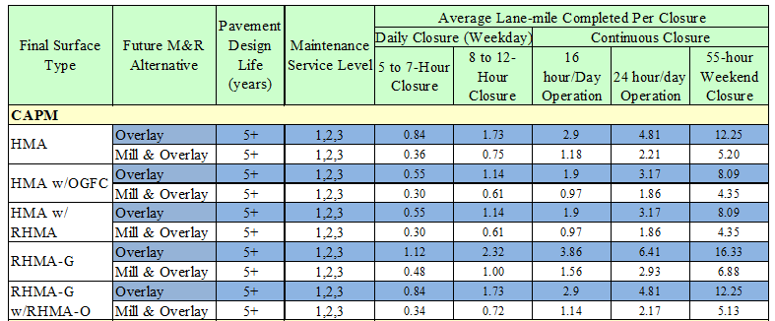

Pavement Area:

Pavement Area includes the new lane and inside shoulder.

Milling Existing Pavement Option:

100% of the milling of existing pavement area was assumed.

After inputting the required information, click “OK” to transfer the calculated cost into the Agency Construction Cost in the Alternative 1, Activity 2 window, as shown in Figure 17.

Input the remaining required information into Alternative 1, Activity 2 window. A completed Alternative 1, Activity 2 window is shown in Figure 20.



Figure 20. Completed Alternative 1, Activity 2

When the Alternative 1, Activity 2 window is completed, select the “OK” button.

Alternative 1, Activity 3: REHAB HMA (20 YR)

Click the “Cost” button to calculate the Agency Construction Cost via RealCost. Since the project is Rehabilitation on Flexible, choose Flexible or Composite Button as show in Figure 18. The “Rehabilitation Flexible or Composite Pavement” window as shown in Figure 21 will appear.

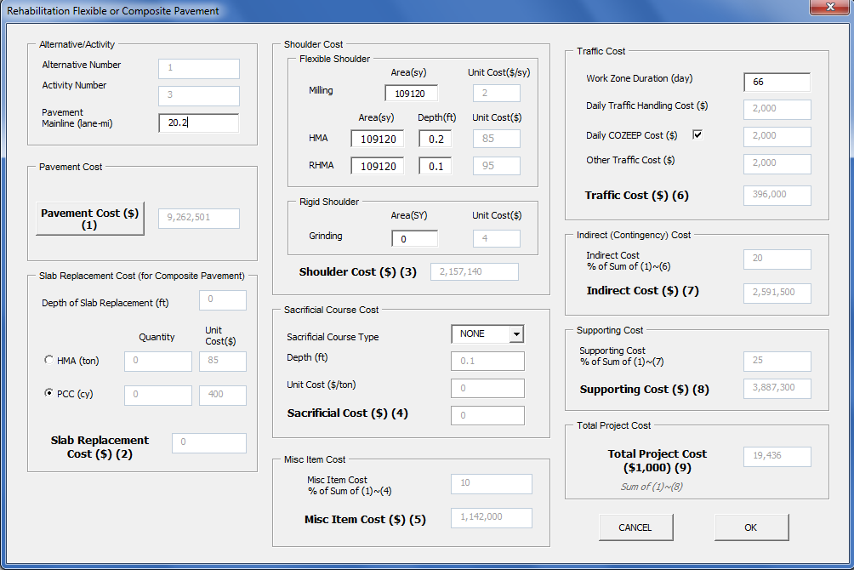

Figure 21. Rehabilitation Flexible or Composite Pavement Window

After clicking the “Pavement Cost” button, a “Pavement Selection” window as shown in Figure 22 will appear.

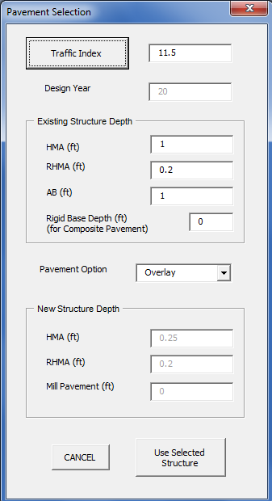

Click this button to estimate Traffic Index.

Figure 22. Pavement Selection Window

After clicking the “Traffic Index” button, a “Traffic Index (TI) Computation for Flexible Pavement” window will appear, as shown in Figure 23.

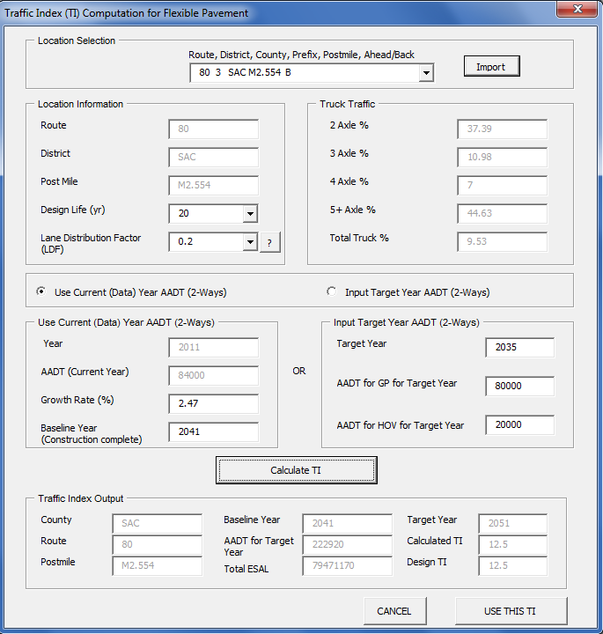

6. Click “Use This TI” to import the new TI

5. Click button to calculate TI.

1. Choose Project location from the drop-down menu, and then click the “Import” button.

3. Select “Use Current (Data) Year AADT (2-ways)” if using current year AADT

2. Specify Design life and Lane Distribution Factor. See example below

Figure 23. Traffic Index (TI) Computation for Flexible Pavement Window

$$Baseline Year \left(Construction Complete\right)=2016\left(initial construction year\right)+20yr \left(Act.1\right)+5yr\left(Act. 2\right)=2041$$

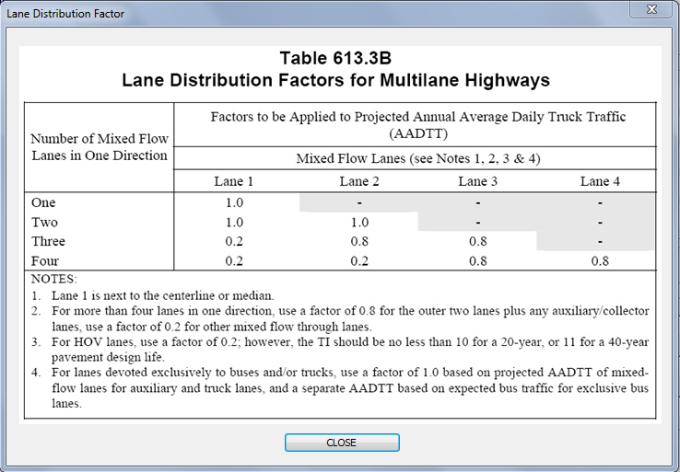

Figure 24. Lane Distibution Factors For Multilane Highways

After clicking the “Use This TI” button, a “Pavement Selection” window will appear, as shown in Figure 25.

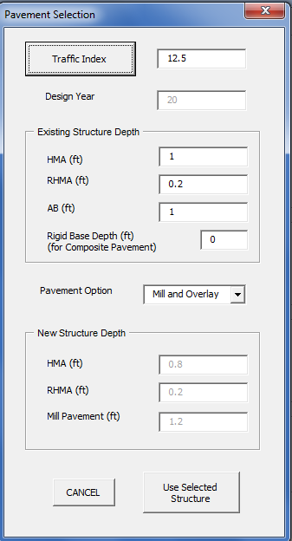

Click this button after calculating the new TI.

Select “Mill and Overlay”

Use existing pavement structure and previous activity‘s info.

Value was obtained from TI Calculator.

Figure 25. Pavement Selection Window

After clicking the “Use Selected Structure”, a “Rehab Flexible or Composite Pavement Cost” window will appear, as shown in Figure 26.

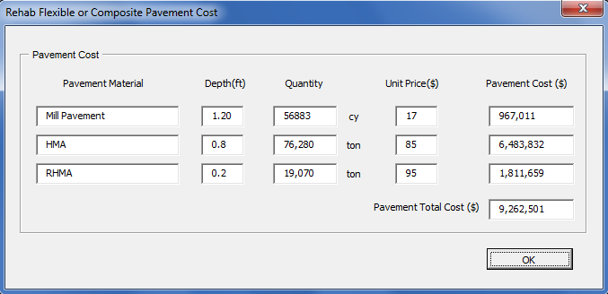

Click OK.

Figure 26. Rehab Flexible Or Composite Pavement Cost Window

A completed Rehabilitation Flexible or Composite Pavement window is shown in Figure 27.

For Flexible Shoulder: Specify Milling and HMA area. Also, specify the depth of HMA shoulder. It is not anticipated that RHMA will be replaced.



Click OK, which will take you back to the Alternative window.

Figure 27. Completed Rehabilitation Flexible or Composite Pavement Window

After completing the required information on Figure 26, click ok and the completed Alternative 1, Activity 3 will appear as shown in Figure 28.

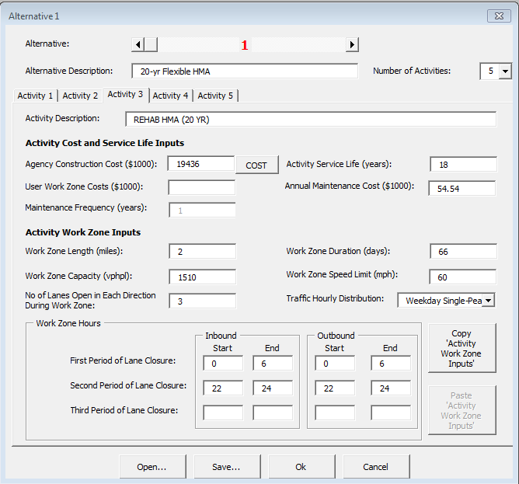

Figure 28. Completed Alternative 1, Activity 3 Window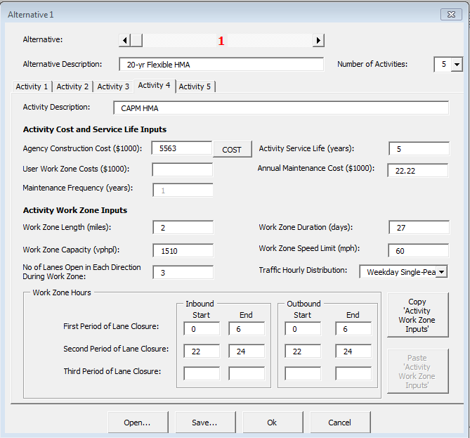

When the Alternative 1, Activity 3 window is completed, select the “OK” button.

Alternative 1, Activity 4: CAPM (FLEX OVERLAY)

Click the “Cost” button to calculate the Agency Construction Cost via RealCost. Since the project is CAPM on Flexible pavement, click the Flexible or Composite Button as show in Figure 18. The “CAPM Flexible or Composite Pavement” window will appear as shown in Figure 19.

Follow the procedure of Alternative 1, Activity 2 to update and input the required information into the CAPM Flexible or Composite Pavement window. After updating and inputting the required information, click “OK”.

A completed Alternative 1, Activity 4 is shown in Figure 29.



Figure 29. Completed Alternative 1, Activity 4 Window

Alternative 1, Activity 5: REHAB HMA (20 YR)

Click the “Cost” button to calculate the Agency Construction Cost via RealCost. Since the project is Rehabilitation on Flexible pavement, click the Flexible or Composite Button as show in Figure 18. The “Rehabilitation Flexible or Composite Pavement” window will appear as shown in Figure 21.

Follow the procedure of Alternative 1, Activity 3 to update and input the required information into the Rehabilitation Flexible or Composite Pavement window. After updating and inputting the required information, click “OK”.

*(i.e. The updated information corresponds to the “Baseline Year” as shown in Figure 23.)*

$$Baseline Year \left(Construction Complete\right)=2016\left(initial construction year\right)+20yr \left(Act.1\right)+5yr\left(Act. 2\right)+20yr\left(Act. 3\right)+5yr(Act.4)=2066$$

A completed Alternative 1, Activity 5 is shown in Figure 30.

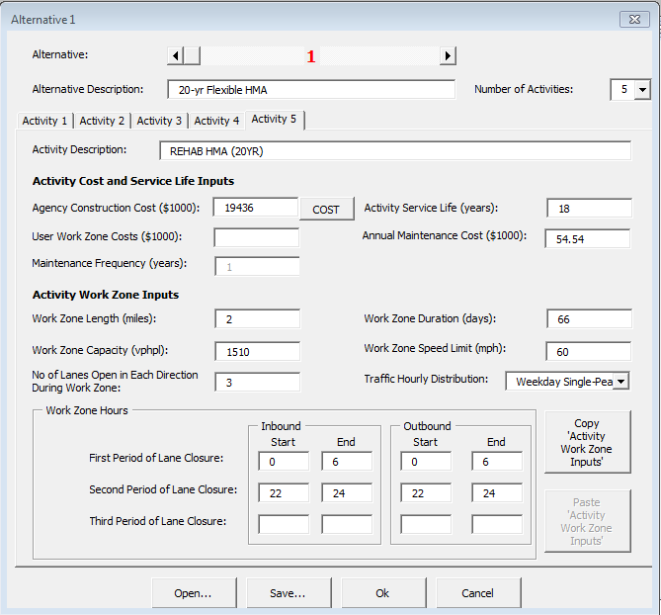

Figure 30. Completed Alternative 1, Activity 5 Window

**Alternative 2**

Alternative 2, Activity 1: 40-yr Rigid Concrete Pavement

Agency Construction Cost

Input the initial cost estimate, from Table 2, of paving items in this version of *RealCost Version 2.5CA.* See Figure 31 for the completed window.

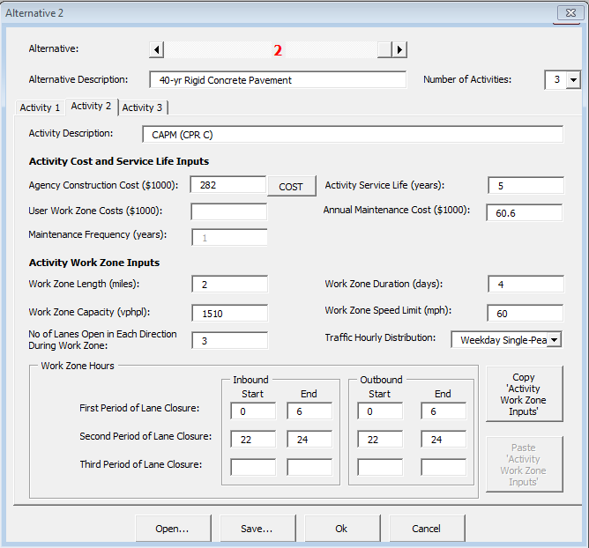

Figure 31. Completed Alternative 2, Activity 1 Window

Alternative 2, Activity 2 CAPM (CPR C)

After Alternative 2, Activity 1 inputs are completed; select the Alternative 2, Activity 2. All Activities after Activity 1 need to use the cost estimate calculator in the software to calculate initial construction cost.

Clicks on the “COST” button shown in Figure 17 and Figure 18 will appear.

Since this activity is CAPM on Rigid pavement, use the CAPM Rigid button in Figure 18. Then the “CAPM Rigid Pavement” window is activated as shown Figure 32. The items that are shown in black font can be selected or inputted, and the items shown in gray font are either a program default value or the item is calculated by *RealCost Version 2.5CA*.

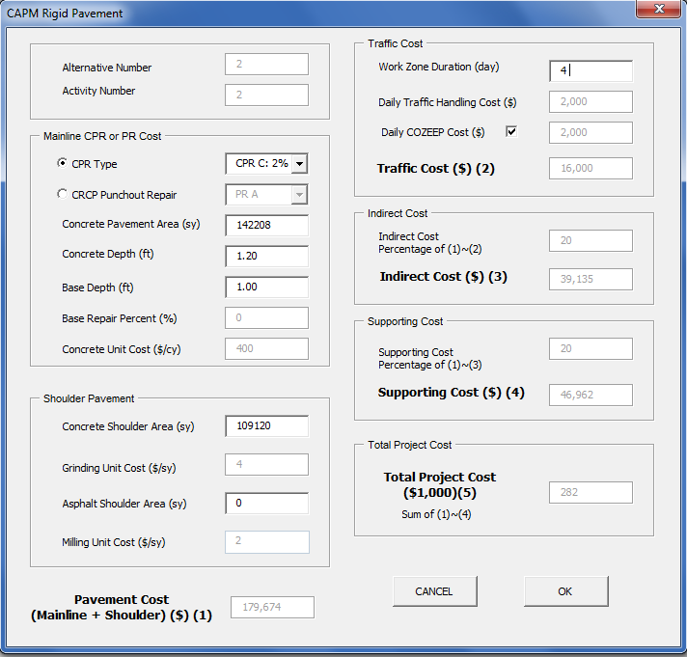

1. Calculate the Work Zone Duration. *see calculation below

3. Specify the Concrete Pavement Area for the Mainline and for the Shoulder.

2. Click on JPCP CPR. Also specify the type of concrete pavement repair.

Figure 32. CAPM Rigid Pavement Window

$$∴Work Zone Duration \left(days\right)=\frac{20.2 Lane-mile}{6.27}=3.22→4 days$$

Since the existing pavement is rigid, use

Use Table 6 to determine productivity rate. Since the project type is CAPM with a final rigid surface, go to CAPM section and JPCP subsection; then Concrete Pavement Rehab C and 4-hr RSC as the future M&R sequence. Subsequently, choose 5+yr for the pavement design. Then choose Maintenance Service Level. Since the implementation of the M&R alternative requires 8 hour closure daily, choose the productivity rate corresponding to the 8 to 12 hour closure column. The productivity rate is 6.27.

The logic for selecting productivity rate is shown below.

Existing Rigid🡪

Table 6🡪Project Type: CAPM🡪Final Surface Type: Rigid🡪Concrete Pavement Rehab C in future M&R🡪5+yr. design life🡪MSL=1🡪8 hr. closure 🡪 PR = 6.27

Table 6. Productivity Estimates of Typical Future Rehabilitation for Rigid and Composite Pavements ( Table 3-6 on LCCA Manual)

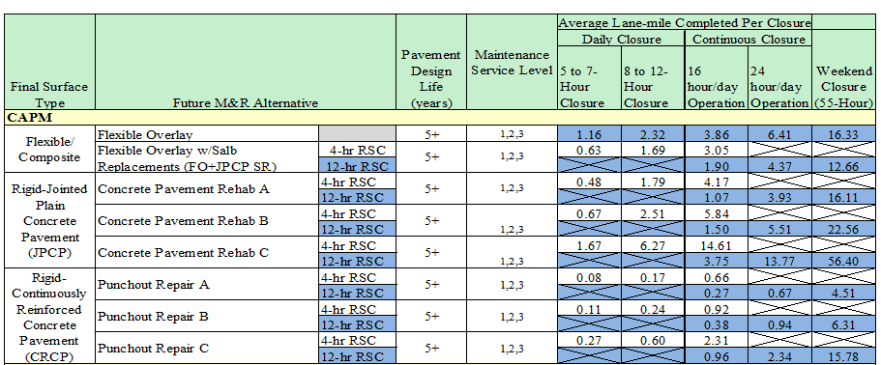

After inputting the required information, click “OK” to transfer the calculated cost into the Agency Construction Cost. Input the remaining required information into Alternative 2, Activity 2 window. A completed Alternative 2, Activity 2 window is shown in Figure 33.



Figure 33. Completed Alternative 2, Activity 2 Window

When the Alternative 2, Activity 2 window is completed, select the “OK” button.

Alternative 2, Activity 3 CAPM (CPR B)

Follow the procedure of Alternative 2, Activity 2 to update and input the required information into the CAPM Rigid Pavement Window. After updating and inputting the required information, click “OK”.

A completed Alternative 2, Activity 3 window is shown in Figure 34.

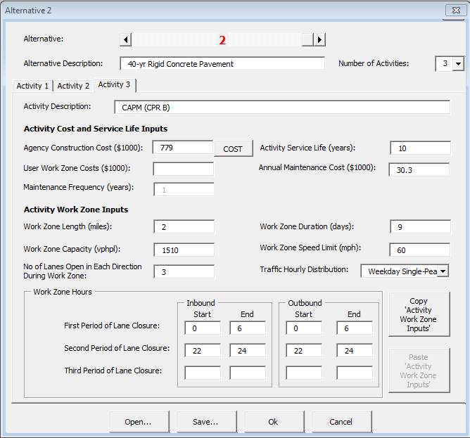

Figure 34. Completed Alternative 2, Activity 3 Window

Since this is the last activity of the last alternative, click “OK”. The software will return to the main *RealCost* switchboard.

Show Warnings

Click the “Show Warnings” button. A “Warnings” window, as shown Figure 35, will appear.

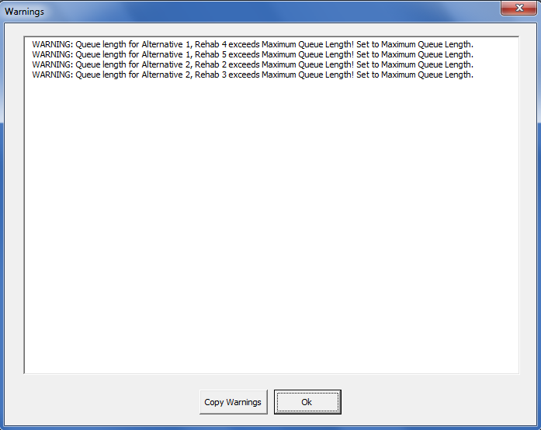

Figure 35. Warnings Window

Fix input errors and ensure warnings are acceptable; then click “OK”.

Deterministic Results

Click “Deterministic Results” button to see result. The Deterministic Results window is shown in Figure 36.

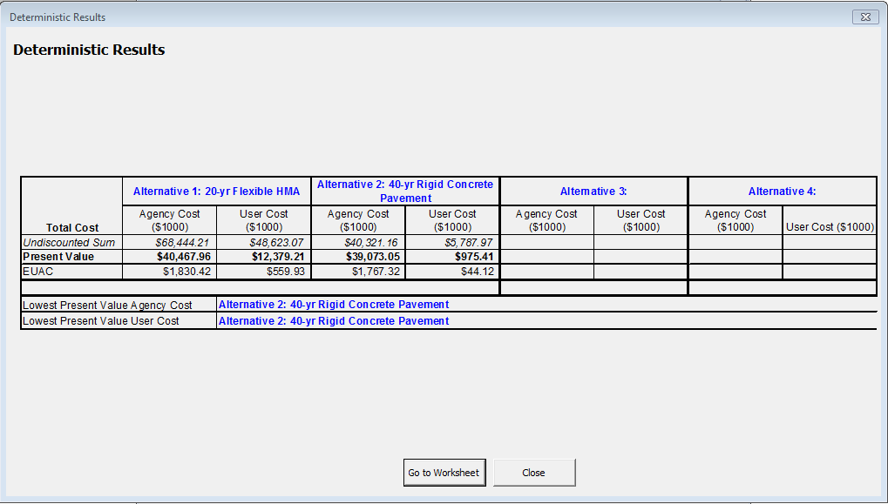

**Figure 36. Deterministic Results**

Click “Go to Worksheet” button to go to spreadsheets and see the results in detail.

Report

Click “Report” button to see *RealCost v2.5CA* Report. An example of the report for this analysis is shown in Figure 37.

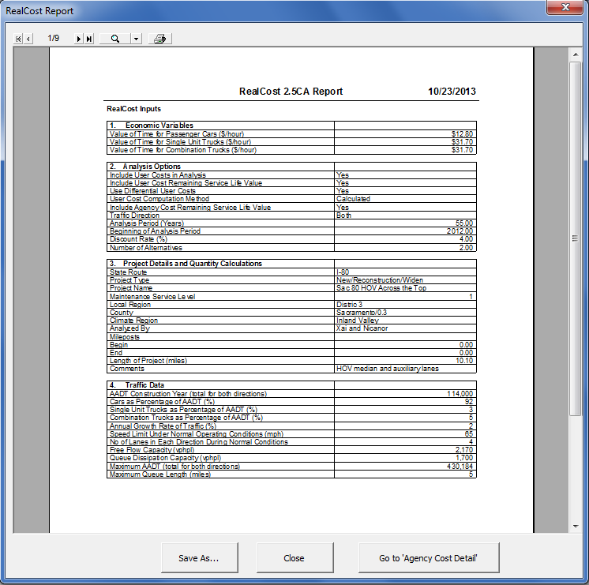

Figure 37. *RealCost v2.5CA* Report

**Step 5**

Conclusion

The pavement alternatives were analyzed with *RealCost v2.5CA* software. Alternative 2’s total life cycle cost and agency cost are the lowest among the two alternatives in the 55-year analysis period. Base on this analysis, it is concluded that Alternative 2, 40-year JPCP Pavement, is the recommended pavement alternative.

**Step 6**

Documentation

To document life-cycle costs in project documents follow the procedures in Appendix O-O of the Project Development Procedures Manual (PDPM). When the pavement alternative with the lowest life-cycle cost is not selected, the reasons must also be documented.

Also, submit your LCCA to HQ for data collection. Per PDPM Appendix O-O, a copy of the completed project initiation document, project report, or project scope summary report with life-cycle costs included shall be sent to:

Attn: HQ Program Advisor  
HQ Division of Maintenance, Pavement Program  
2389 Gateway Oaks, Suite 200, MS 91  
Sacramento, CA 95833

Or

lcca@dot.ca.gov

An alternative is to submit a *RealCost* LCCA Report.