# INTRODUCTION

This example project will go through the entire Life-Cycle Cost Analysis (LCCA) process to determine the most cost-effective pavement alternative. It will follow step by step procedures found in the 2013 LCCA Procedures Manual.

This example project proposes to construct a new interchange at Duncan Canyon Road and Interstate 15 (I-15) in San Bernardino County (Post Mile 11).

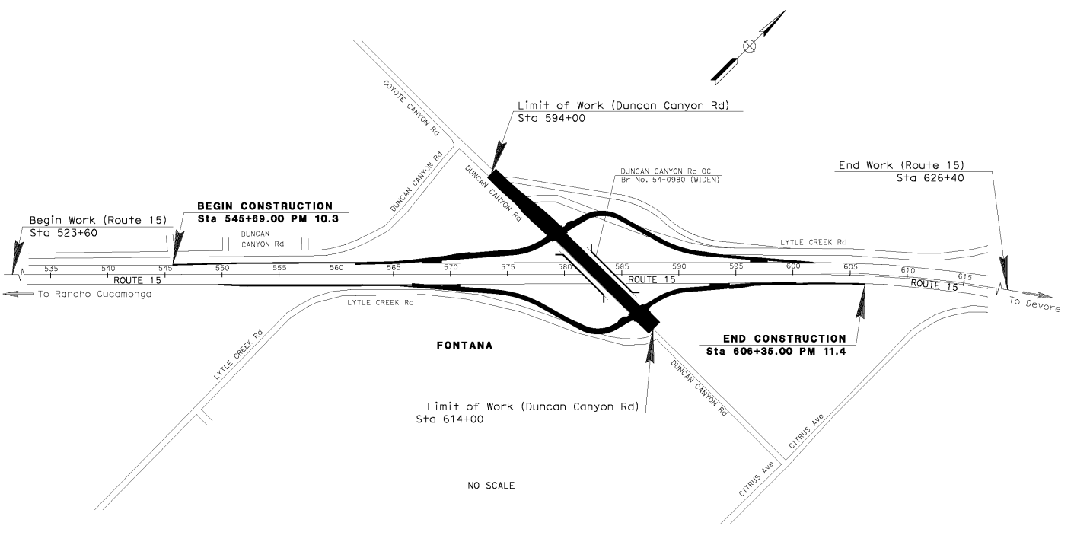

**Figure 1.** **Project Location Map**

**Step 1:** Since this project is a new interchange construction, determine the pavement alternatives from the LCCA New Construction and Reconstruction Pavement Type Selection Flowchart (Figure 2).

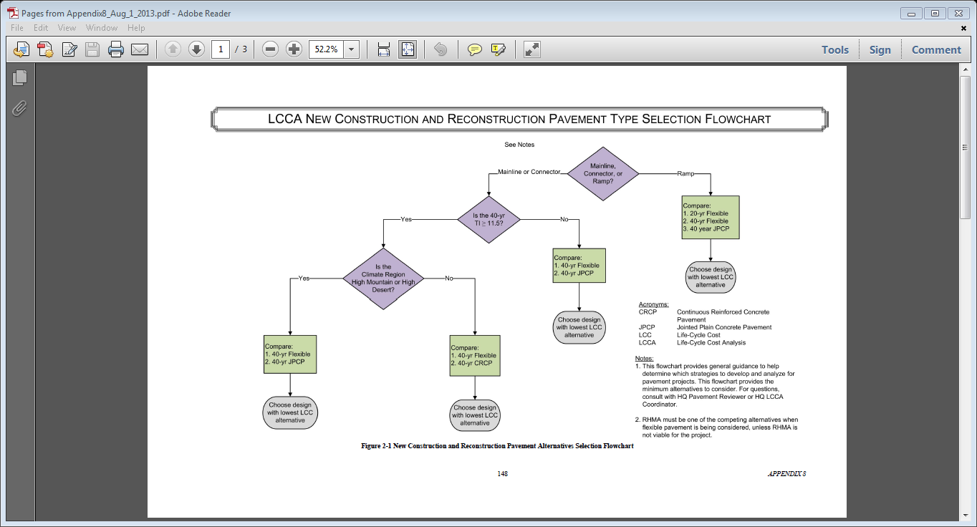

Follow the “Ramp” arrow, and go to the “Compare” box, which gives 3 pavement alternatives to compare.

**Figure 2. LCCA New Construction Flowchart**

From the flowchart, it is recommended to perform LCCA for the following pavement alternatives:

* Pavement Alternative 1:

20-yr Flexible; HMA over Class 2 AB

* Pavement Alternative 2:

40-yr Flexible; Hot Mix Asphalt (HMA) with Rubberized Hot mix Asphalt (RHMA), over Class 2 AB

* Pavement Alternative 3:

40-yr Jointed Plain Concrete Pavement (JPCP); JPCP with Lean Concrete Base (LCB) and Aggregate Subbase (AS)

**Step 2:** Traffic data and pavement structure for each alternative.

Table 1 is the traffic forecasting data summary from District Traffic Forecasting Unit. Annual growth rate is 1%. It is not necessary to perform LCCA for each individual ramp. Select one off-ramp which has the highest traffic volume, which is the northbound off-ramp. Therefore, LCCA will be conducted only on the northbound off-ramp. Appendix 6 of the LCCA Manual shows the formulas and methods for determining the annual growth rate and determining the AADT for the construction year.

**Table 1 – 2030/2050 Projected Traffic Volumes & Traffic Index**

|  |  |  |  |  |  |  |
| --- | --- | --- | --- | --- | --- | --- |
| **Location** | | | **2013 ADT** | **2030 ADT** | **2050 ADT** | **40-Year TI** |
| Ramps | NB | Off | 15,500 | 19,400 | 23,300 | 12 |
| SB | Off | 3,700 | 4,600 | 5,500 | 10 |

From District Materials Unit, the following pavement structure in Table 2 was provided.

**Table 2 – Summary of Structural Sections for the Ramps**

|  |  |  |  |  |
| --- | --- | --- | --- | --- |
| **Pavement Design Alternative** | **Design Life (year)** | **Ramp TI** | **Section** | |
| **Material** | **Thickness (ft)** |
| 1- HMA | 20 | 10 | HMA | 0.60 |
| Class 2 AB | 1.35 |
| 2-RHMA | 40 | 12 | RHMA-O | 0.10 |
| RHMA-G | 0.20 |
| HMA | 1.15 |
| Class 2 AB | 0.50 |
| 3-JPCP | 40 | 12 | JPCP | 0.9 |
| LCB | 0.35 |
| AS | 0.60 |

From the Traffic Data Branch website, the following traffic data was obtained in Table 3 and 4. Since this project is a new interchange, the average between the upstream and downstream location was calculated. ([*https://dot.ca.gov/programs/traffic-operations/census*](https://dot.ca.gov/programs/traffic-operations/census))

**Table 3. I-15 Traffic Counts**

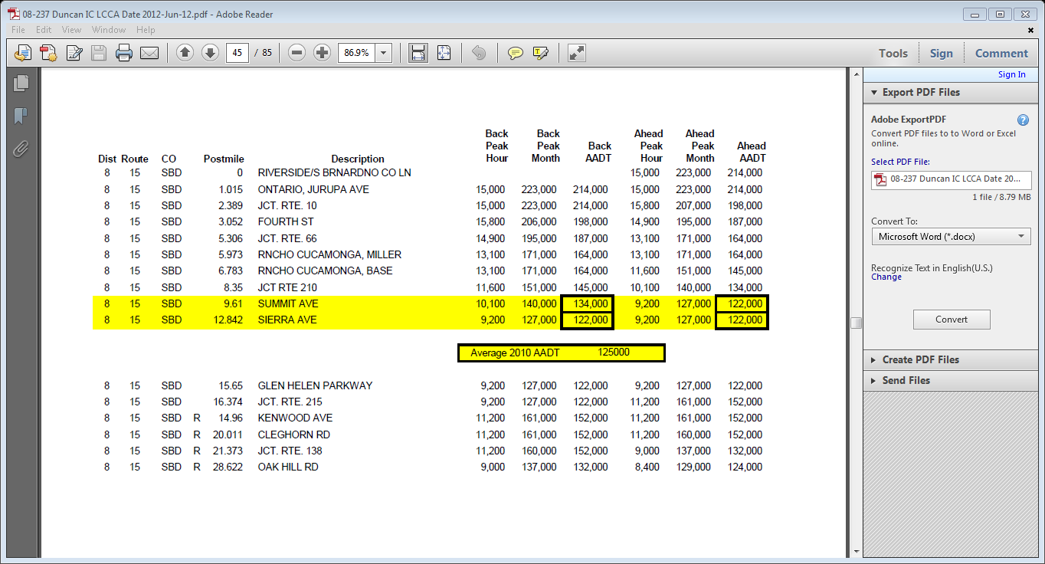

**Table 4—Truck Information**

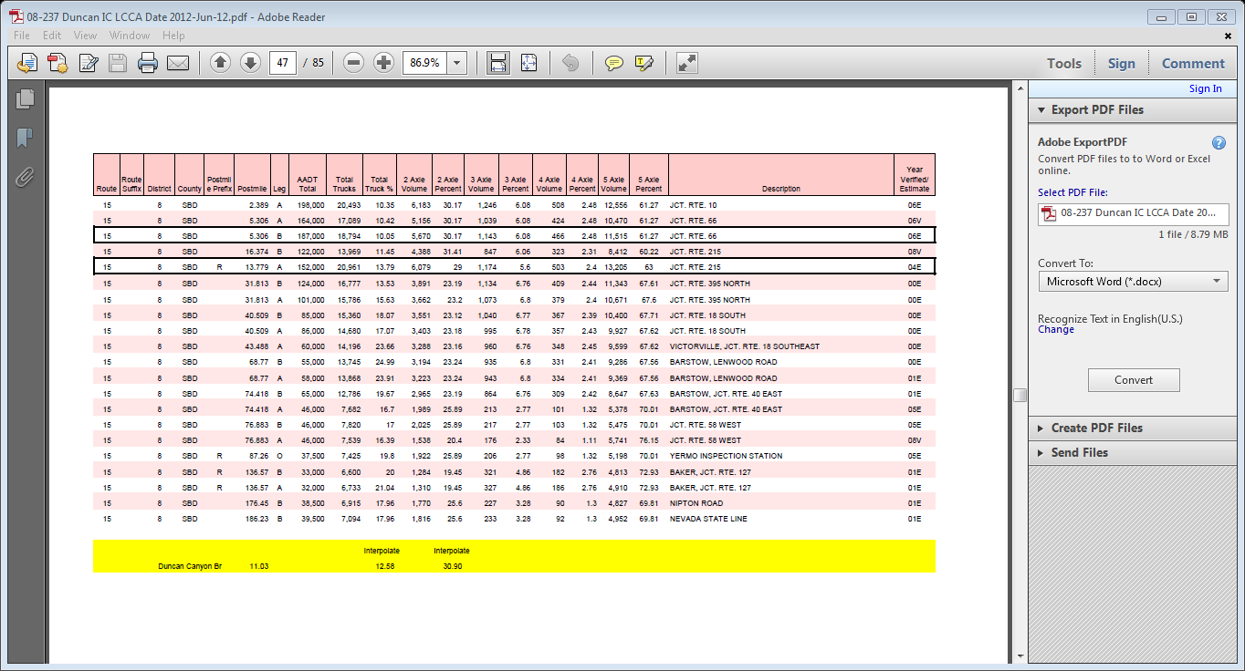

Figure 3 depicts approximate schematics of the traffic flow.

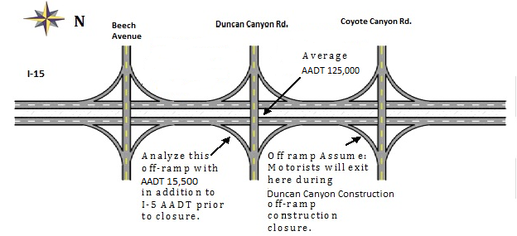

**Figure 3. Schematic of I-15 and Ramps**

**Step 3:** Develop Initial Construction Costs for Each Pavement Alternative

Initial pavement construction cost for the northbound off-ramp were calculated based on the pavement item quantity calculations and the 2012 weighted average unit prices for these items. Table 5 shows the cost breakdown for each pavement alternative. The items which are the same between the alternatives may be omitted from the initial construction cost calculation.

**Table 5 – Initial Construction Cost Estimate**

|  |  |  |  |  |  |  |  |  |
| --- | --- | --- | --- | --- | --- | --- | --- | --- |
| **Pavement Alternative 1: 20-yr HMA NB Off-Ramp** | | | | | | | | |
| **Material Description** | **Area (SF)** | **Depth (LF)** | **Volume (CF)** | **Unit Weight (PCF)** | **Quantity** | **Unit** | **Unit Price** | **Cost** |
|  |  |  |  |  |  |  |  |  |
| Aggregate Base | 95040 | 1.35 | 128304 |  | 4752 | CY | $35.00 | $166,320.00 |
| Hot Mix Asphalt (TypeA) | 95040 | 0.60 | 57024 | 149 |  | TON | $90.00 | $382,345.92 |
|  |  |  |  |  |  |  |  |  |
|  |  |  |  |  |  |  |  |  |
| **Pavement Initial Construction Cost = $548,665.92** | | | | | | | | |

|  |  |  |  |  |  |  |  |  |
| --- | --- | --- | --- | --- | --- | --- | --- | --- |
| **Pavement Alternative 2: 40-yr HMA w/RHMA-G w/RHMA-O NB Off-Ramp** | | | | | | | | |
| **Material Description** | **Area (SF)** | **Depth (LF)** | **Volume (CF)** | **Unit Weight (PCF)** | **Quantity** | **Unit** | **Unit Price** | **Cost** |
|  |  |  |  |  |  |  |  |  |
| Aggregate Base | 95040 | 0.5 | 47520 |  | 1760 | CY | $35.00 | $ 61,000.00 |
| Hot Mix Asphalt (TypeA) | 95040 | 1.15 | 109296 | 149 | 8143 | TON | $90.00 | $732,829.68 |
| Rubberized Hot Mix Asphalt (Type G) | 95040 | 0.20 | 19008 | 149 | 1416 | TON | $95.00 | $134,520.00 |
| Rubberized Hot Mix Asphalt (Type O) | 95040 | 0.10 | 9504 | 120 | 570 | TON | $100.00 | $ 57,024 |
|  |  |  |  |  |  |  |  |  |
|  |  |  |  |  |  |  |  |  |
| **Pavement Initial Construction Cost = $985,373.68** | | | | | | | | |

|  |  |  |  |  |  |  |  |  |
| --- | --- | --- | --- | --- | --- | --- | --- | --- |
| **Pavement Alternative 3: 40-yr JPCP NB Off-Ramp** | | | | | | | | |
| **Material Description** | **Area (SF)** | **Depth (LF)** | **Volume (CF)** | **Unit Weight (PCF)** | **Quantity** | **Unit** | **Unit Price** | **Cost** |
|  |  |  |  |  |  |  |  |  |
| Import Borrow |  |  | 9504 |  | 352 | CY | $30.00 | $ 10,560.00 |
| Aggregate Base | 95040 | 0.6 | 57024 |  | 2112 | CY | $35.00 | $ 73,920.00 |
| Lean Concrete Base (LCB) | 95040 | 0.35 | 33264 |  | 1232 | CY | $105.00 | $129,360.00 |
| Jointed Plain Concrete Pavement (JPCP) | 95040 | 0.90 | 85536 |  | 3168 | CY | $180.00 | $570,240.00 |
|  |  |  |  |  |  |  |  |  |
|  |  |  |  |  |  |  |  |  |
| **Pavement Initial Construction Cost = $784,080.00** | | | | | | | | |

**Step 4:** Run the most current [RealCost Version 2.5.4CA (ZIP)](https://dot.ca.gov/-/media/dot-media/programs/maintenance/documents/office-of-concrete-pavement/life-cycle-cost-analysis/realcost-version-2-5-4ca-setup.zip)

Figure 4 shows the “Switchboard,” which is the main menu that allows navigation between panels.

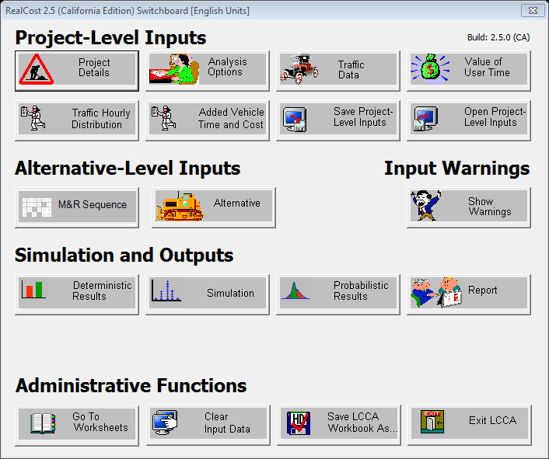

**Figure 4. Switchboard**

“Project Details” panel is shown in Figure 5. Enter project information.

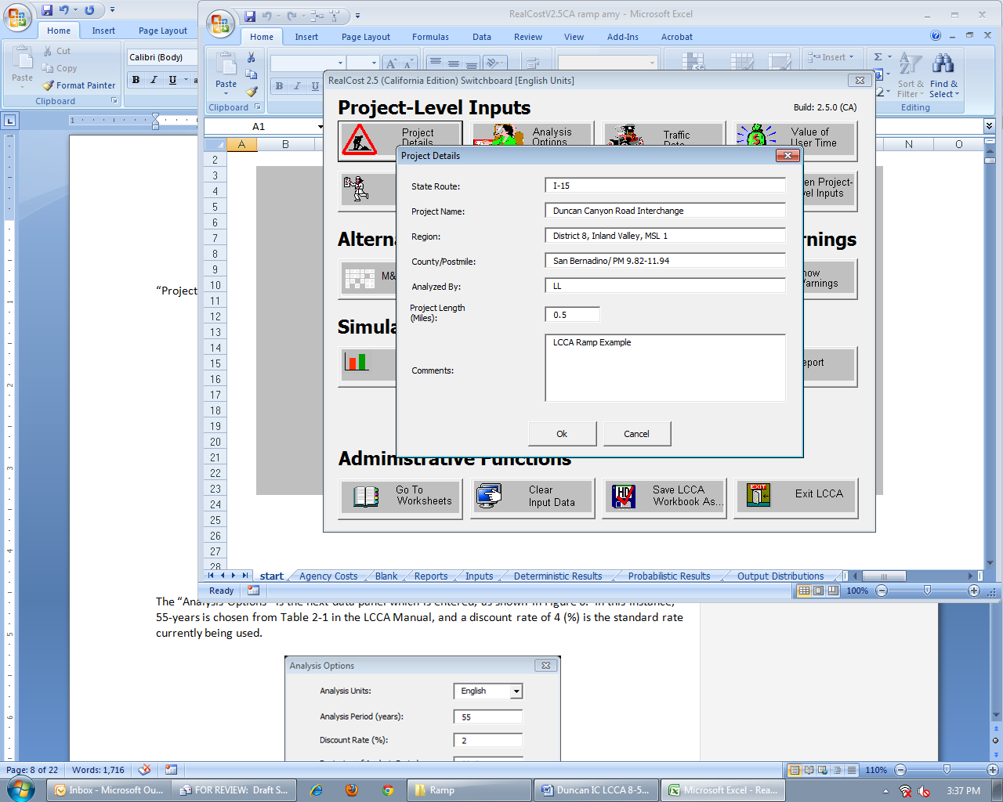

Approximate length of off-ramp in miles.

**Figure 5. Project Details**

The “Analysis Options” panel is shown in Figure 6. In this instance, 55-years is chosen from Table 2-1 in the LCCA Procedures Manual.

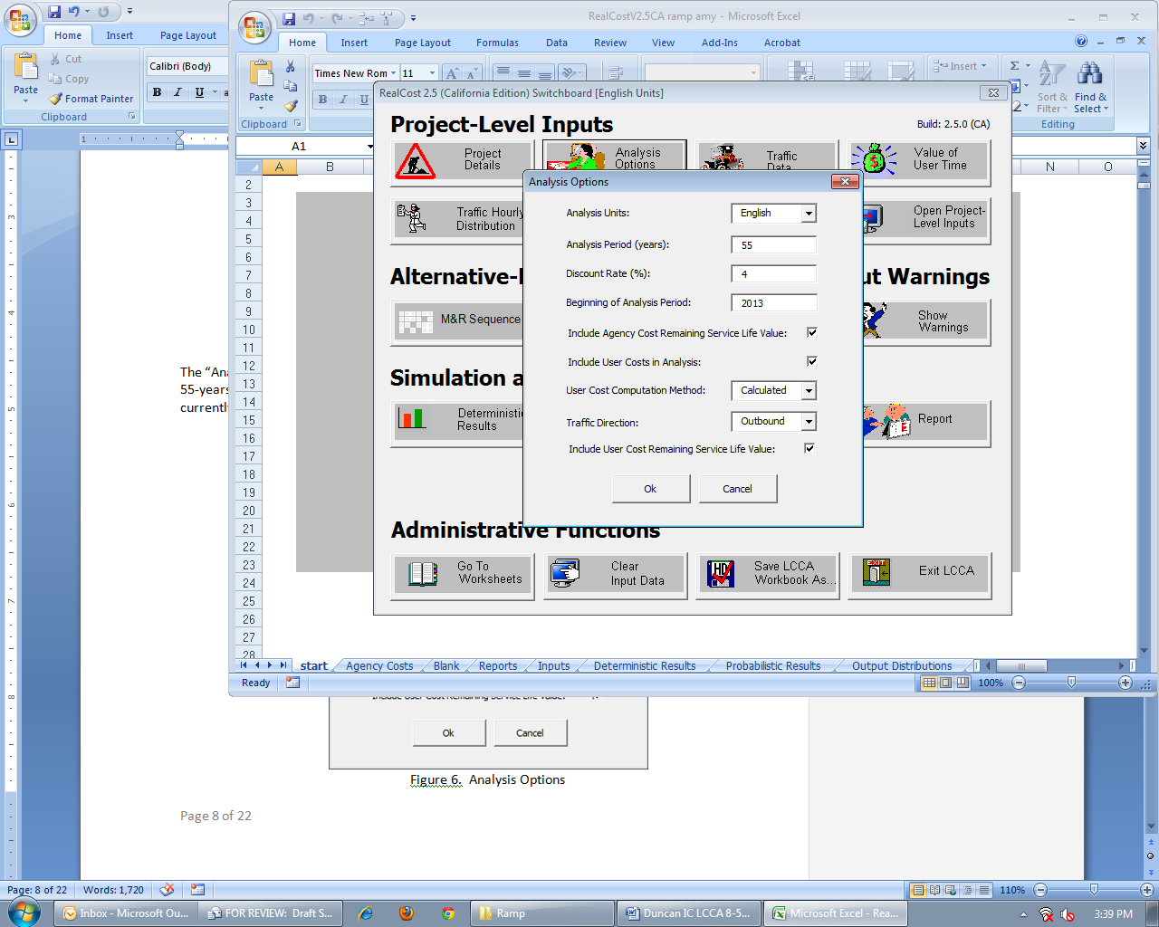

Select **Outbound** to analyze NB off-ramp

Default selection

See Table 2-1

Default selection

End of Construction Year = **2013**

Default value = **4%**

Caltrans uses English units.

**Figure 6. Analysis Options**

The “Traffic Data” panel is shown in Figure 7. See Step 2, Table 3 and Table 4, on traffic data. The “Info” button displays Table 3-1 Traffic Input Values from the LCCA Procedure Manual. For Ramp LCCA, the construction year AADT input is ramp traffic volumes must be added with mainline AADT. The northbound off-ramp traffic AADT must be multiplied by two because ***RealCost Version 2.5CA*** will calculate only one direction when “Outbound” Traffic Direction is selected. The AADT of 125,000 is the total for traffic in both directions.

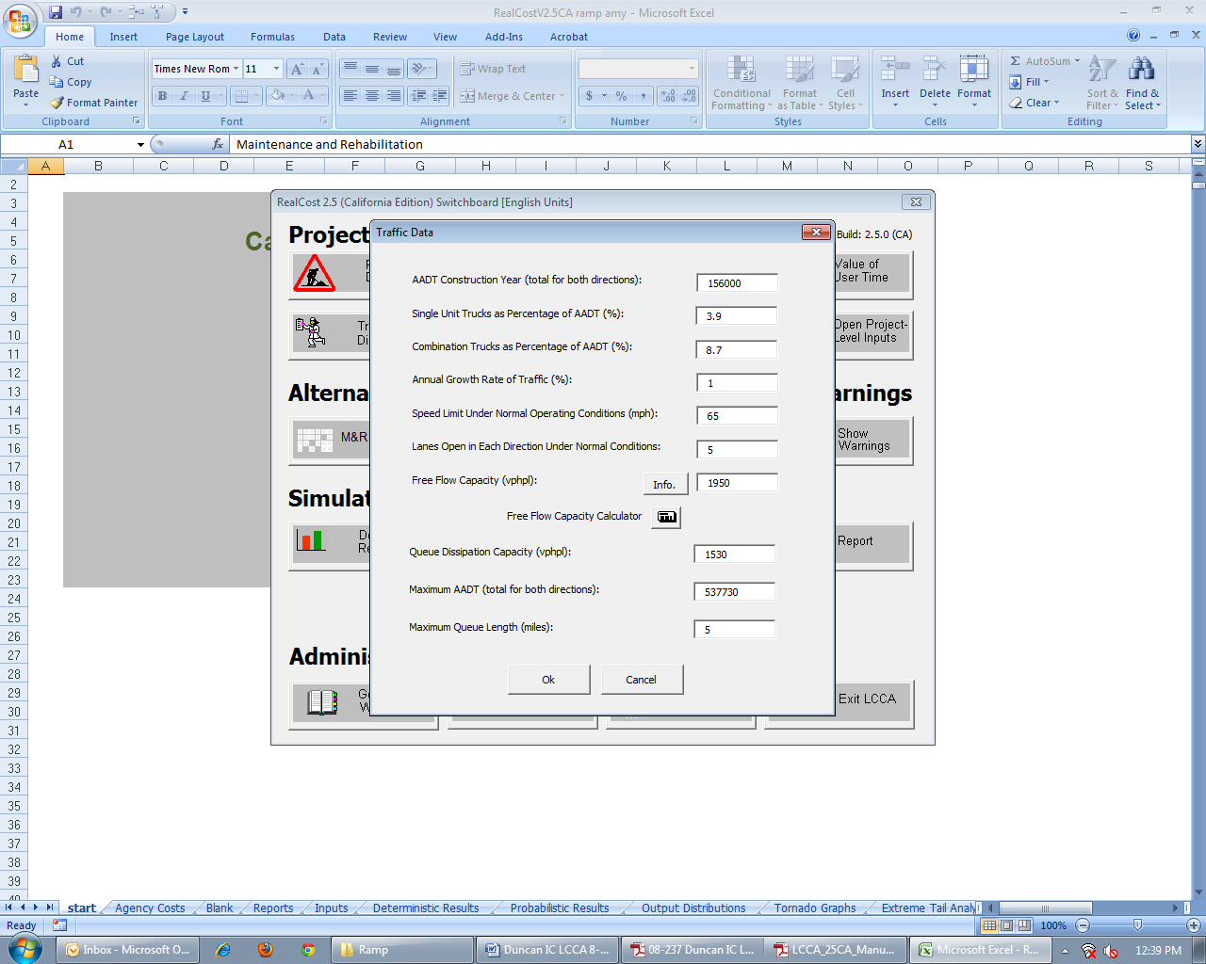

Values from Table 3-1; available from “Info.” button.

4 Existing mainline lanes + 1 ramp lane

Posted speed limit

From Step 2 and using Equation 3-1 and 3-2 from LCCA Procedure Manual.

Note: Use data for both directions even if construction is for only one direction.

Mainline AADT in both directions x 2 x NB Ramp AADT

125,000 + 2 x 15,500 = 156,000

Note: NB Ramp AADT is multiplied twice since Outbound analysis was selected.

**Figure 7. Traffic Data**

The “Value of User Time,” as shown in Figure 8, has been updated to the most recent values (2012). See the [LCCA website](https://dot.ca.gov/-/media/dot-media/programs/maintenance/documents/office-of-concrete-pavement/life-cycle-cost-analysis/value-of-user-time-2013-a11y.pdf) for the latest values, which are updated annually.

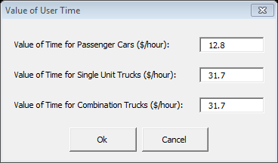

**Figure 8. Value of User Time**

Figure 9 shows the options for traffic hourly distribution pattern. The “Traffic Hourly Distribution Selection” panel is for viewing purposes. Traffic Pattern selection is made in the “Alternative” panel. For this example, Weekday Single-Peak traffic distribution is chosen because the peak traffic occurs in the late afternoon, when people are returning from work. Figure 10 shows the “Weekday Single Peak” traffic pattern.

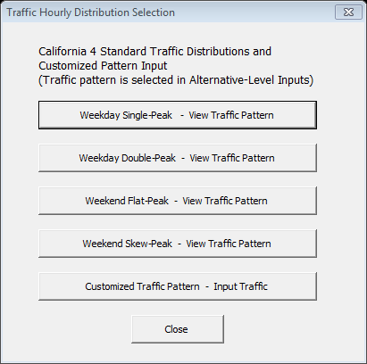

View traffic pattern for this example in Figure 10.

**Figure 9. Traffic Hourly Distribution Selection**

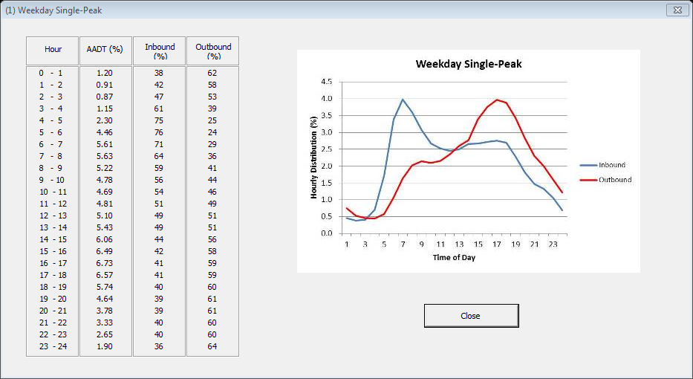

Red line shows outbound traffic distribution.

**Figure 10. Weekday Single Peak Traffic Pattern**

Figure 11 shows the “Added Time and Vehicle Stopping Costs” panel. Update to the most current Consumer Price Index (CPI) value with the “Current Year” as the end of construction year. Visit the [LCCA website](https://dot.ca.gov/-/media/dot-media/programs/maintenance/documents/office-of-concrete-pavement/life-cycle-cost-analysis/cpi-value-2013-a11y.pdf) for the most current CPI information, which is updated annually.

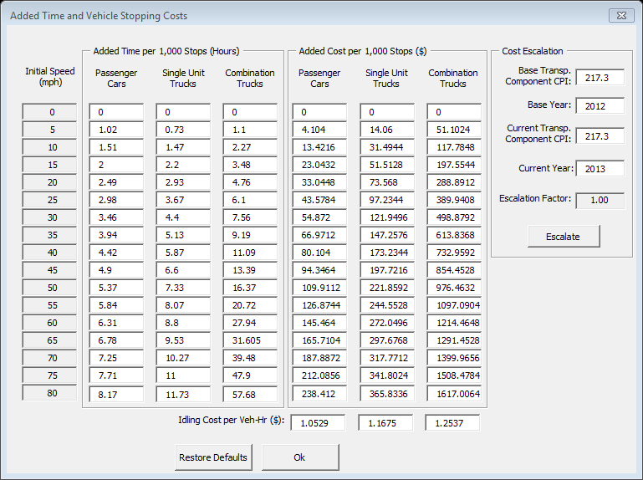

Click “Escalate” once.

End of construction year

Update to most recent CPI Value

**Figure 11. Escalated Values for “Added Time and Vehicle Stopping Costs”**

With the “Project Level Input” completed, the “Alternative Level Inputs” are started with the “M & R Sequence Selection” as shown in Figure 12. Per the flowchart shown in Figure 2, three alternatives are chosen, HMA (20 Year), HMA W/RHMA (40 Year), and JPCP (40 Year). A check mark must be selected by each pavement alternative to be analyzed. Up to four pavement alternatives may be chosen for LCCA per run. Future M&R sequences are automatically transferred to the “Alternative” panel.

Check here for each pavement alternative to be analyzed.

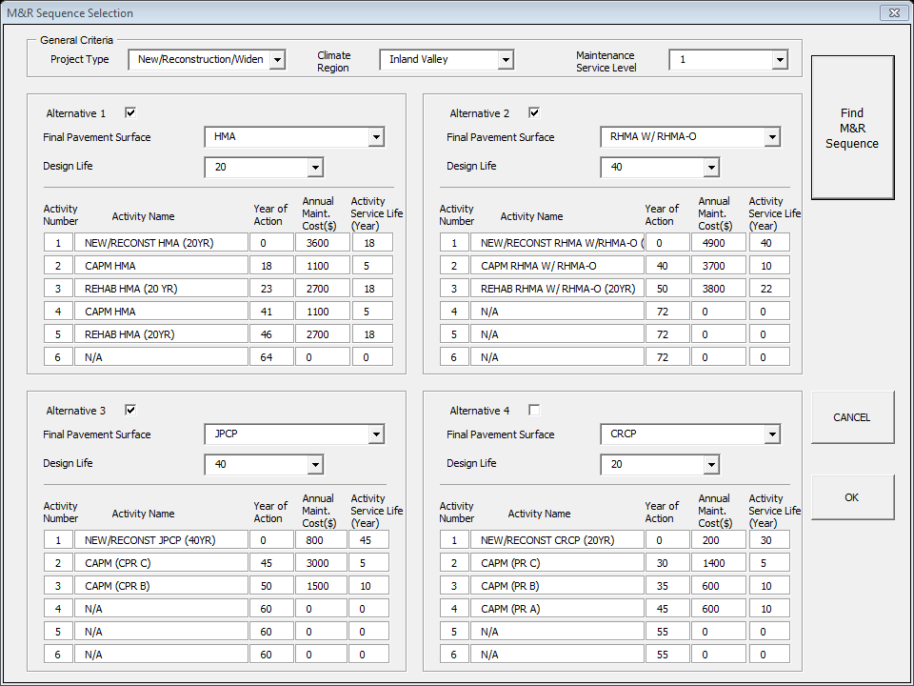

**Figure 12. “M & R Selection Sequence”**

Figure 13 shows “Alternative 1”, with “Activity 1”. “Activity 1” for each pavement alternative is the initial construction, and the “Agency Construction Cost” must be manually computed and entered. For this example, refer to Table 5 for the three “Activity 1” cost estimates.

The lane closure times were received from the Traffic Management Unit, and the military time is used with hours only. It is assumed that during initial construction, the ramp lane will be closed 24 hours behind k-rail, and it is estimated that it will take 20 lane closure days to construction the ramp.

Estimate the total number of closure days to construct the ramp and enter the value in Work Zone Duration.

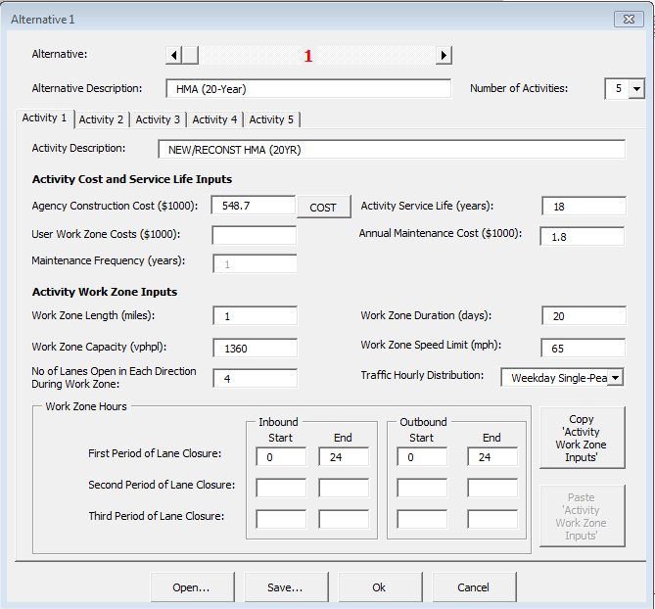

Manually calculate/input for widening projects.

Project length x # lanes in a direction x Annual maintenance cost

“Agency Construction Cost” to be manually calculated and entered for “Activity 1”

**Figure 13. Alternative 1, Activity 1, HMA (20 Year) Initial Construction**

Use the production rate tables to develop Work Zone Duration Days. Use Table 3-5, “Productivity Estimates of Typical Future Rehabilitation Ramp Strategies for Flexible Pavements” from the LCCA Procedures Manual for this pavement alternative. Figure 14 illustrates the use of Table 3-5 to determine “Work Zone Duration”.

Figure 15 shows the next activity, “Activity 2”.

**Table 3-5 Productivity Estimates of Typical Future Rehabilitation Ramp Strategies for Flexible Pavements**

**Screen shot of Productivity Estimates of Typical Future Rehabilitation Ramp Strategies for Flexible Pavements **

CAPM without milling is

shown as 1.02 miles per

closure for a 12-hour

closure period, so the

construction days for

Activity 2 would be “1”

since the ramp is 0.5 mile in length. (Act. 2)

Notes:

1. Refer to Appendix 1, “Glossary and list of Acronyms” for definitions of terms used in the table.
2. Production rates in the table are based on representative assumptions that are applied consistently throughout the table.

These rates are only for calculating future user costs for the procedures in this manual and not for any other purpose.

More project specific user costs for some freeway situations can be obtained from the CA4PRS software.

1. 24-hour continuous closure with 16 hours of operation per day
2. 24-hour continuous closure with 24 hours of operation per day
3. 55-hour extended closure over the weekend

**Figure 14. Illustration of use of Table 3.5**

Rehab with milling is

shown as 0.18 miles per

closure for a 12-hour

closure period, so the

construction days for

Activity 2 would be “3”

since the ramp is 0.5 mile in length. (Act. 3)

Ramp length/production rate= construction days

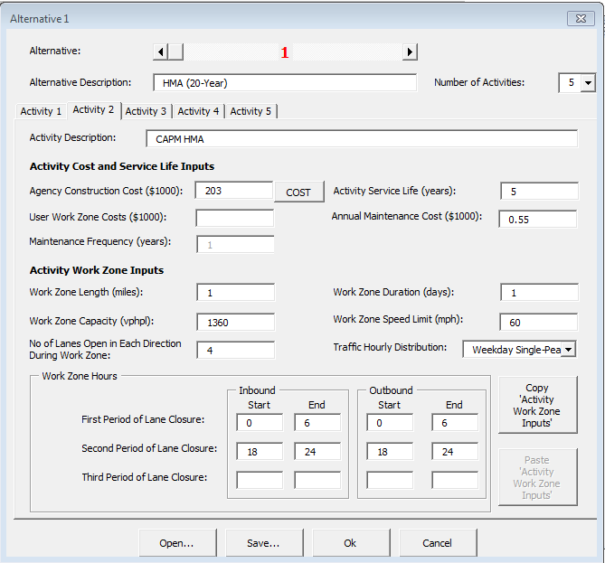

“Agency Construction Cost” for Activity 2 and beyond to be calculated by the ***RealCost Version 2.5CA program*** calculator for all activities except for “Activity 1”.

**Figure 15. “Alternative 1”, “Activity 2” HMA CAPM**

To estimate the Agency Construction Cost, select the “Cost” button. Since this activity is a CAPM, select the CAPM “Flexible or Composite” button, as shown in Figure 16.

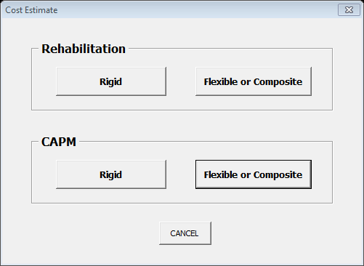

Use this calculator button for “Alternative 1”, “Activity 2”, CAPM

**Figure 16. Cost Estimate Calculator Panel**

After the “Flexible or Composite” button is selected, the “CAPM Flexible or Composite Pavement” panel as shown in Figure 17. The inputs for CAPM are Pavement Area, Milling Area, and RHMA or HMA choice of pavement.

Assumptions:

1. There is no milling.

2. The area is calculated to be 10,560 sq. yd. from Table 5.

3. The overlay is HMA.

Total Project Cost is automatically entered on the “Alternative 1” panel

Manually enter the Pavement Area (SY)

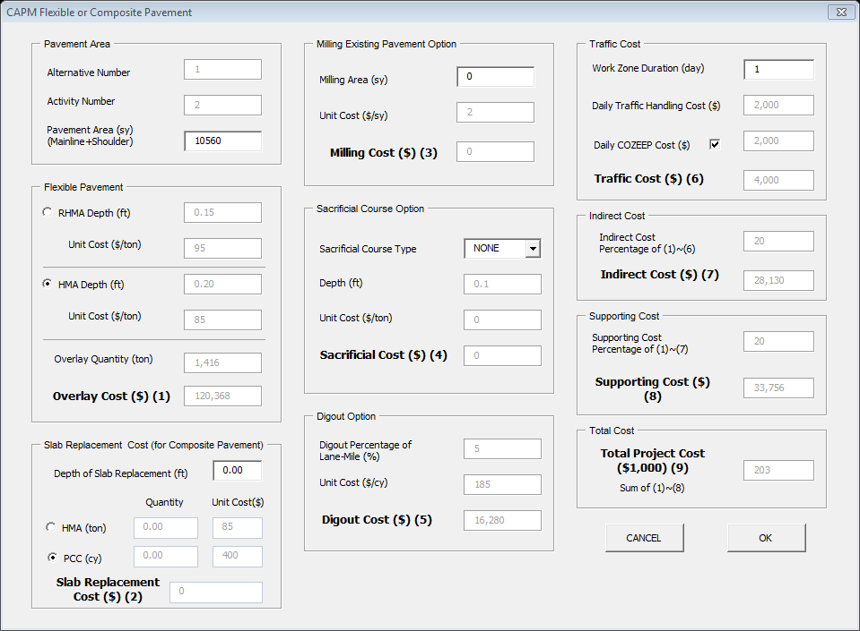

**Figure 17. CAPM for Flexible or Composite Pavement Cost Calculator**

By selecting the “OK” button, the “Agency Construction Cost” is automatically entered on the “Alternative 1, Activity 2” panel as shown in Figure 15. Next, select the “Alternative 1”, “Activity 3” button, which leads to a “Rehabilitation” activity in the “M&R Sequence”.

Again, enter the activity description as shown in Figure 18. Then select the “Cost” button. For this activity, select the Rehabilitation “Flexible or Composite” cost estimate button as shown in Figure 19.

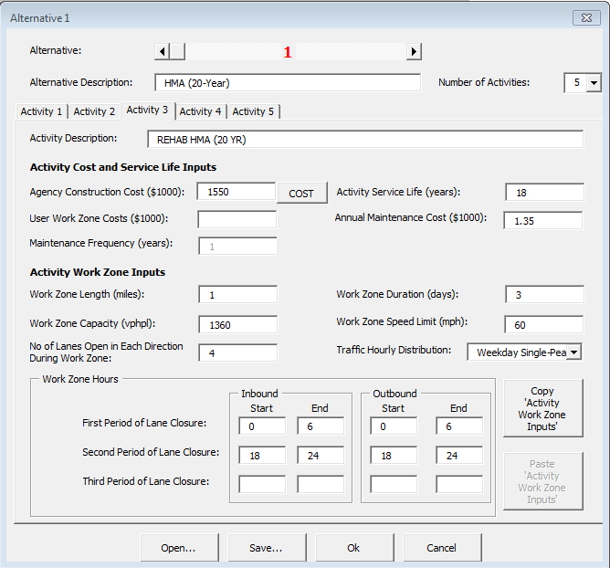

**Figure 18. Alternative 1, Activity 3, M & R Rehabilitation**



Use this calculator button for Alternative 1, Activity 3, Rehab

**Figure 19. Cost Estimate Calculator Panel**

After the “Flexible or Composite” button is selected, the “Rehabilitation Flexible or Composite Pavement” panel as shown in Figure 19. The inputs for Rehabilitation are Pavement Area, Milling Area, and RHMA or HMA choice of pavement.

Assumptions:

1. There is milling.

2. The area is calculated to be 10,560 sq. yd. from Table 5.

3. The overlay is HMA and RHMA.

Table 3-5, “Productivity Estimates of Typical Future Rehabilitation Ramp Strategies for Flexible Pavements” as shown in Figure 14 calculates to be 3 days.

Click on the Pavement Cost button as shown in Figure 20 to begin the Rehabilitation Cost Estimate.

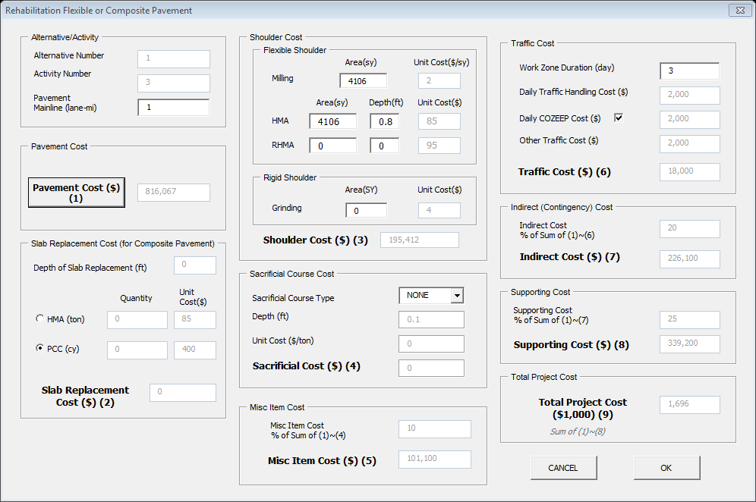

“Pavement Cost” button allows a pavement structure to be selected based on TI.

**Figure 20. Rehabilitation Flexible or Composite Pavement Cost Calculator**

After the “Pavement Cost” button is selected, the “Pavement Selection” panel estimates the future Rehabilitation pavement structure. Enter or select the Traffic Index and the existing structure depth. Select the Pavement Option for “Overlay” or “Mill and Overlay”. Finally, click on “Use Selected Structure” to estimate the pavement cost as shown in Figure 21.

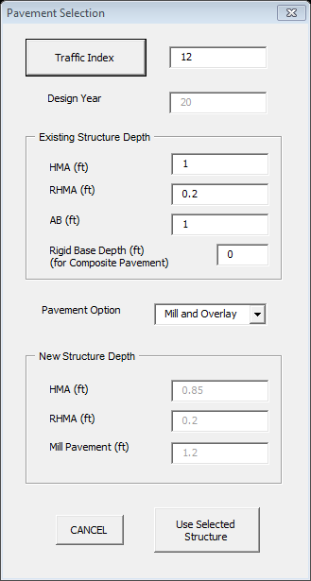

HDM designates TI’s for ramps based on surrounding areas.

13

**Figure 21. Pavement Structure Selection Section**

When the “Use Selected Structure” key is selected in Figure 21, the panel for “Rehab Flexible or Composite Pavement Cost” is shown in Figure 22. When the “OK” button is clicked, the “Alternative 1” panel is shown with the computed cost.

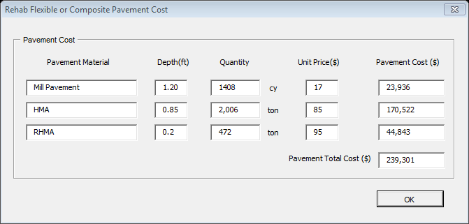

**Figure 22. Rehab Flexible or Composite Pavement Cost**

Next, continue to Alternative 1, Activity 4, as shown in Figure 23. This CAPM cost is computed using the same steps as for Alternative 1, Activity 2, except the overlay will be RHMA.

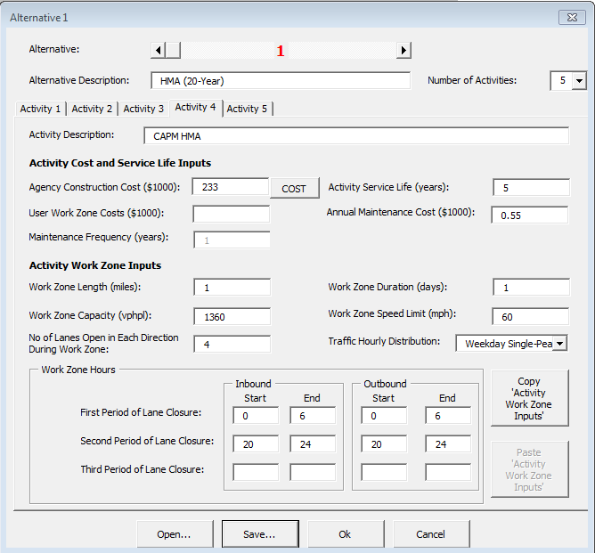

**Figure 23. Alternative 1, Activity 4, CAPM with Program Calculated “Agency Construction Cost”**

Next go to Alternative 1, Activity 5, which is another Rehabilitation as shown in Figure 24. This Rehabilitation cost is computed the same way as Alternative 1, Activity 3 was computed.

Assumptions:

1. There is milling.

2. The area is calculated to be 10,560 sq. yd. from Table 5.

3. The overlay is HMA and RHMA.

Table 3-5, “Productivity Estimates of Typical Future Rehabilitation Ramp Strategies for Flexible Pavements” as shown in Figure 14 calculates to be 3 days.

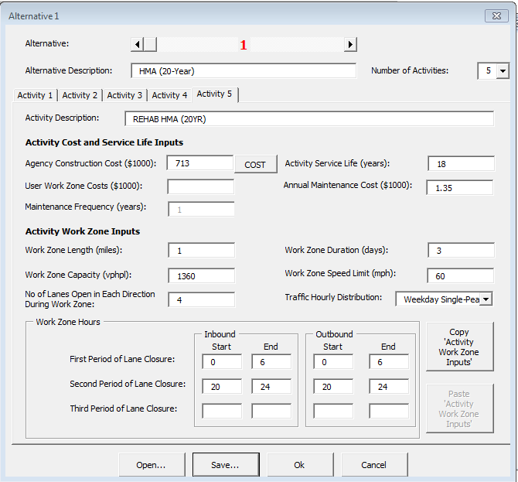

**Figure 24. Alternative 1, Activity 5, REHAB with Program Calculated “Agency Construction Cost”**

Pavement Alternatives 2 and 3 are “Alternative” inputs which are similar to the process of Pavement Alternative 1. Alternative 2 is a 40-year pavement structure with a total asphalt thickness of 1.45 feet comprised of:

1. Aggregate Base—Class 2 AB with a thickness of 0.5 foot
2. Hot Mix Asphalt—HMA (Type A) with a thickness of 1.15 feet
3. Rubberized Hot Mix Asphalt Gap Graded—RHMA-G with a thickness of 0.20 foot
4. Rubberized Hot Mix Asphalt Open Graded—RHMA-O with a thickness of 0.1 foot

Figure 25 shows Alternative 2, Activity 1 with the Agency Construction Cost.

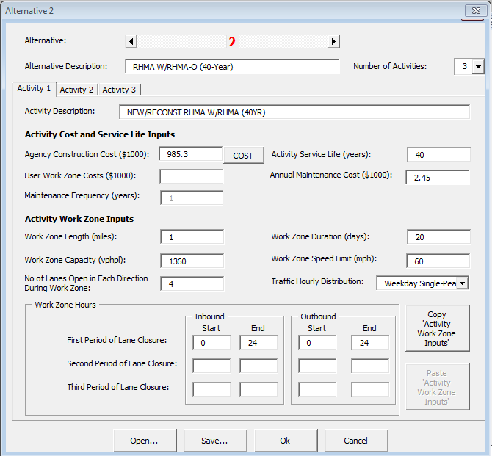

To be manually entered for Activity 1

**Figure 25. Alternative 2, Activity 1 Panel with Manually Entered “Agency Construction Cost”**

Next go to Alternative 2, Activity 2, as shown in Figure 26, for the next M & R sequence which is a CAPM. Click on the “Cost” button for the program to go to the “Cost Calculator” panel and choose the CAPM “Flexible or Composite” calculator button.

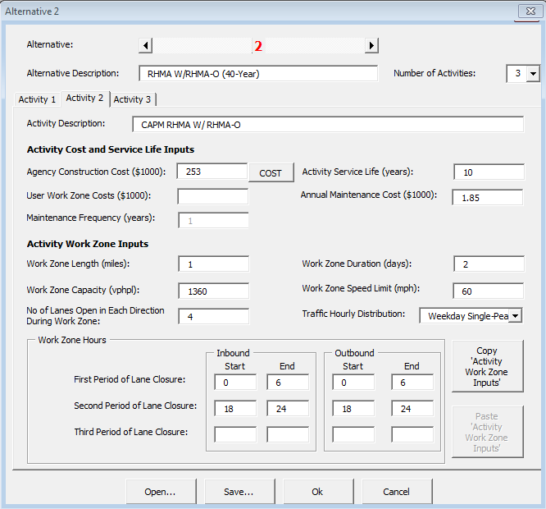

**Figure 26. Alternative 2, Activity 2**

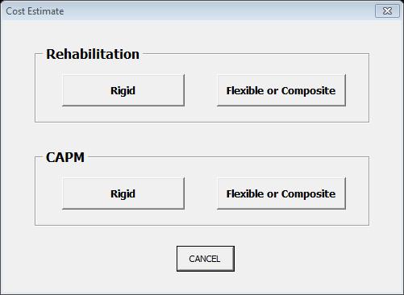

Use this calculator button for Alternative 2, Activity 2, CAPM

**Figure 27. Cost Estimate Calculator Panel**

Figure 28 shows the “CAPM Flexible or Composite Pavement” panel which computes the CAPM cost when the “Pavement Area (sy)” is entered, and the milling or no milling option is chosen. When the “OK” button is selected, the estimate is entered on Figure 28, Alternative 2, Activity 2. Next Alternative 2, Activity 3 is selected, as shown in Figure 29.

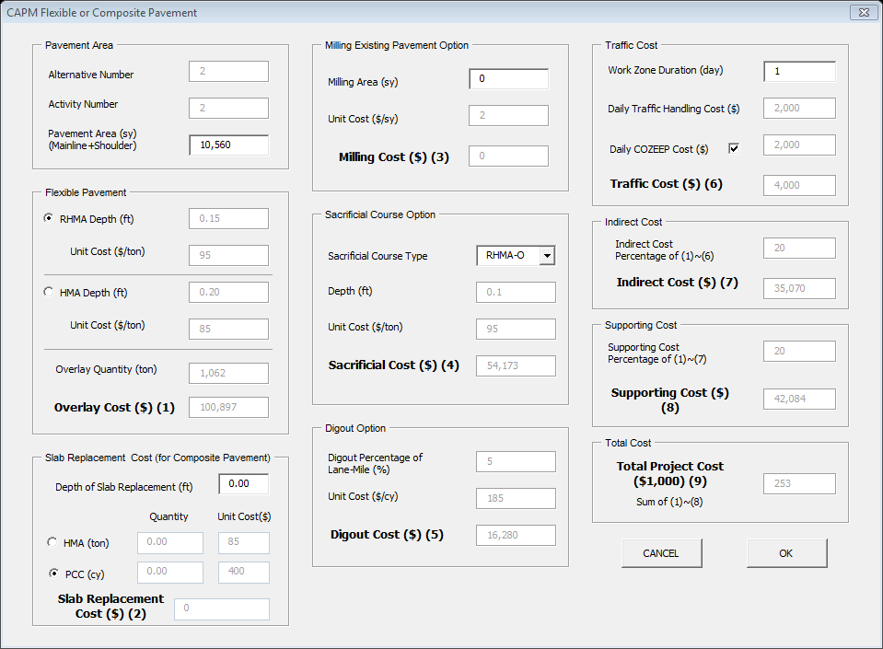

**Figure 28. Alternative 2, Activity 2, CAPM Cost Calculator Panel**

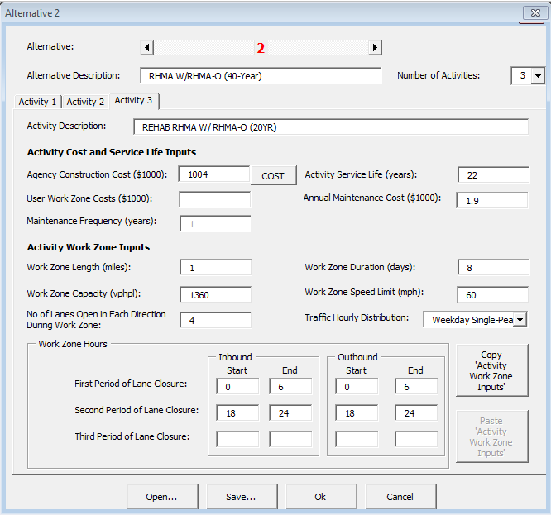

**Figure 29. Alternative 2, Activity 3**

For Alternative 2, Activity 3, the “Flexible or Composite” button is chosen in the “Cost Estimate” as shown in Figure 30, and the “Rehabilitation Flexible or Composite” is shown in Figure 31 for the next M&R sequence cost estimate to be calculated.



Use this calculator button for Alternative 2, Activity 3, CAPM

**Figure 30. Cost Estimate Selection Panel**

When the “Flexible or Composite” button is selected, Figure 31 appears. This panel allows the rehabilitation costs to be computed. For this example, there is a sacrificial RHMA-O that must be removed as part of the rehabilitation, and the flexible shoulder area needed to be part of the input, as well and “Pavement Cost”. When the cost button is selected, Figure 32, the “Traffic Index” panel is the next action.

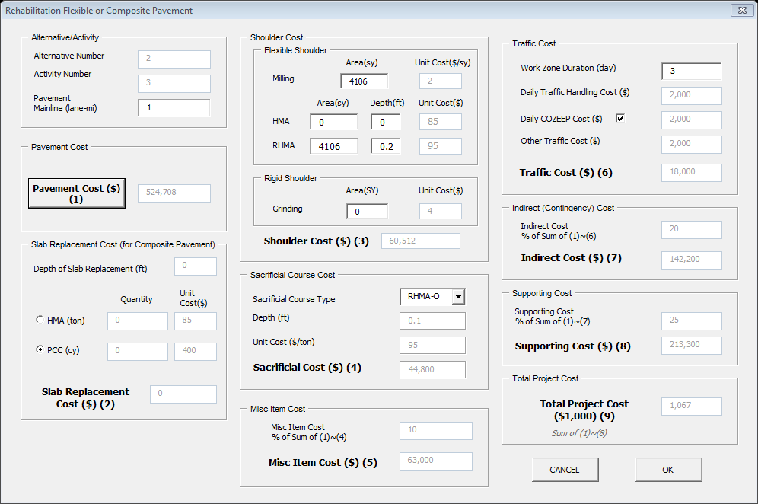

“Pavement Cost” button allows a pavement structure to be selected based on TI.

**Figure 31. Alternative 2, Activity 3, Rehabilitation Cost Calculator Panel**

Figure 32, the “Pavement Selection” panel allows the traffic index (TI) to be entered for a new structural section to be computed by *REALCOST Version 2.5CA****.***

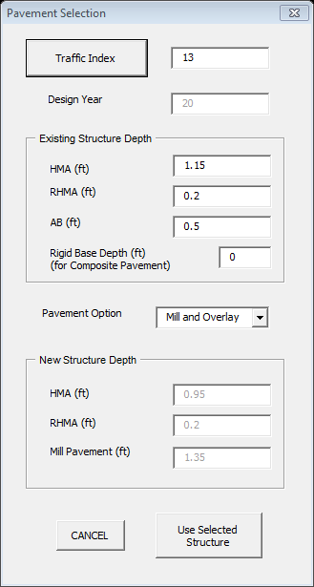

**Figure 32. Pavement Structure Selection Panel**

When “Use Selected Structure” is selected, Figure 33,” Rehab Flexible or Composite Pavement Cost” panel is shown. When “OK” is selected, Figure 34 is shown with the updated estimate.

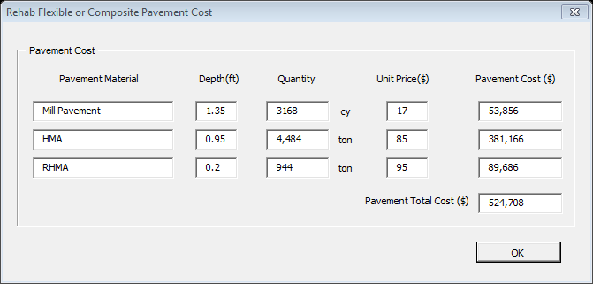

**Figure 33. Rehabilitation for Flexible or Composite Pavement with Milling**



**Figure 34. Alternative 2, Activity 3 REHAB with Calculated Cost from** ***RealCost Version 2.5CA***

With Alternative 2 completed, scroll to Alternative 3.

Alternative 3 is a 40-year pavement structure with a total structure thickness of 1.85 feet comprised of:

1. Aggregate Base—Class 2 AB with a thickness of 0.6 foot

2. Lean Concrete Base—LCB with a thickness of 0.35 foot

3. Jointed Plain Concrete Pavement—JPCP with a thickness of 0.90 foot

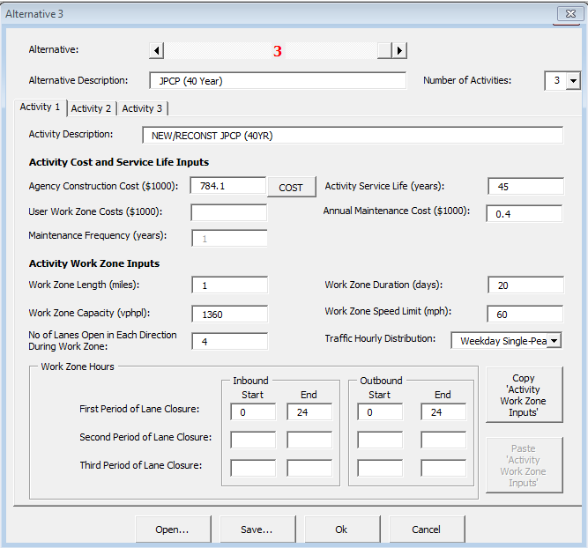

To be manually calculated entered for Activity 1

**Figure 35. Alternative 3, Activity 1 with Manually Entered “Agency Construction Cost”**

Next, scroll to “Activity 2” which is a CAPM with 2% distressed concrete panels for JPCP. Select the “Cost” button and Figure 37, will be shown. Select “CAPM”, “Rigid Pavement” from the “Cost Estimate” panel. Figure 38, “CAPM Rigid Pavement” panel is shown, next select CPR Type C for 2% Distress Panels with the proper input for concrete depth (feet), and area (square yards). The cost is computed, and when the “OK” button is selected, the Alternative 3, Activity 2 panel has the updated “Agency Construction Cost”.

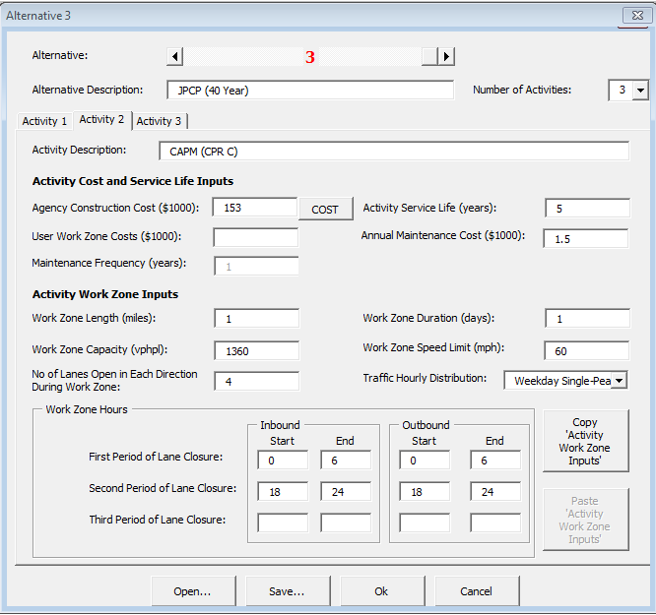

**Figure 36. Alternative 3, Activity 2 for JPCP**



Use this calculator button for Alternative 3, Activity 2, CAPM

**Figure 37. Cost Estimate Calculator Panel**

Next for Figure 38, “CAPM Rigid Pavement” panel, input the % distress, pavement area mainline, pavement area shoulders, and pavement depth and select “OK”.

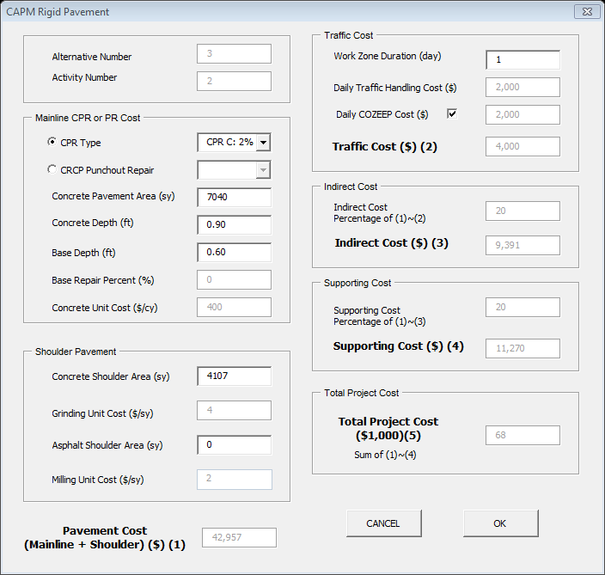

**Figure 38. CAPM Rigid Pavement Panel with CPR Type C for 2% Distress Panels**

After “OK” is selected in Figure 38, the Alternative panel appears with updated costs, as shown in Figure 39, “Alternative 3”. Next, scroll to “Activity 3” in this panel. Figure 40 shows “Alternative 3”, “Activity 3”.



**Figure 39. Alternative 3, Activity 2 with Program Generated “Agency Construction Cost”**

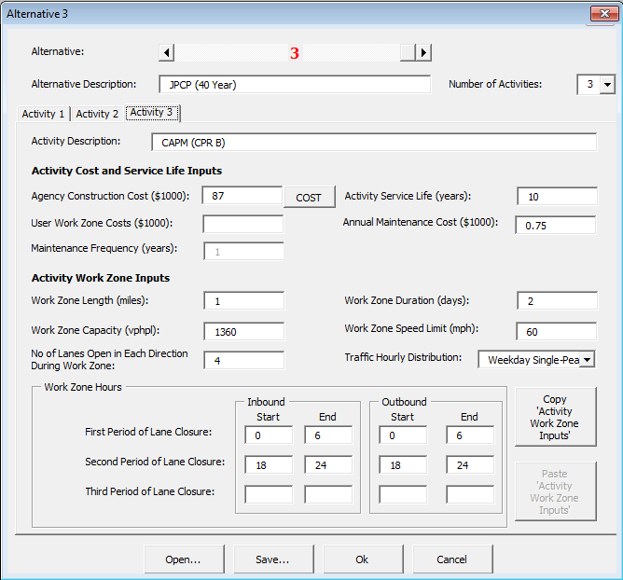

**Figure 40. Alternative 3, Activity 3 for CPR B, or 5% Distress**

The “Cost” button is selected, and Figure 41, the “Cost Estimate” panel is shown. Select the CAPM Rigid button, and the “CAPM Rigid Pavement” panel is shown in Figure 42.

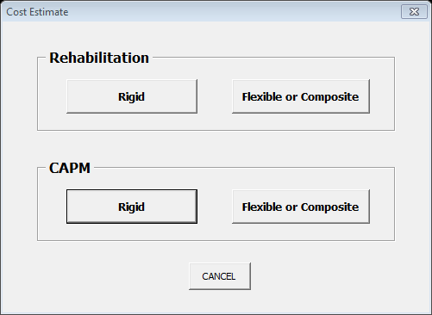

Use this calculator button for Alternative 3, Activity 3, CAPM

**Figure 41. Cost Estimate Calculator Panel**

Next for Figure 42, “CAPM Rigid Pavement” panel, input the % distress, pavement area mainline, pavement area shoulders, and pavement depth and select “OK”.

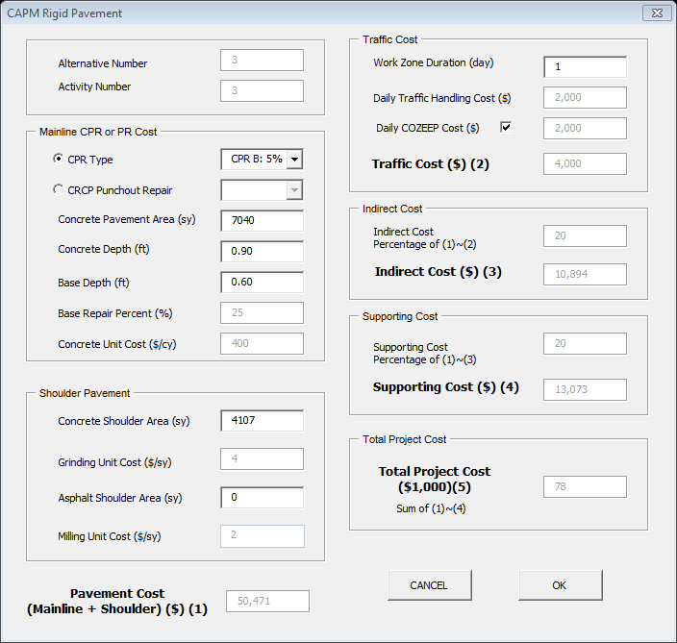

**Figure 42. CAPM Rigid Pavement Panel for CPR B or 5% Distress**

After “OK” is selected in Figure 42, the Alternative panel appears with updated costs, as shown in Figure 43, “Alternative 3”. This concludes the cost estimates for all the alternatives and activities.



**Figure 43. Alternative 3, Activity 3 after Program Cost Calculated by *RealCost Version 2.5CA***

**Step 5. Conclusion**

Once all inputs are entered and warnings checked, Figure 44 shows the Deterministic Results.

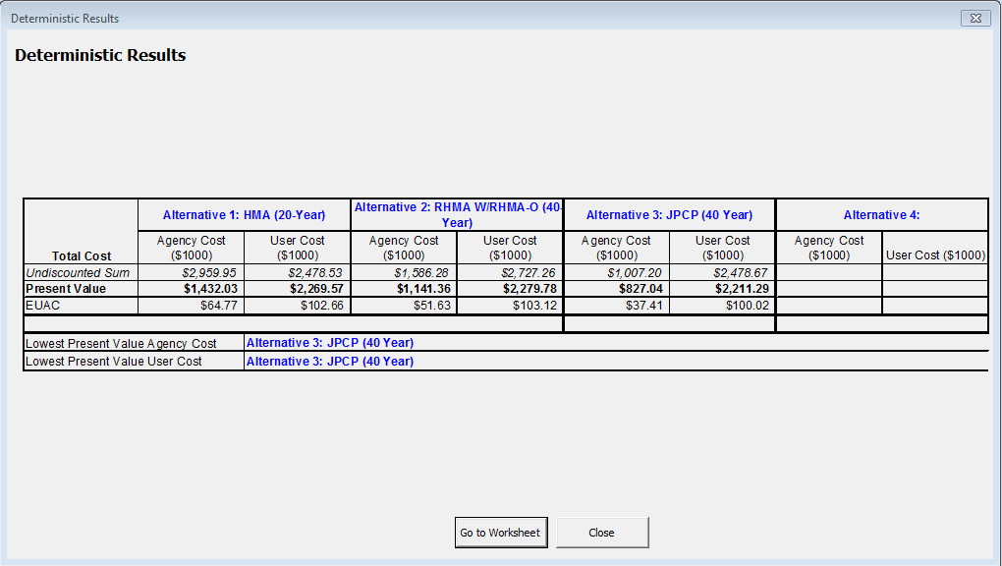

**Figure 44. Deterministic Results Generated by *RealCost***

The total life-cycle cost is the sum of the total agency cost and total user cost as summarized in Table 6 below:

**Table 6 – Summary of Total Costs**

|  |  |  |
| --- | --- | --- |
| **Pavement Alternatives Total Life-Cycle Cost for 55 Year Analysis Period (Present Value)** | | |
| **Alt. No.** | **Alternative Description** | **Total Life-Cycle Cost** |
| 1 | Hot Mix Asphalt (20-Year) | $3,701,600 |
| 2 | Hot Mix Asphalt with Rubberized Hot Mix Asphalt (40-Year) | $3,421,140 |
| 3 | Jointed Plain Concrete Pavement (40-Year) | $3,038,330 |

Result of this analysis has confirmed that Pavement Alternative 3, JPCP, has the lowest overall cost of

construction, maintenance and user delay; therefore, JPCP will be the preferred pavement alternative for this interchange project.

**Step 6. Documentation**

To document life-cycle costs in project documents follow the procedures in Appendix O-O of the Project Development Procedures Manual (PDPM). When the pavement alternative with the lowest life-cycle cost is not selected, the reasons must also be documented.

Also, submit your LCCA to HQ for data collection. Per PDPM Appendix O-O, a copy of the completed project initiation document, project report, or project scope summary report with life-cycle costs included shall be sent to:

Attn: HQ Program Advisor  
HQ Division of Maintenance, Pavement Program  
2389 Gateway Oaks, Suite 200, MS 91  
Sacramento, CA 95833

Or

lcca@dot.ca.gov

An alternative is to submit a *RealCost* LCCA Report.