Attachment 1

FY 2026 Earmark Repurposing Process
This guidance describes the steps necessary to implement the statutory requirements to request earmarks to be repurposed. FHWA’s Earmark Repurposing website is http://www.fhwa.dot.gov/cfo/earmarkrepurposing/. Please submit questions to RepurposedEarmarks@dot.gov.

Earmark Repurposing Process
- If the funds are not allocated in the Fiscal Management Information System (FMIS), then a written request should first be made by the State to the FHWA division office. A Demo ID should also be requested for these funds. The FHWA division office will send the request to the appropriate FHWA program office to allocate the funds following the normal process. The request should note that the funds will be used for repurposing and a Demo ID is needed. This process may take 30 days which should be included in the timeline to meet the September 4, 2026, deadline and should be received before August redistribution submittals. States should account for this when prioritizing the preparation of repurposing requests.

Once the funds are allocated in FMIS and a Demo ID is assigned, the State may continue to step 2 of this process.

- The State submits a request to repurpose eligible earmarks to the FHWA division office for concurrence using the FMIS Fund Control module. A separate transfer request should be submitted for each Demo ID to be repurposed.

State Creation of a FMIS Transfer Request

Step 1: To create a new transfer request, select the “Add New Transfer” option under the FMIS Fund Control Module’s “Manage Transfers” List. (See screenshot)

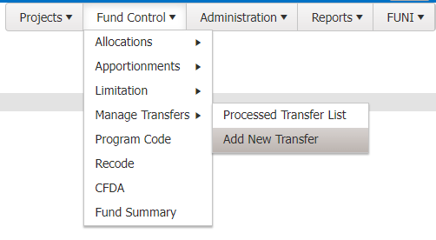

Step 2: (Required) On the “Add Funds Transfer” screen, select “Repurposed Earmark” for the transfer type from the “Transfer Type” dropdown. (See screenshot)

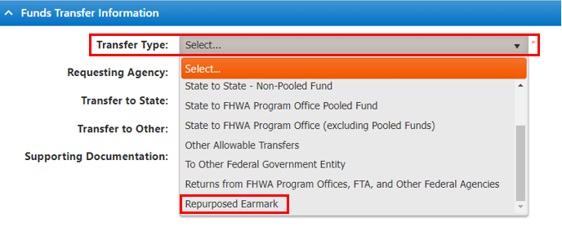

Step 3: (Required) From the “Requesting Agency” dropdown, select the State submitting the request (if it differs from the default “Requesting Agency” associated with your User ID). (See screenshot)

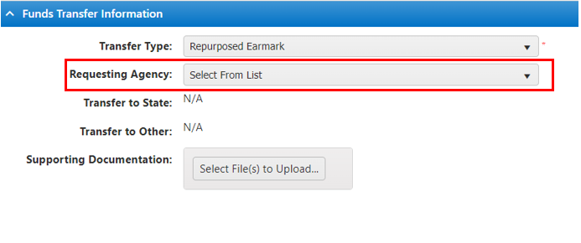

Step 4: (Optional) Attach supporting documentation. (See screenshot)

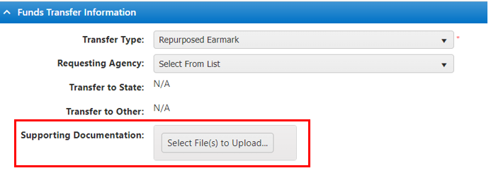

Step 5: (Optional) Insert information on the State’s Transfer Request Contact and the State’s Tracking Number. An FHWA Tracking Number will be assigned after the request is initially saved. (See screenshot)

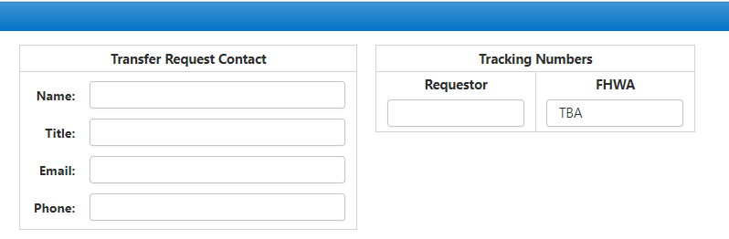

Step 6: (Required) Certify the designated earmark meets the requirements for repurposing and that the repurposed funds will be obligated for eligible purposes on the identified project(s) by selecting “Yes” or “No.” (See screenshot)

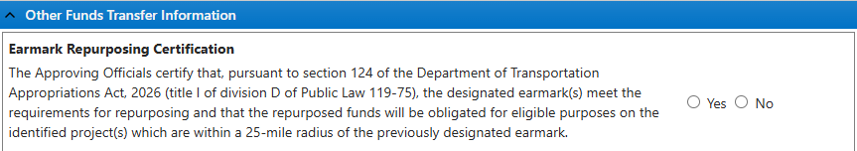

Step 7: (Required) Insert any relevant information in the “Enter Detail #, Pooled Fund Project Description, or any additional information” section. The State should provide the information of the new project(s) description(s) and the amount of funds for each project of the repurpose request.

The submission must contain sufficient information to demonstrate that each requested earmark is eligible for repurposing and each new project meets the requirements of the Repurposing Provision (section 124 of division D, title I, of the Department of Transportation Appropriations Act, 2026, (Public Law 119-75)). (See screenshot)

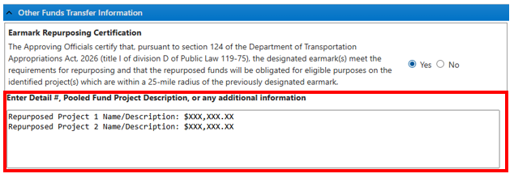

Step 8: (Required) Save the transfer request. Saving takes you from the “Add Funds Transfer” screen to the “Edit Funds Transfer” screen. In addition, this step creates the FHWA Tracking Number and puts the request in the “Recipient Signature Needed” status. (See screenshot)

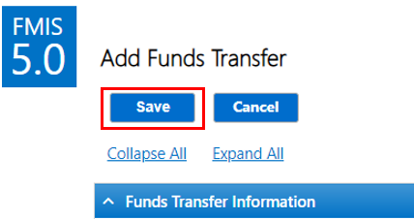

Step 9: Once on the “Edits Funds Transfer” screen, add detail lines by selecting “Add Funds Transfer Detail.” At this point, a FHWA tracking number has also been assigned. (See screenshot)

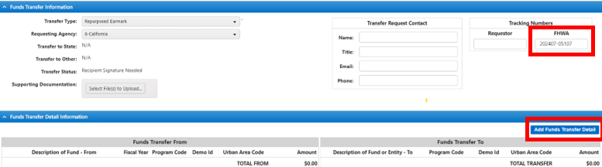

Step 10: (Required) On the “Add Funds Transfer Detail” screen, select the From “Program Code”, appropriate “Fiscal Year”, “Demo ID”, and “Law-Section-Sub Section”. The “Description of Fund” will automatically populate based on the “Program Code” chosen. The “Fiscal Year” will be limited to the FYs associated with the Program Code and to those FYs with unobligated balances based on FIFO. The “Demo ID” will be limited to the State and program code selected. The “Law-Section-Sub Section” will be limited to the public law information associated with the Demo ID selected. At this point, the amount of (1) pending transfers, (2) pending obligations, (3) unobligated balance, (4) FY apport/alloc Balance, (5) FY unobligated balance, and the (6) limitation balance, if applicable, will auto populate. The Demo Description is also updated to reflect “Repurposed-” as part of the description. (See screenshot)

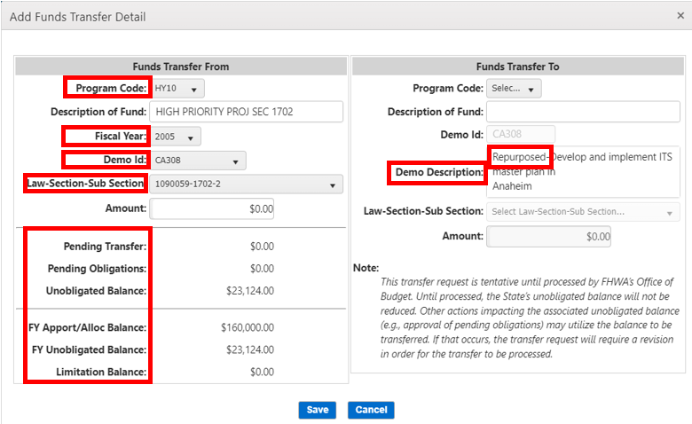

Step 11: (Required) Insert the “Amount” of the request on the “From” side, which will automatically populate the “Amount” on the “To” side. This should be the full unobligated balance for the earmark as of the date of the repurposing request. (See screenshot)
- The amount on the “From” and “To” side for each detail line will be equivalent. If $200 is being transferred from PC WXYZ, with $100 going to PC ABCD and $100 going to PC KLMN, then two detail lines must be created with $100 being transferred from PC WXYZ in each detail line, and
- There cannot be multiple details lines with the same “To” and “From” PC/FY combination on the same transfer request.
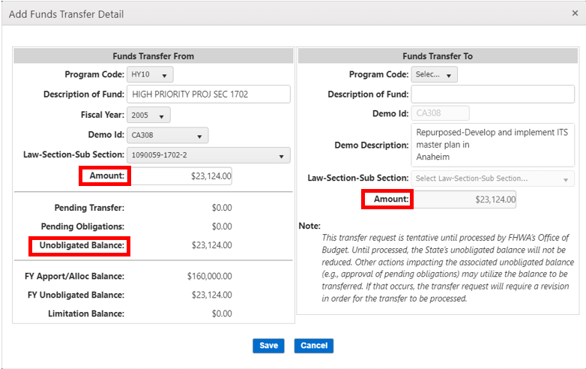

Step 12: (Required) Select the appropriate To “Program Code” and “Law-Section-Sub Section.” Once selected, the To “Description of Fund” will automatically populate. The “Law-Section-Sub Section” will be limited to public law information associated with the program code selected. (See screenshot)

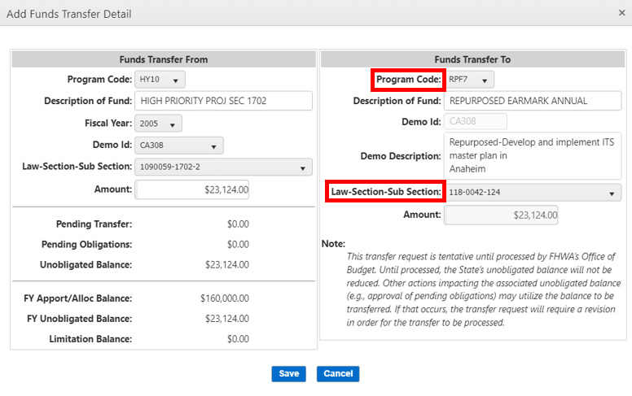

Step 13: (Required) Click Save. If the amount does not pass funds control checks against the “FY Unobligated Balance”, then the user will not be able to save, and an error message will appear. If the amount passes funds control, then a message confirming addition will be displayed. (See screenshot)
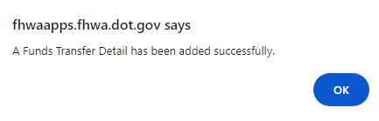
The detail line information is now shown under the “Funds Transfer Detail Information” section and can be edited or reviewed by clicking the detail line number. If an additional detail line is necessary, add it by clicking “Add Funds Transfer Detail” and following the above steps again.
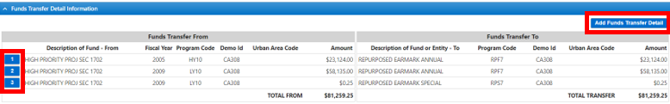

Step 14: (Required) Once completed, a State user with “Transfer Signature Allowed” rights may sign the request by clicking “Sign.” If all required fields and documentation are complete and all system validations pass, then the request will be signed. Once signed, the status will change to “Division Signature Needed” and will appear in Division Office users’ default pending transfers list.

Step 15: (Required) Once the request is signed by the State, the Division Office may review and approve it in their “Pending Transfer” tab. Review the information in the “Funds Transfer Information” for accuracy and click on the appropriate “Funds Transfer Detail Information” line item to review the details.

After review, the FHWA Division Office reviewer/approver inputs any comments into the “FHWA Comments” field, which is the only editable field for an FHWA Division Office reviewer/approver. The DA approval, or, if designated, the Deputy Division Administrator (DDA) or the Chief Operating Officer (COO) (see next paragraph), should be noted in this section.

The Division Administrator (DA) or, if designated, the Deputy Division Administrator (DDA) or the Chief Operating Officer (COO), will either approve or reject the transfer request. The DA may delegate this authority only to the DDA or COO. The DA’s approval represents the FHWA’s concurrence on eligibility of each earmark requested for repurposing and the requirements for project selection. The DA is responsible for confirming the following:
  - The earmark is less than 10 percent obligated as of October 1, 2025, or all related projects that used the earmarked funds are final vouchered and closed.
  - The new project is eligible under the Surface Transportation Block Grant Program (STBG) (23 U.S.C. 133(b)), or Territorial and Puerto Rico Highway Program (THP) (23 U.S.C. 165) and located within 25 miles of the earmark description in the same State or Territory.
  - Obligation limitation available is properly identified, if applicable.

The FHWA division office is also responsible for verifying the amount of funds available for repurposing.

After review, the FHWA Division Office approver may either “reject” or “sign” the request.

- If the Division Office approver rejects the request, the approver must input a reason for rejection either from the supplied list of reasons or by choosing “Other” with a written explanation. Once rejected, the status changes to “Rejected by Division Office” and is sent to the State’s pending transfers list. Note: A State must acknowledge the reason for rejection prior to revising and resubmitting.

- If the Division Office approver signs the request and all system validations pass, then the status changes to “Pending HCFB Processing” and is sent to the HCFB pending transfers list.

- Step 16: (Required) Once the request is signed by the State and approved by the Division, HCFB may review and process it from their “Pending Transfer” tab. After review, the HCFB processor may either “process” or “reject” the request.

- If the HCFB processor rejects the request, a reason for rejection must be provided. Once rejected, the status changes to “Rejected by HCFB” and is sent to the State’s pending transfers list. Note: A State must acknowledge the reason for rejection prior to revising and resubmitting.

- If the HCFB processor processes the request and all system validations pass, then the transfer will process, and its status will change to “Processed.” In addition, the transfer can now be viewed on the “Processed Transfers” tab.

Note: At any point after the initial save by the State, a PDF version of the 1575C report can be viewed and downloaded by clicking the “FHWA 1575C Rpt” button.

State Creation of a Transfer Request with Competitive Grant Program Funding Eligible for Repurposing, but Funds Are Not Allocated to a Demo ID in FMIS.

Competitive grant program funding (e.g., Ferry Boat Program, Interstate Maintenance Program, Bridge Investment Program, etc.) that was congressionally designated to a specific project identified in a report accompanying legislation such as appropriations acts are eligible for repurposing. These funds are not allocated to a Demo ID in FMIS. States should create the transfer request in FMIS using the following steps.

Steps 1-9: Follow the same steps listed under “State Creation of a Transfer Request.”

Step 10: (Required) On the “Add Funds Transfer Detail” screen, select the From “Program Code” and the appropriate “Fiscal Year”. The “Description of Fund” will automatically populate based on the “Program Code” chosen. The “Fiscal Year” will be limited to the FYs associated with the Program Code and to those FYs with unobligated balances based on FIFO. At this point, the amount of (1) pending transfers, (2) pending obligations, (3) unobligated balance, (4) FY apport/alloc Balance, (5) FY unobligated balance, and the (6) limitation balance, if applicable, will auto populate. (See screenshot)

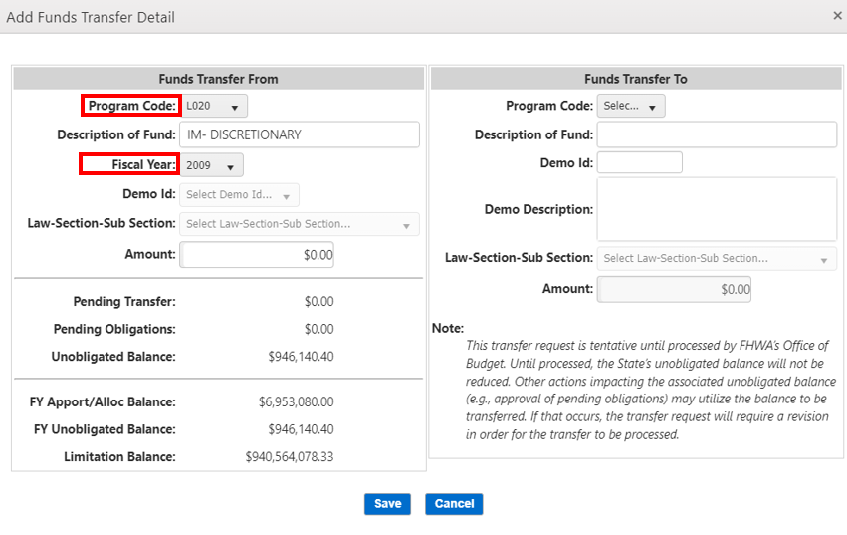

Step 11: (Required) Insert the “Amount” of the request on the “From” side, which will automatically populate the “Amount” on the “To” side. This should be the full unobligated balance for the earmark as of the date of the repurposing request. (See screenshot)
- The amount on the “From” and “To” side for each detail line will be equivalent. If $200 is being transferred from PC WXYZ, with $100 going to PC ABCD and $100 going to PC KLMN, then two detail lines must be created with $100 being transferred from PC WXYZ in each detail line, and
- There cannot be multiple details lines with the same “To” and “From” PC/FY combination on the same transfer request.
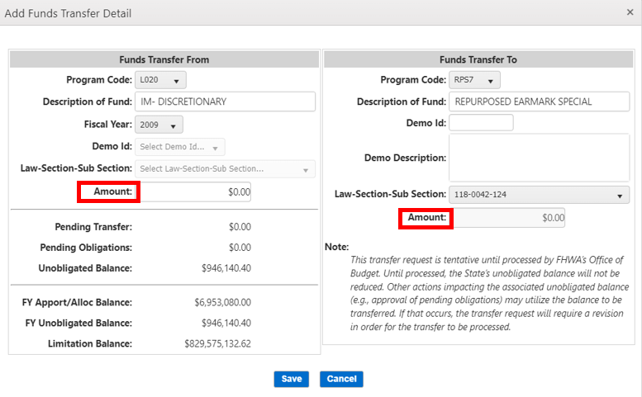

Step 12: (Required) Select the appropriate To “Program Code” and “Law-Section-Sub Section”. Once selected, the To “Description of Fund” will automatically populate. The “Law-Section-Sub Section” will be limited to public law information associated with the program code selected. (See screenshot)
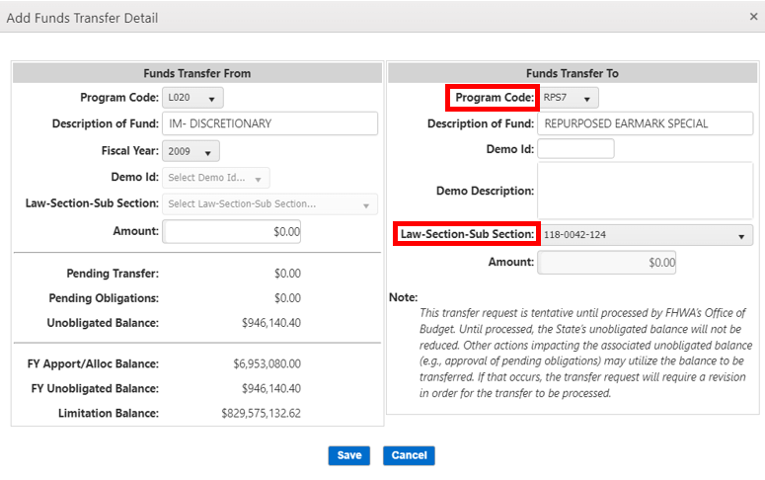

Step 13: (Required) Enter the assigned Demo ID the FHWA program office provided for the request. (See screenshot)
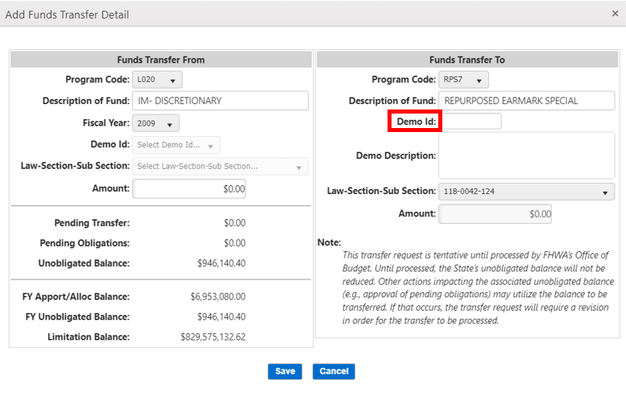

A message asking for confirmation that the entered Demo ID is correct. Confirm the Demo ID is accurate and matches the assigned Demo ID from the FHWA program office then select “Yes”. (See screenshot)
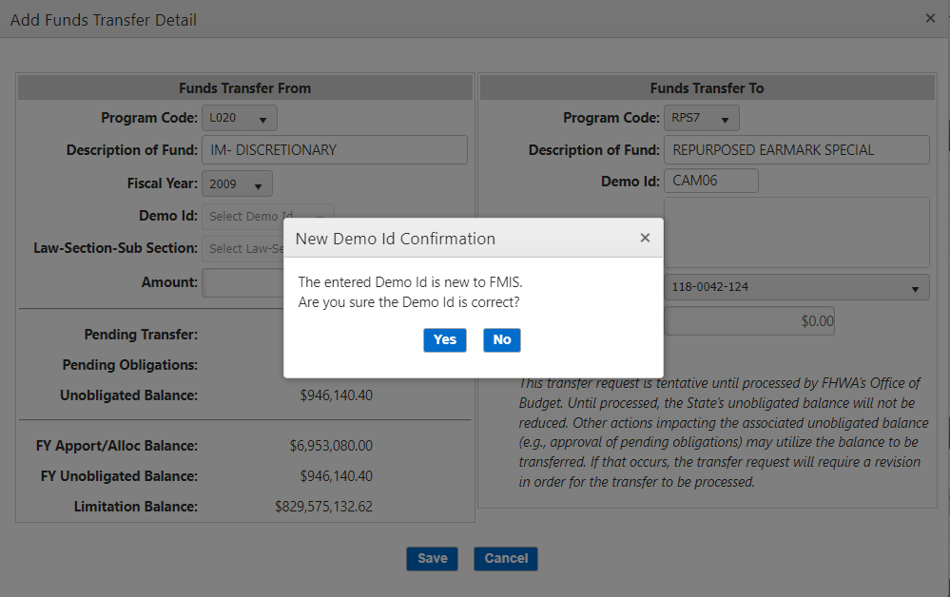

Step 14: (Required) Enter the assigned Demo Description. This should reflect the original earmark description. (See screenshot)

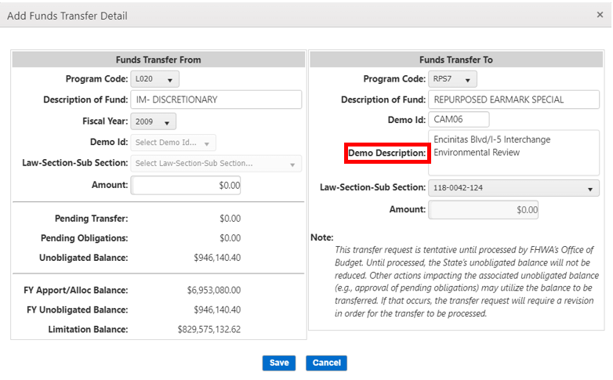

Step 15: (Required) Click Save and continue to follow steps 13-16 listed under “State Creation of a Transfer Request.”

ANNUAL REPORT
The FHWA will facilitate the annual reporting required by the States in the Repurposing Provision. The HCF will consolidate the list of repurposed projects received during the year. The timeline for HCF to provide the annual list of projects to the FHWA division offices to then be provided to the States will be determined and communicated to the division offices and States at a later date.

The State should provide a letter to the FHWA division office confirming the list of projects and certifying that the earmarks were eligible for repurposing and the projects identified are within 25 miles of the earmark location within the State and will be obligated for eligible purposes as required in the Repurposing Provision. The State should attach the list of projects to the letter. The timeline for the FHWA division office to provide the State’s certification to the “Repurposed Earmarks” mailbox will be determined and communicated to the division offices and States at a later date.

The HCF will consolidate the reports for the required annual report to Congress.

OBLIGATIONS

The State should obligate the funds in FMIS for the eligible projects as identified on the transfer request. The State has until the end of FY 2029 to establish project agreements and make the obligations for earmarks repurposed in the 2026 process pursuant to the Repurposing Provisions. Note, this does not change the availability period for previously repurposed earmarks. The project title and description should clearly reflect the purpose of the project as identified on the transfer request.

If transfers to Federal Lands or other agencies are desired, the repurpose transfer process should be followed first. Then, a request to transfer the repurposed funding to Federal Lands or another agency should be submitted following the normal process after the funds are repurposed.
When the funds are obligated on a project agreement in FMIS, the FHWA division office must ensure the project description clearly reflects the use of the funds for the new project and is consistent with the repurpose request on the transfer request. The project should use the associated demo ID.

If an obligated project is completed and excess funds are de-obligated, the unobligated funds may be used only on another project from the same earmark identified on the transfer request submitted before September 4, 2026; based on the definition of “earmarked amount” in the Repurposing Provision, once funds are repurposed for a specific project, the funds may not be changed to a different project that was not on the repurposing request.

