ATP Count Methodology Guidance – Key Changes & Guidelines

There has been a recent update to the Count Methodology Guide (Count Guide) for the California Active Transportation Program (ATP). These updates are in effect immediately and will apply to our upcoming monitoring of your project. It is crucial that all projects review the updated protocols to ensure compliance. Review the updated ATP Count Methodology Guide to ensure all current and future projects are aligned.

Key Changes and Guidelines Include:
The required number of count locations has been reduced to a maximum of three for large infrastructure projects, and for SRTS NI projects, counts are only required at one out of ten schools served. Count duration guidance has been simplified to require seven continuous days of 24-hour counts for Infrastructure projects.
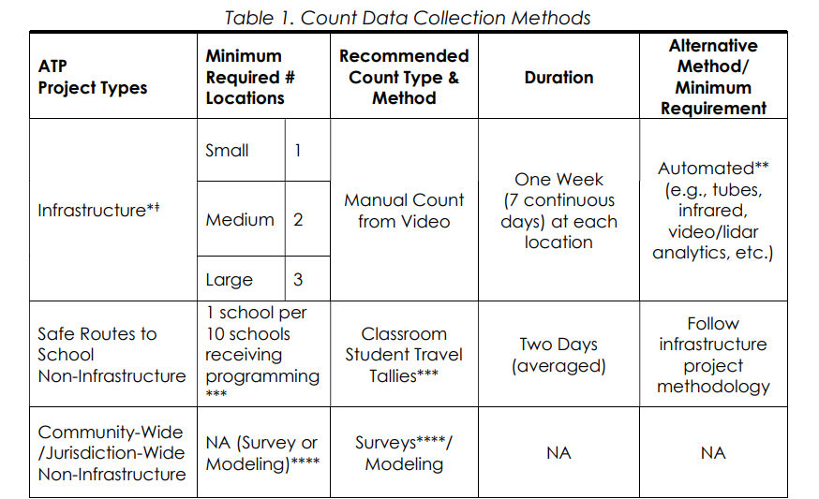
The ATRC created a robust data portal (CAT Data Portal) for you to report your counts. This data portal will supercharge your data with Accuracy Adjustment Factors and projections of Annual Average Daily Bicycle and Pedestrian Traffic (AADBT and AADPT) accessible in a beautiful map interface and made available to researchers for even greater impact. You’ll then report the estimated Average Annual Daily Bicyclist Traffic (AADBT) and Average Annual Daily Pedestrian Traffic (AAPT) generated by the CAT Data Portal into CalSMART for reporting purposes.

To ensure agencies account for the costs associated with the required count duration/methodology, the Engineer’s Estimate for the Cycle 8 application has been updated to include a field for the cost of collecting counts. If you’ve already allocated Construction or Construction-NI funds (or both in the case of Combo projects) before the March 2026 CTC meeting, your project will continue to follow the old Interim Count Methodology Guidance for that component.
Lastly, the guidance includes the requirement for projects, adopted into Cycle 6 and newer, to do a 5-year-Performance Analysis on the intended long-term benefits (outcomes/performance metrics), which is required by the SB 1 Accountability and Transparency Guidelines, and came into effect March 2023. Thus, an additional after count will be required and included in the 5-year-Performance Analysis.
If an alternative methodology is needed, it must be approved by Caltrans prior to start of the construction phase of work at atp-pm@dot.ca.gov.
For project specific questions, reach out to your ATP District Coordinator(s).

