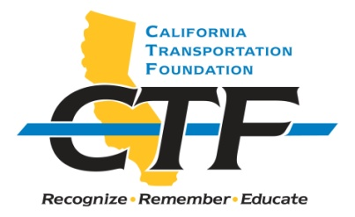

2021 CTF TRANSPORTATION

SCHOLARSHIP

The California Transportation Foundation (CTF), a nonprofit organization, announces four $1,000 scholarship: the CTF Transportation Scholarship for the 2020/2021 academic year.

Applicants must be a college/university sophomore or junior enrolled in a major other than civil engineering and interested in pursuing a career in transportation after graduation. The award of the scholarship is based on the applicant’s commitment to a career in transportation, current job skills, and academic record. Financial need may be considered, but it is not a primary factor.

Applicants must meet the following general criteria:

- Must be a United States citizen, permanent resident, or documented international student.
- Must be a college/university sophomore or junior enrolled in a major other than civil engineering.
- Must plan to pursue a career in transportation after graduation.
- Must provide an official transcript and proof of current enrollment.
- Must provide a sealed letter of recommendation from a school faculty member.
- Must provide a sealed letter of recommendation from a work supervisor.
- Cannot have received a CTF scholarship within the last two years.

Information about the award including the scholarship recipient’s photograph will be posted at https://transportationfoundation.org/scholarships/.

The CTF Transportation Scholarship is supported by a gift to the CTF. The scholarship is endowed, and scholarship funds are administered by CTF, a nonprofit organization established in 1988 to “Promote and Recognize Excellence in California Transportation.” It is a 501(c)(3) charitable organization with tax exempt status. The Federal EIN # is 68-0165257.

Submit completed applications to:

Department of Transportation
Division of Human Resources
Office of Examinations and Recruitment Services (MS-86)
Attention: Heather Lewis
P.O. Box 168036
Sacramento, CA 95816-8036

Applications will be accepted through October 15, 2021. Incomplete applications will not be accepted.

Contact: by phone at (916) 227-7725 or by e-mail at askrecruitment@dot.ca.gov
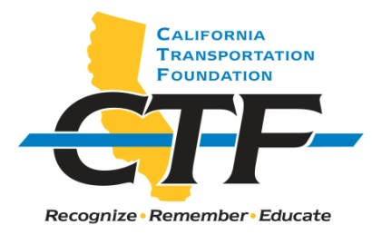
2021 CTF TRANSPORTATION SCHOLARSHIP

APPLICATION INSTRUCTIONS

Applicant Name: _______________________________________________________

Current Address: ______________________________________________________

Mailing Address (if different from Current Address):

_____________________________________________________________________

Phone: ______________ E-mail address: ___________________________________

COLLEGE DATA:

College name: _________________________________________________________

College location: ______________________________________________________

Area of concentration: __________________________________________________

Class level: ___________________________________________________________

Overall grade point average (GPA): _______________________________________

CAREER OBJECTIVE: Provide a short statement. (No more than five lines.)

PERSONAL AND/OR SCHOOL AFFILIATIONS/HONORS: (Brief list.)

WHY I AM INTERESTED IN A CAREER IN TRANSPORTATION: Attach a typed, one-page essay. (Not more than 500 words.)

ATTACHMENTS

Please enclose the following with this application:
- Copy of official transcripts and proof of current enrollment
- One sealed letter of recommendation from a school faculty member
- One sealed letter of recommendation from a work supervisor

SIGNATURE: ________________________ DATE: __________________________

