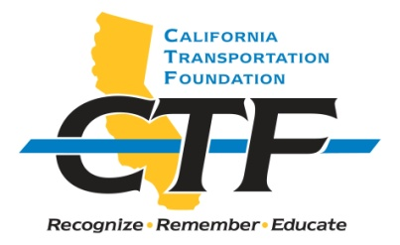

2021 JAMES E. ROBERTS

ENGINEERING SCHOLARSHIP

The California Transportation Foundation (CTF), a nonprofit organization, announces seven $1,500 scholarships: the James E. Roberts Engineering Scholarship for the 2020/2021 academic year.

Applicants must be in their senior year of a California high school and interested in pursuing a college degree in civil engineering. The award of the scholarship is based on the applicant’s commitment to a career in transportation, current job skills, academic record, and specific goals and experience. Financial need may be considered, but it is not a primary factor.

Applicants must meet the following general criteria:

- Must be a United States citizen, permanent resident, or documented international student.
- Must be in his/her senior year of a California high school.
- Must intend to enroll in civil engineering curriculum at a California college or university.
- Must plan to pursue a career in transportation after graduation.
- Must exhibit community and school involvement.
- Must provide an official transcript.
- Must provide a sealed letter of recommendation.
- Work experience and/or volunteer experience may be considered.

Information about the award including the scholarship recipient’s photograph will be posted at https://transportationfoundation.org/scholarships/.

The James E. Roberts Engineering Scholarship is supported by a gift to the CTF. The scholarship is endowed, and scholarship funds are administered by CTF, a nonprofit organization established in 1988 to “Promote and Recognize Excellence in California Transportation.” It is a 501(c)(3) charitable organization with tax exempt status. The Federal EIN # is 68-0165257.

Submit completed applications to:

Department of Transportation
Division of Human Resources
Office of Examinations and Recruitment Services (MS-86)
Attention: Heather Lewis
P.O. Box 168036
Sacramento, CA 95816-8036

Applications will be accepted through June 1, 2021. Incomplete applications will not be accepted.

Contact: by phone at (916) 227-7725 or by e-mail at askrecruitment@dot.ca.gov
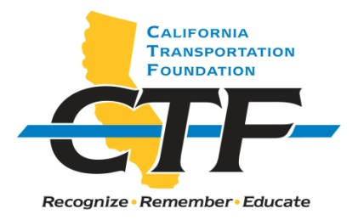
2021 JAMES E. ROBERTS ENGINEERING SCHOLARSHIP

APPLICATION INSTRUCTIONS

Applicant Name: _______________________________________________________

Current Address: ______________________________________________________

Mailing Address (if different from Current Address):

_____________________________________________________________________

Phone: ______________ E-mail address: ___________________________________

High school name: _____________________________________________________

High school phone number: _____________________________________________

Overall grade point average (GPA): _______________________________________

College choice: _______________________________________________________

Intended major: ________________________________________________________

PLEASE COMPLETE THE APPLICATION USING THE FOLLOWING HEADINGS:

PERSONAL STATEMENT: (Typed on one page and double spaced.)
- What are your college and career plans?
- Why are you interested in a career in transportation?
- How can you contribute to Caltrans as a Civil Engineer in the transportation field?
- Please indicate if there is a financial need.

COMMUNITY AND SCHOOL ACTIVITIES (List)

WORK AND/OR VOLUNTEER EXPERIENCE (List)

ATTACHMENTS

Please enclose the following with this application:
- Copy of official transcripts and proof of current enrollment
- One sealed letter of recommendation from a school faculty member
- One sealed letter of recommendation from a work supervisor

SIGNATURE: ________________________ DATE: __________________________

