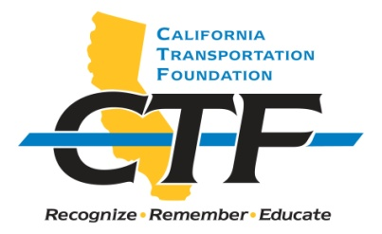
2021 G. LANGSNER

MEMORIAL SCHOLARSHIP

The California Transportation Foundation (CTF), a nonprofit organization, announces four $1,000 scholarships: the G. Langsner Memorial Scholarship for the 2020/2021 academic year.

Applicants must be a college/university undergraduate majoring in civil engineering, interested in pursuing a career in transportation after graduation, and affiliated with Caltrans. Current student assistants, volunteers, and sons or daughters of Caltrans employees are eligible to apply. The award of the scholarship is based on the applicant’s commitment to a career in transportation, current job skills, and academic record. Financial need may be considered, but it is not a primary factor.

Applicants must meet the following general criteria:

- Must be a United States citizen, permanent resident, or documented international student.
- Must be a college/university undergraduate majoring in civil engineering.
- Must plan to pursue a career in transportation after graduation.
- Must provide an official transcript and proof of current enrollment.
- Must provide a sealed letter of recommendation from a school faculty member.
- Must provide a sealed letter of recommendation from a work supervisor.
- Cannot have received a CTF scholarship within the last two years.

Information about the award including the scholarship recipient’s photograph will be posted at https://transportationfoundation.org/scholarships/.

The G. Langsner Scholarship is supported by gifts to the CTF. This scholarship is awarded annually by CTF in memory of George Langsner, a California Freeway design pioneer. The scholarship is endowed, and scholarship funds are administered by CTF, a nonprofit organization established in 1988 to “Promote and Recognize Excellence in California Transportation.” It is a 501(c)(3) charitable organization with tax exempt status. The Federal EIN # is 68-0165257.

Submit completed applications to:

Department of Transportation
Division of Human Resources
Office of Examinations and Recruitment Services (MS-86)
Attention: Heather Lewis
P.O. Box 168036
Sacramento, CA 95816-8036

Applications will be accepted through June 1,2021. Incomplete applications will not be accepted.

Contact: by phone at (916) 227-7725 or by e-mail at askrecruitment@dot.ca.gov
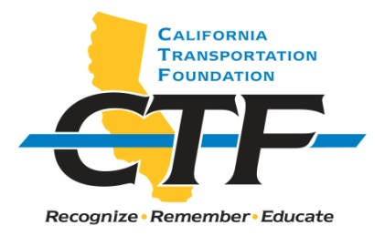
2021 G. LANGSNER MEMORIAL SCHOLARSHIP

APPLICATION INSTRUCTIONS

Applicant Name: _______________________________________________________

Current Address: ______________________________________________________

Mailing Address (if different from Current Address):

_____________________________________________________________________

Phone: ______________ E-mail address: ___________________________________

COLLEGE DATA:

College name: _________________________________________________________

College location: ______________________________________________________

Area of concentration: __________________________________________________

Class level: ___________________________________________________________

Overall grade point average (GPA): _______________________________________

CAREER OBJECTIVE: Provide a short statement. (No more than five lines.)

PERSONAL AND/OR SCHOOL AFFILIATIONS/HONORS: (Brief list.)

WHY I AM INTERESTED IN A CAREER IN TRANSPORTATION: Attach a typed, one-page essay. (Not more than 500 words.)

ATTACHMENTS

Please enclose the following with this application:
- Copy of official transcripts and proof of current enrollment
- One sealed letter of recommendation from a school faculty member
- One sealed letter of recommendation from a work supervisor

SIGNATURE: ________________________ DATE: __________________________

