Stacked Stone Texture on Concrete Barrier Type 60


California Department Of Transportation
Office of State Landscape Architecture

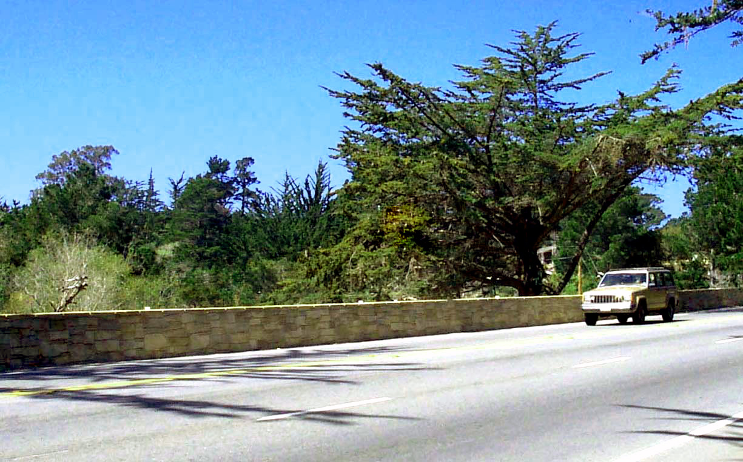

Location:
This textured concrete barrier is located in Monterey County on State Route 1, in Carmel, California at Kp117.5/118.5 (PM 73.0/73.6). This barrier is 359 meters long (1177 ft.). This stacked stone surface treatment meets the Federal Highway Administration approved guidelines for texture described in the report “Crash Testing of Various Textured Barriers”, prepared by the California Department of Transportation.

March 24, 2003
Page 1 of 2
Stacked Stone Texture on Concrete Barrier Type 60

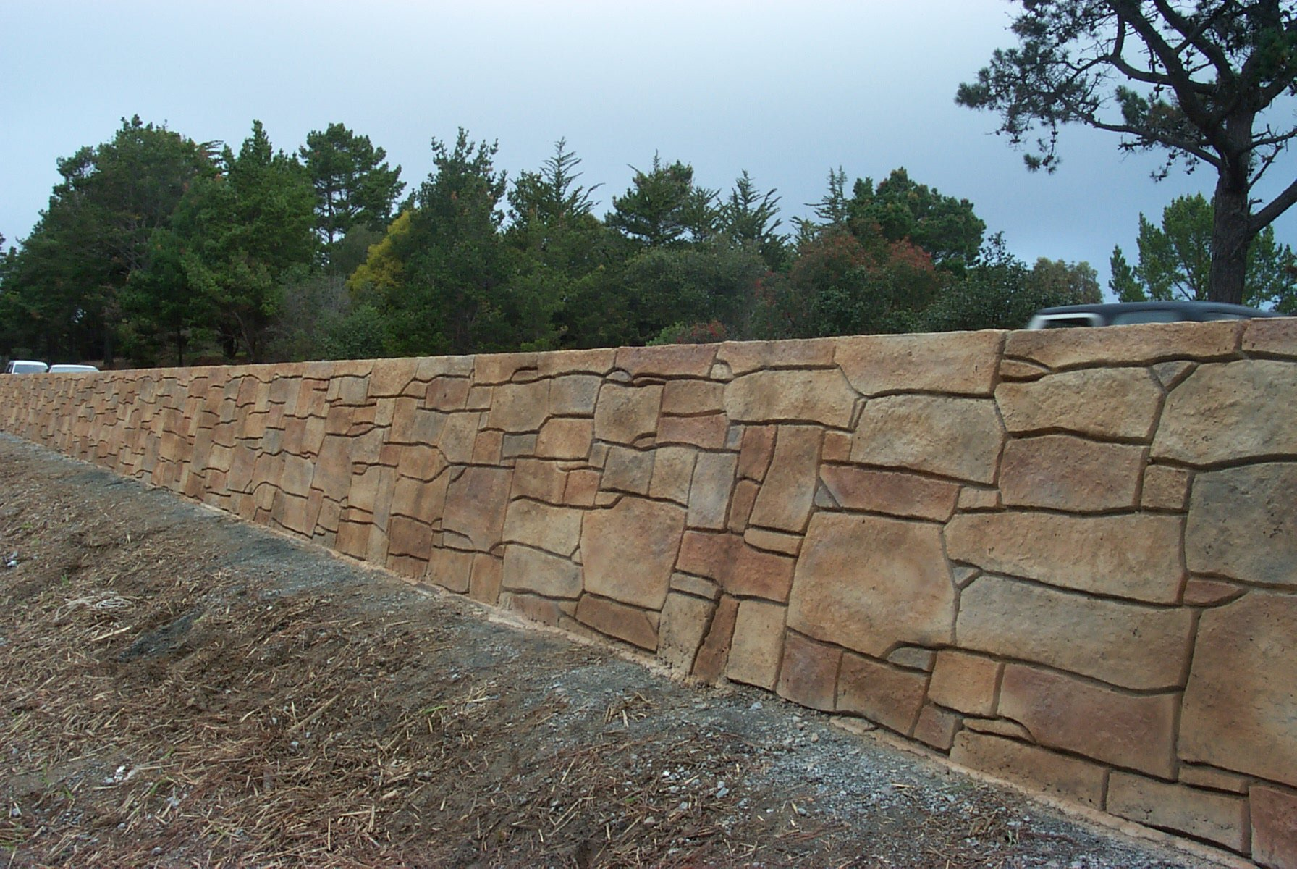

Cost:
Total cost was $629/M
Cost of barrier concrete and rebar $148/M
Cost of from work, texture and integral color $323/M
Cost for surface color $158/M

Texture:
The architectural texture was applied to both sides and top of the barrier. The joints between stones vary in width and depth, with a maximum width of 20 mm. There is 5mm maximum surface differential across the projected face of the concrete barrier between adjacent stones.
The wall was cast in place using form liners. The texture repeats every 32 linear feet.

Color:
The concrete mix included an integral earth tone color, conforming to Color #33522.
Concrete surfaces were painted with Acrylic Masonry Paint in three earth tone colors, conforming to Color #30340, #30372 and #33522. The mortar color, conforming to Color #36440, accents the joint lines and shadows. All colors used conform to Federal Standard 595B
The application process was as follows: First a light colored primer was applied followed by colors of paint applied in a random manner. Paint was applied using the lightest color first then darker applications thereafter. Stones were painted. Then a sponge was used immediately to wipe off areas of the newly applied paint to give the stone highlights. This resulted in realistic effect. The staining process took 5 working days.

March 24, 2003
Page 2 of 2

