|  |  |  |
| --- | --- | --- |
|  | State of California | California State Transportation Agency |
| **DEPARTMENT OF TRANSPORTATION** |  |
| DIVISION OF CONSTRUCTION |  |
| OFFICE OF LABOR COMPLIANCE  **Memorandum** |  |
| **To:** | DISTRICT LABOR COMPLIANCE MANAGERS | **Date:** June 25, 2025 |
| **From:** | LINDSEY WOOLSEY |  |

Labor Compliance Manager

Division of Construction

### Subject: 2025 ANNUAL EQUAL EMPLOYMENT OPPORTUNITY REPORT: FORM FHWA 1391

Pursuant to United Sates Code of Federal Regulations, Title 23, Section 230.121 and federal-aid contract requirements, contractors are required to report annually on the composition of their workforce by race, gender, and job category. Using the federal form FHWA 1391, “Federal-Aid Highway Construction Contractors Annual EEO Report,” prime contractors and any lower- tier subcontractors with subcontracts in excess of $10,000 must complete the report for work performed during the last full work week of July.

The 2025 reporting period begins **Sunday, July 20th, 2025 through Saturday, July 26th, 2025**. To facilitate timely processing contractors should be directed to submit completed reports to designated district construction staff no later than August 15, 2025. Contractors should also be informed that they are subject to a progress pay deduction for failure to submit the report or if the report they submit is unsigned, illegible, or incomplete. The applicable procedures and amounts are listed in Sections 8-209, “Deducting Payment for Failure to Submit Reports,” and Section 5-103F (1c), “Deductions” of the *Construction Manual*.

### Districts must forward the completed reports electronically to the Caltrans Office of Civil Rights (OCR) at the e-mail address [1391@dot.ca.gov](mailto:1391@dot.ca.gov)

DISTRICT LABOR COMPLIANCE MANAGERS June 25, 2025

Page 2

### District/Region Responsibility

* Notify all contractors of the reporting requirement and due date.
* Review the form for completeness and accuracy including both the contractor and district construction personnel signatures.
* Return incomplete or inaccurate reports to the contractor as soon as possible.
* Submit all completed forms to OCR.

### Reporting Milestones

* Reporting period is July 20, 2025 through July 26, 2025
* Reports are due to district construction no later than August 15, 2025
* Reports are due to OCR no later than August 22, 2025

Attached is the FHWA 1391 form with instructions. This is federal document and cannot be modified in any way other than entering the requested information. The form is also located on the USDOT FHWA internet site at:

<https://www.fhwa.dot.gov/eforms/> (Ctrl+Click to follow link)



Local agency reports will continue to be collected by the Division of Local Assistance and inquiries they may contact [Loi.Tran@dot.ca.gov](mailto:Loi.Tran@dot.ca.gov). If you have any questions regarding the reporting requirements, please contact Leah Van Dyne at (916) 879-6065 or [Leah.VanDyne@dot.ca.gov](mailto:Leah.VanDyne@dot.ca.gov)

Attachments

* FHWA-1391 Form
* FHWA-1391 Instructions
* Guide: How to Process Annual EEO Report Form FHWA-1391

# CALIFORNIA DEPARTMENT OF TRANSPORTATION INSTRUCTIONS FOR COMPLETING FORM FHWA-1391 FEDERAL FISCAL YEAR 2025

## AUTHORITY

* Code of Federal Regulations, Title 23, Subpart A, Section 230.121
* FHWA-1273, “Required Contract Provisions Federal-Aid Contracts”
* Caltrans Standard Specifications
* Caltrans Local Assistance Procedures Manual (local public agency contracts only)

## WHO IS REQUIRED TO REPORT?

* All prime contractors on FHWA-assisted construction contracts, and all related subcontractors with subcontracts of $10,000 or more
* A separate FHWA-1391 must be completed by each prime contractor and each related subcontractor that meets the reporting threshold

## REPORTING PERIOD

* Contractors must identify all employees who perform work during all or any part of the last payroll period of July 2025.
* Capture data for employees’ who worked during the last payroll period in July as shown below:
  + July 20 through July 26

## DUE DATES

* Caltrans contracts: FHWA-1391s are due to Caltrans’ District Labor Compliance Offices by August 15, 2025
* All reports shall be submitted electronically to Office of Civil Rights [1391@dot.ca.gov](mailto:1391@dot.ca.gov) no later than August 22, 2025

## CONTACT

Leah Van Dyne, Caltrans, Office of Civil Rights, at (916) 879-6065, or [Leah.VanDyne@dot.ca.gov](mailto:Leah.VanDyne@dot.ca.gov)

# CALIFORNIA DEPARTMENT OF TRANSPORTATION INSTRUCTIONS FOR COMPLETING FORM FHWA-1391 FEDERAL FISCAL YEAR 2025

## JOB CATEGORIES LISTED IN TABLE A OF FORM FHWA-1391

The job categories shown in Table A of the FHWA-1391 can often be different than the specific job category or work classification that is printed on the certified payroll report. Use the following examples to place employees in the appropriate job classification:

Example #1: List flaggers as Laborers-Unskilled

Example #2: List operators of paint striping trucks as Truck Drivers or Equipment Operators

Example #3: List form builders and helper as Carpenters Example #4: List form setters as Laborers-Semi-Skilled Example #5: List survey crews as Laborers-Semi-Skilled

## INSTRUCTIONS FOR FILLING OUT FIELDS

|  |  |
| --- | --- |
| 1. Mark Appropriate Block | Check only one box |
| 2. Company Name, City, State | Enter the complete company name, city, and state in which the company is based |
| 3. Project Number | Caltrans contracts: Enter the contract number  Local public agency contracts: Enter the local public agency’s contract number and the federal-aid contract number  If you are a subcontractor and do not know the  contract number or federal-aid project number, contact the prime contractor |
| 4. Dollar Amount of Contract | Enter the dollar amount of the contract, including amendments |
| 5. Project Location | Enter the county/counties and stat(s) in which the work is taking place |
| 6. Pay Period Ending | Enter the “25” for “2025” |
| 7. Employment Data: Table A, Table B, and Table C | Enter the number of employees, apprentices, and on- the-job trainees by race, gender, and job category Note: Totals for tables B and C for the FHWA-1391 should match. Table C must include a breakdown, by  ethnicity, of all apprentices/trainees shown in table B |
| 8. Prepared by | Signature and title of contractor’s representative |
| 9. Date | Date the form was signed |
| 10. Reviewed by | For Caltrans/local public agency use only |
| 11. Date | For Caltrans/local public agency use only |

Note: Fields 1-9 are required to be completed by contractors. Fields 10 and 11 are required to be completed by Caltrans/local public agency staff.

**CLEAR FORM**

|  |  |  |  |  |  |  |  |  |  |  |  |  |  |  |  |  |  |  |  |  |  |  |  |
| --- | --- | --- | --- | --- | --- | --- | --- | --- | --- | --- | --- | --- | --- | --- | --- | --- | --- | --- | --- | --- | --- | --- | --- |
| **FEDERAL-AID HIGHWAY CONSTRUCTION CONTRACTORS ANNUAL EEO REPORT** | | | | | | | | | | | | | | | | | | | | | | | |
| **1. MARK APPROPRIATE BLOCK** | | | | **2. COMPANY NAME, CITY, STATE:** | | | | | **3. PROJECT NUMBER:** | | | **4. DOLLAR AMOUNT OF CONTRACT:** | | | | | | **5. PROJECT LOCATION: (County and State)** | | | | | |
| * **Contractor** * **Subcontractor** | | | |  | | | | |  | | |  | | | | | |  | | | | | |
| This collection of information is required by law and regulation 23 U.S.C. 140a and 23 CFR Part 230. The OMB control number for this collection is 2125-0019 expiring in March 2025. | | | | | | | | | | | | | | | | | | | | | | | |
| **6. WORKFORCE ON FEDERAL-AID AND CONSTRUCTION SITE(S) DURING LAST FULL PAY PERIOD ENDING IN JULY 20 (INSERT YEAR)** | | | | | | | | | | | | | | | | | | | | | | | |
| **TABLE A** | | | | | | | | | | | | | | | | | | | | **TABLE B** | | | |
| **JOB CATEGORIES** | **TOTAL EMPLOYED** | | **TOTAL RACIAL/ ETHNIC MINORITY** | | **BLACK or AFRICAN AMERICAN** | | **WHITE/HISPANIC OR LATINO** | | **AMERICAN INDIAN OR ALASKA NATIVE** | | **ASIAN** | | **NATIVE HAWAIIAN OR OTHER PACIFIC**  **ISLANDER** | | **TWO OR MORE RACES** | | | **WHITE/NON- HISPANIC OR LATINO** | | **APPRENTICES** | | **ON THE JOB TRAINEES** | |
|  | **M** | **F** | **M** | **F** | **M** | **F** | **M** | **F** | **M** | **F** | **M** | **F** | **M** | **F** | **M** | **F** | | **M** | **F** | **M** | **F** | **M** | **F** |
| **OFFICIALS** | 0 | 0 | 0 | 0 |  |  |  |  |  |  |  |  |  |  |  |  | |  |  |  |  |  |  |
| **SUPERVISORS** | 0 | 0 | 0 | 0 |  |  |  |  |  |  |  |  |  |  |  |  | |  |  |  |  |  |  |
| **FOREMEN/WOMEN** | 0 | 0 | 0 | 0 |  |  |  |  |  |  |  |  |  |  |  |  | |  |  |  |  |  |  |
| **CLERICAL** | 0 | 0 | 0 | 0 |  |  |  |  |  |  |  |  |  |  |  |  | |  |  |  |  |  |  |
| **EQUIPMENT OPERATORS** | 0 | 0 | 0 | 0 |  |  |  |  |  |  |  |  |  |  |  |  | |  |  |  |  |  |  |
| **MECHANICS** | 0 | 0 | 0 | 0 |  |  |  |  |  |  |  |  |  |  |  |  | |  |  |  |  |  |  |
| **TRUCK DRIVERS** | 0 | 0 | 0 | 0 |  |  |  |  |  |  |  |  |  |  |  |  | |  |  |  |  |  |  |
| **IRONWORKERS** | 0 | 0 | 0 | 0 |  |  |  |  |  |  |  |  |  |  |  |  | |  |  |  |  |  |  |
| **CARPENTERS** | 0 | 0 | 0 | 0 |  |  |  |  |  |  |  |  |  |  |  |  | |  |  |  |  |  |  |
| **CEMENT MASONS** | 0 | 0 | 0 | 0 |  |  |  |  |  |  |  |  |  |  |  |  | |  |  |  |  |  |  |
| **ELECTRICIANS** | 0 | 0 | 0 | 0 |  |  |  |  |  |  |  |  |  |  |  |  | |  |  |  |  |  |  |
| **PIPEFITTER/PLUMBERS** | 0 | 0 | 0 | 0 |  |  |  |  |  |  |  |  |  |  |  |  | |  |  |  |  |  |  |
| **PAINTERS** | 0 | 0 | 0 | 0 |  |  |  |  |  |  |  |  |  |  |  |  | |  |  |  |  |  |  |
| **LABORERS-SEMI SKILLED** | 0 | 0 | 0 | 0 |  |  |  |  |  |  |  |  |  |  |  |  | |  |  |  |  |  |  |
| **LABORERS-UNSKILLED** | 0 | 0 | 0 | 0 |  |  |  |  |  |  |  |  |  |  |  |  | |  |  |  |  |  |  |
| **TOTAL** | 0 | 0 | 0 | 0 | 0 | 0 | 0 | 0 | 0 | 0 | 0 | 0 | 0 | 0 | 0 | 0 | | 0 | 0 | 0 | 0 | 0 | 0 |
| **TABLE C** *(Table B data by racial status)* | | | | | | | | | | | | | | | | | | | | | | | |
| **APPRENTICES** | 0 | 0 | 0 | 0 |  |  |  |  |  |  |  |  |  |  |  |  | |  |  |  | |  | |
| **OJT TRAINEES** | 0 | 0 | 0 | 0 |  |  |  |  |  |  |  |  |  |  |  |  | |  |  |
| **8. PREPARED BY:**  **(Signature and Title of Contractors Representative)** | | | | | | | | **9. DATE** | | **10. REVIEWED BY:**  **(Signature and Title of State Highway Official)** | | | | | | |  | | | | | **11. DATE** | |
|  | | | | | | |
| Form FHWA- 1391 (Rev. 06-22) **PREVIOUS EDITIONS ARE OBSOLETE** | | | | | | | | | | | | | | | | | | | | | | | |

**Guide for Caltrans Districts:**

**How to Process Annual EEO Report Form FHWA-1391 (July 20 )**

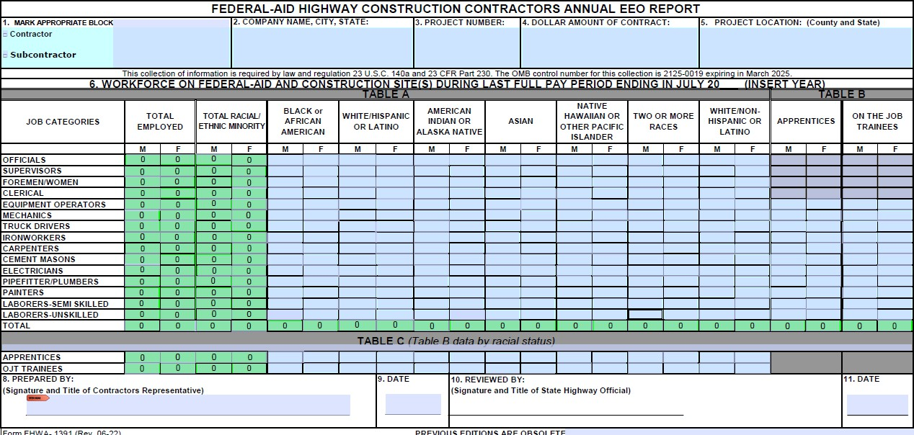

**Note: The 1391 cannot be altered from the FHWA-approved form (e.g.: Adding/Changing Job Categories, adding/changing races, etc.). Any alterations will not be accepted.**

**Additionally, forms must be completed correctly and, in their entirety, to be accepted. Instructions for each field:**

1.

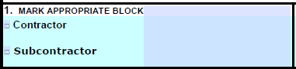

* One box must be checked.



2.

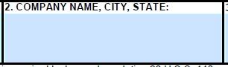

* The complete company name, city, and state in which the company is based must be listed.

3.

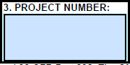

* The **contract number** and the **federal-aid contract number**.
  + A common area where errors occur is the omission of the federal-aid contract number. Please ensure this number is included. A helpful way to identify it is to look for a sequence of letters and numbers formatted as follows:



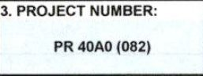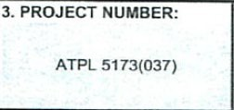

12-0R3114



ACNH-P091(159)E

* + - It should not consist solely of numbers, nor should it be formatted in the following manner::



* + - If this field is completed incorrectly, the district should respond with the following message:  
      *“Please re-submit the form and ensure that the full and correct federal-aid project number is provided in Box #3.”*



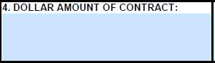

4.

* + - The dollar amount of the contract, including amendments.

5.

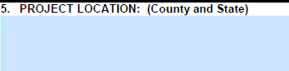

* + The county/counties and state(s) in which the work is taking place.

6.



* + Fill in “FY” for the year “20XX.”
    - Example: enter “25” for the year of “2025”

7.

Tables A, B, and C:

* Table A (basic employment data) must be complete (blanks count as zeros) and the figures must balance, across and down
  + Example:

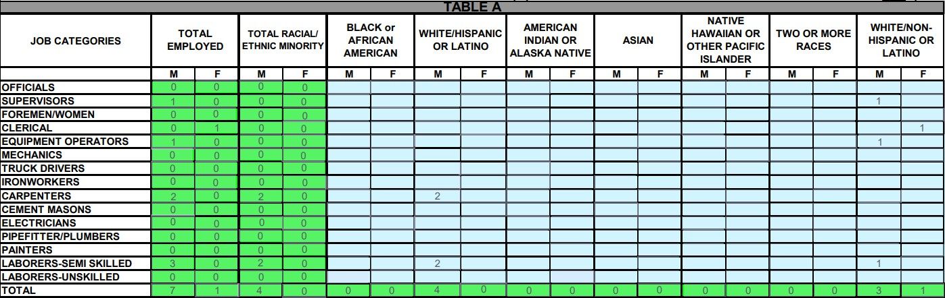



* Complete Tables B and C as applicable. Apprentices and trainees should be recorded under the job category that corresponds to the trade or occupation in which they are receiving training.
* Table C should reflect the race and ethnicity of the Apprentices and On-the-Job Trainees (OJT) listed in Table B.
* 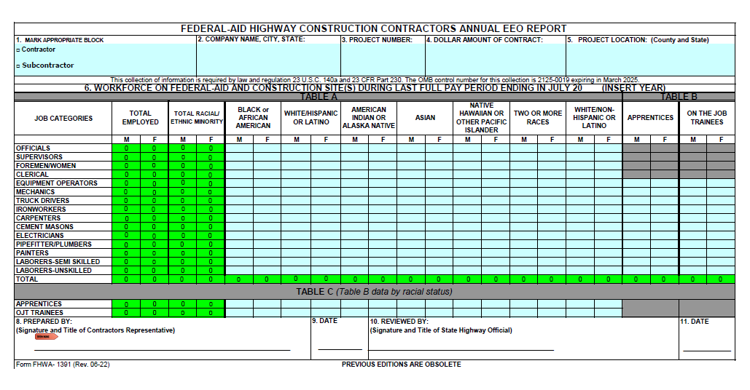The **total number of Apprentices and OJT Trainees must match** in both Tables B and C to ensure consistency.
* One of the most frequent errors occurs in Tables B and C. Please pay close attention to ensure that the number of Apprentices and On-the-Job Trainees reported in Table B exactly matches the number reported in Table C, and vice versa.



8.

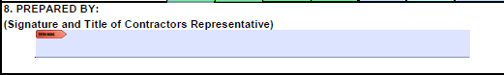



* + Sign with the Name and Title of Contractor’s Representative

9.

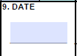

* + Date the form was signed by preparer.

10.

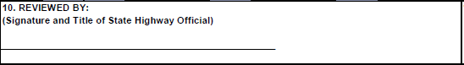

* + Name and Title of State Highway Official
  + A common error is leaving Box #10 unsigned, often due to the mistaken belief that it is reserved for Caltrans. If a form is submitted without a signature in Box #10, the appropriate response is:  
    *“Please re-submit the form with Boxes #10 and 11 signed.”*
  + Box #10 should be signed by the Local Agency Resident Engineer or the Project Manager—whichever individual is responsible for enforcing submission of the forms. This person is accountable for verifying the accuracy of the information provided and will serve as the point of contact in the event of an audit or discrepancy.



11.

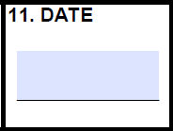

* + Date the form was signed by the local agency.



12. If no work was performed, please submit the form with the notation 'No Work Performed' clearly indicated.

**Example:**



**No work performed**



13. Once the form has been completed in full and verified for accuracy, please forward it to the appropriate contact at Caltrans**.**

**Common Errors**

* + Ensure the form is signed by both the Prime Contractor and the Resident Engineer (RE) or Contract Manager.
  + Verify that the figures in Table B exactly match those in Table C.
  + Do not modify, alter, or reformat the form in any way.
  + Confirm that the date (2025) is correctly included on the form.
  + Ensure the project number is accurate.