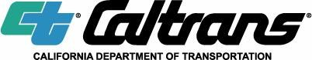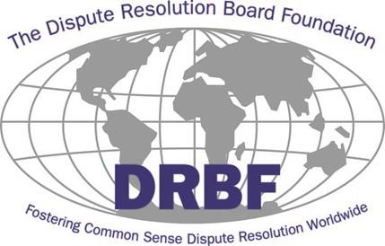

Dispute Resolution Board (DRB) & Dispute Resolution Advisor (DRA) Training
Registration Link:
https://bit.ly/caltrans2026
This training is REQUIRED for prospective Caltrans DRB or DRA member candidates with no Conflict of Interest * (Please see 2nd page)
Training Dates & Location
October 13-15, 2026, 9:00am-1:00pm Pacific Zoom Meeting
Pre-Registration Required

Class instruction and manuals will be provided at no cost to the attendees!
This training will provide the essential elements of the DRB and DRA processes to new member candidates. This instruction will satisfy the DRBF training requirement to be considered for placement on the Caltrans DRB and DRA Member Candidate List. A Certificate of Completion will be provided. Instruction will include the following:
- Requirements to be placed on the Caltrans DRB and DRA Candidates List
- Caltrans’ DRB and DRA standard specifications and agreements
- Code of ethics for DRB and DRA members
- Operating procedures for first meetings, status meetings, and informal/traditional dispute meetings
- DRB and DRA deliberation and recommendation preparation
- The value and importance of a quality recommendation
- Review of findings/conclusions from past DRB/DRA recommendations
- Case study and roundtable discussion

This will be a virtual three-day training class that will combine both the DRB and DRA processes. Workshop will begin promptly at 9:00am Pacific each day and will end by 1:00pm Pacific. All days must be attended to receive the Certificate of Completion.

For questions regarding the training, contact Kimberly Peterson, DRBF Liaison at (206) 715- 9319 or email at Kpeterson@drbf.org.

Conflict of Interest and Neutrality Requirements:
A board member must be fully independent and free of any real or perceived conflict of interest such as, but not limited to:

1. No Prior Involvement in Caltrans Contract: The board member must not have had any direct, previous involvement in a prospective Contract, including planning, design, procurement, or administration.
2. No Financial or Business Interests: The board member must not have any financial interest in a prospective Contract or in any associated party, including but not limited to the Contractor, subcontractors, suppliers, consultants, or legal/ or business service providers, during the Contract and within six (6) months before Contract award. Exceptions include compensation for DRB/ or DRA services on projects, and retirement payments or pensions not tied to the financial performance of any party.
3. No Employment Relationships: The board member must not be an active employee—full time, part time, temporary, or contractual—of any industry organization, Contractor, subcontractor, or government agency associated with the project, or other projects in the district or region where the project is located
4. No Recent Work for the Funding Agency: The board member must not have performed work for the government agency serving as the project’s funding source within one (1) year before appointment.
5. No Role as Legal Counsel: The board member must not serve, or have served within the past one (1) year, as legal counsel for any party to the Contract.

