Memorandum

To: Chair And Commissioners February 1, 2024
California Transportation Commission
From: Tony Tavares, Director, Department Of Transportation
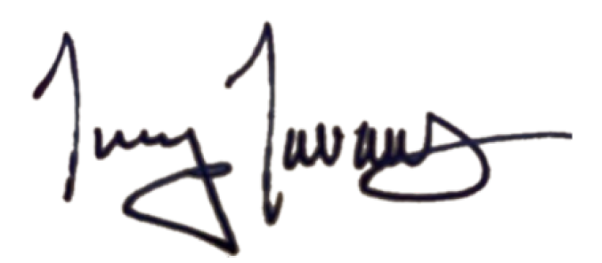
Subject: Declaration Of Transportation Emergency In Orange County

Whereas on October 3, 2022, I made a declaration of a transportation emergency due to an unstable portion of slope adjacent to and within the locally-owned railroad right-of-way, in the vicinity of Mile Post 206.8 on the Orange Subdivision near San Clemente Beach in Orange County along the Los Angeles-San Diego–San Luis Obispo (LOSSAN) Rail Corridor; and
Whereas on June 16, 2023, I made a second declaration of a transportation emergency due to an unstable portion of slope in and near the same location; and
Whereas severe weather in early 2024 has continued to add to the instability of certain slopes along the LOSSAN Rail Corridor; and
Whereas on January 24, 2024, another landslide occurred at Milepost 204.2 on the Orange Subdivision in the City of San Clemente at Mariposa Point in Orange County along the LOSSAN Rail Corridor; and
Whereas the January 24, 2024 landslide resulted in significant slope movement and debris has fouled the tracks, slope stabilization measures must be constructed to maintain operation of the LOSSAN Rail Corridor; and
Whereas this section of railway hosts passenger routes funded and/or operated by the California Department of Transportation, Metrolink, and Amtrak, carrying between 3,000 and 5,000 passengers daily; and
Whereas under the provisions of Government Code section 14120, the Director of the Department of Transportation may declare an emergency, if, in their opinion, the emergency is a matter of State concern, and work and remedial measures are required to immediately alleviate, repair, or restore damage from storms and floods; and
Whereas I find that closure of state and locally-funded intercity and commuter passenger services, as well as freight rail services, to be a matter of State concern; and
Whereas I find that immediate measures are necessary to stabilize the slide, repair damage, and ensure the operational safety of a vital rail line,
Now, therefore, I, Tony Tavares, Director of the California Department of Transportation, in accordance with the authority vested in me by the State Constitution and statutes, including Government code section 14120, hereby proclaim a transportation emergency to exist at the slide location adjacent to and within the railroad right-of-way, in the vicinity of Mile Post 204.2 on the Orange Subdivision near Mariposa Point in Orange County.

