# **Introduction**

This example project will go through the entire Life-Cycle Cost Analysis (LCCA) effective pavement type. It will follow step by step procedures found in the 2013 LCCA Procedures Manual process to determine the most cost-

This example project proposes to extend the service life of the existing pavement of State Route 580 (SR-580) from PM 0.0 to 5.0 in San Joaquin County shown in Figure 1. The existing SR-580 is a four-lane separated PCC freeway. Since this project has pavement work and is not eligible for an exemption, a LCCA must be performed. Figure 2 shows the typical cross section of the existing roadway.

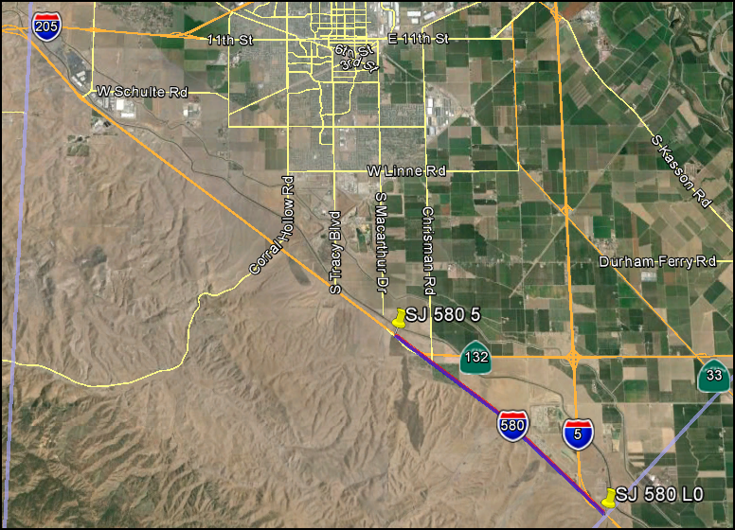

Begin Project

PM 0.0

End Project

PM 5.0

## **N**

Figure 1. Project Location Map

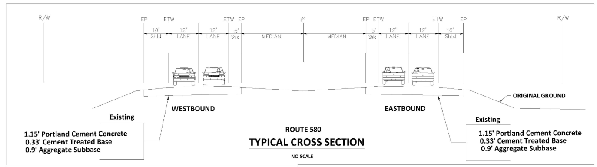

Figure 2. SR-580 Typical Cross Section

**Step 1**

Determine pavement alternatives to analyze.

Since the project type is rehabilitation and the existing pavement is PCC (rigid), use Figure 3 (CAPM and Rehabilitation Pavement Alternatives Selection Flowchart) to determine the pavement alternatives to analyze.

From the flowchart shown in Figure 3, it is recommended to perform LCCA for the following pavement alternatives:

1. 20-yr asphalt concrete crack, seat, and overlay (CSOL)
2. 40-year concrete overlay (all lanes)
3. 40-year concrete lane replacement (outer 2 lanes)

For the concrete options, Continuously Reinforced Concrete Pavement (CRCP) was chosen as the rigid pavement of choice.

The pavement alternatives must meet the LCCA requirements (See Chapter 2, section 2.3 of the 2013 LCCA Procedures Manual): 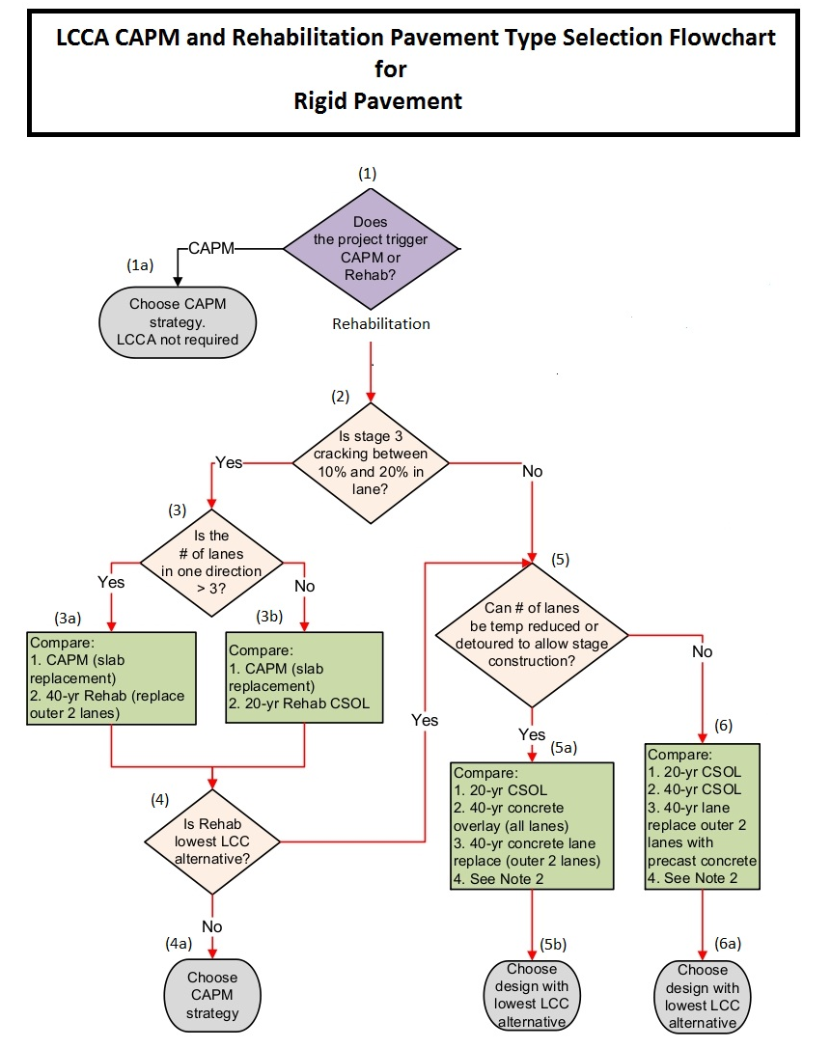

Note:

Follow the black arrows, which identify the possible alternatives to be 20-year asphalt concrete overlay (CSOL), 40-year concrete overlay, or 40-year lane replacement.

|  |  |
| --- | --- |
| **Acronyms:**  **CAPM - Capital Preventive Maintenance**  **CSOL - Crack, Seat, and Overlay**  **FDR - Full Depth Reclamation**  **LCC - Life-Cycle Cost**  **LCCA - Life-Cycle Cost Analysis** | **Notes:**  **1. This flowchart provides general guidance to help determine which strategies to develop and analyze for pavement projects. This flowchart provides the minimum alternatives to consider. For questions, consult with HQ Pavement Reviewer or HQ LCCA Coordinator.**  **2. Where constraints exist, such as sound walls or floodplains, consult with HQ Pavement Reviewer or HQ LCCA Coordinator.**  **3. RHMA must be one of the competing alternatives when flexible pavement is being considered, unless RHMA is not viable for the project.** |

**Figure 3. CAPM and Rehabilitation Pavement Alternatives Selection for Existing Rigid Pavement Flowchart (Figure 2-5 in LCCA Procedure Manual)**

**Step 2**

As early as possible, submit requests to various Functional Units as this information will be needed to perform LCCA.

Through District Traffic Forecasting Unit, the following information was provided.

1. Construction Year AADT = 26,442
2. Total Truck % = 16.94%
3. 2-axle % Truck AADT = 4.26%
4. Annual Growth Rate of Traffic (%) = 2.3%
5. Traffic Index for 20 year = 13.0
6. Traffic Index for 40 year = 14.5

From Traffic Management Unit, the following information was provided.

* Lane closure window chart
  + Provide at least two adjacent through freeway lanes open in direction of travel between 20:00 to 04:00 Mondays through Friday.

From Materials, the following pavement structural recommendation was provided.

* Alterative 1 is a 20-yr Crack, Seat & Flexible Overlay with 0.25’ HMA-A, 0.20’ RHMA-G, and 0.1’ RHMA-O.
* Alterative 2 is a 40-Year rigid overlay with 0.9’ CRCP and 0.1’ HMA-A.
* Alterative 3 is a 40-Year rigid lane pavement with 0.9’ CPRC and 0.25’ HMA.

**Step 2A (Alternative method to gather traffic information)**

There may be times, due to accelerated schedules, when there is not sufficient time to submit request to Functional Units and receive information to perform LCCA. If this is the case, follow this alternate method to gather project information. This preliminary information is for LCCA purposes only and not to be used for design purposes.

Preliminary traffic information can be found at the Traffic Operation website: [*https://dot.ca.gov/programs/traffic-operations/census*](https://dot.ca.gov/programs/traffic-operations/census)

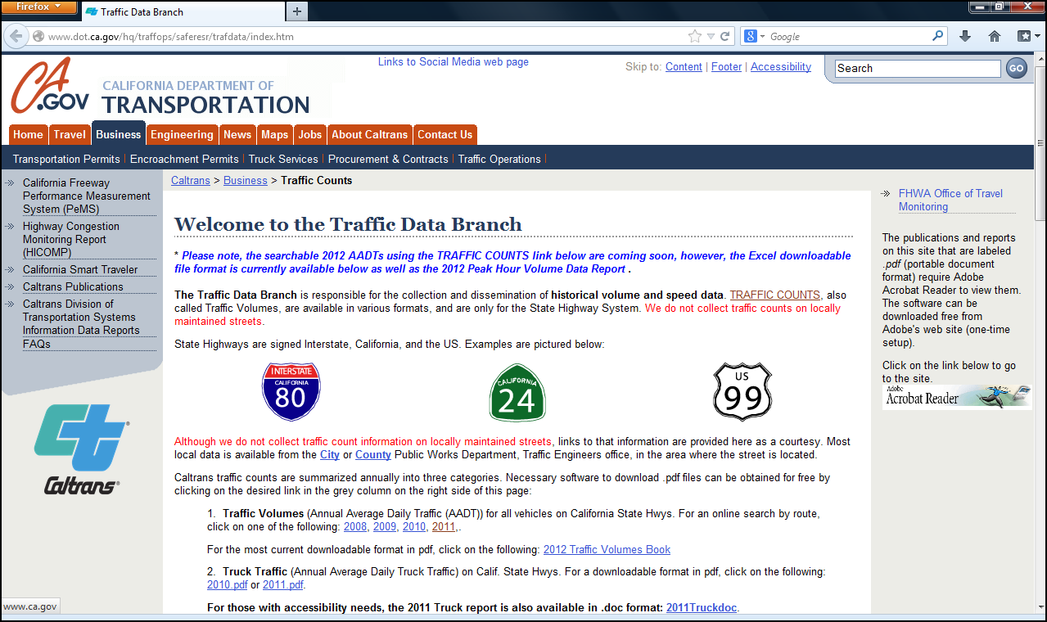

Select the most current Truck Traffic year

Figure 4. Caltrans Traffic Data Branch

The report is sorted by Route, District, County, and Post Mile. Gather information that pertains to your project. Choose information that best represent the overall project. An alternative is use average or weighted average.

**Step 2B**

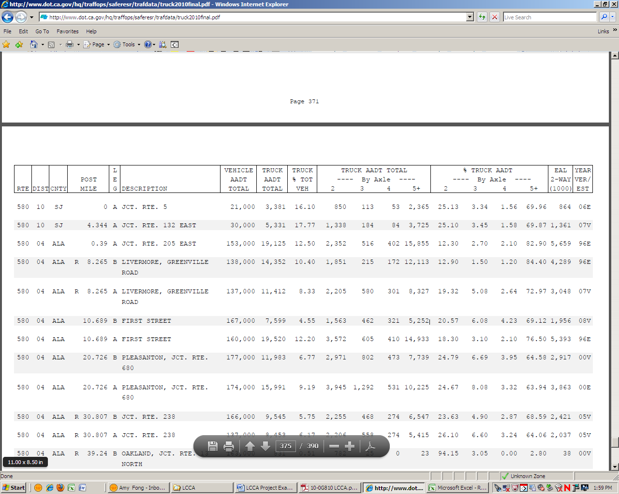

**2**

**3**

**1**

Figure 5. 2011 Truck Traffic Publication

* Determine construction year vehicle AADT:

$$Contruction year vehicle AADT= \frac{21,000+30,000}{2}=25,500$$

(This value will be input in *RealCost*)

(See bullet #1 from Figure 5. Average was taken.)

* Combination truck can be calculated with the following equations:

Single Unit Trucks (SUT):

$$SUT=T X \frac{TA}{100}$$

$$T=Total Truck \%= \frac{16.1+17.77}{2}=16.94 \%$$

(See bullet #2 from Figure 5. Average was taken.)

$$TA=2 axle \% Truck AADT= \frac{25.13+25.1}{2}=25.12 \%$$

(See bullet #3 from Figure 5. Average was taken.)

$$SUT=16.94 X \frac{25.12}{100}$$

$=4.26 \%$ (This value will be an input in *RealCost*)

Combination Truck (CT) as Percentage of AADT:

$$CT=T-SUT$$

$$=16.94-4.26$$

$=12.68\%$ (This value will be an input in *RealCost*)

* Annual Growth Rate of Traffic Estimate (A) = 2.3% (If information is not provided, use calculation from LCCA Procedures Manual)

**Step 3**

Table 1 shows the initial construction cost estimate for the three pavement alternatives. The initial construction cost estimate (developed by the engineer) does not include the following:

* Add on costs such as minor items, supplemental work, mobilization, and contingencies.
* Structure and right of way costs.
* Project support costs for design, environmental, project management, construction administration and inspection costs, etc.
* Common cost between pavement alternatives.

These assumptions may need to be modified if there are differences between the alternatives’ cost estimates.

Table 1. Initial Construction Cost Estimate for SR-580

Table showing initial construction cost for three pavement alternatives.

**Step 4**

Use *RealCost v2.5CA* (see LCCA Procedures Manual for installation instructions). Save your work often in the program by clicking on “Save LCCA Workbook As…” as shown in Figure 6.

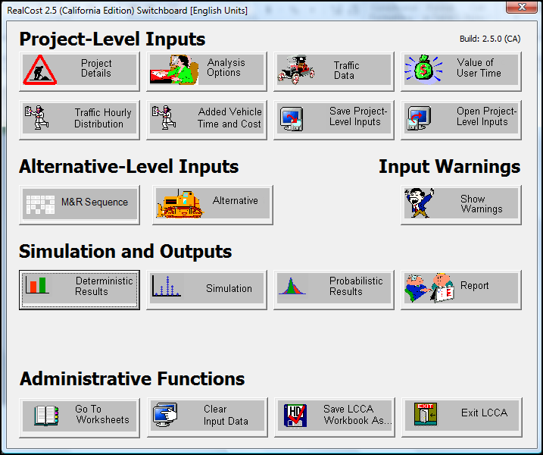

Save often.

Figure 6. *RealCost v2.5* Switchboard Window

Project Details

Input project information.

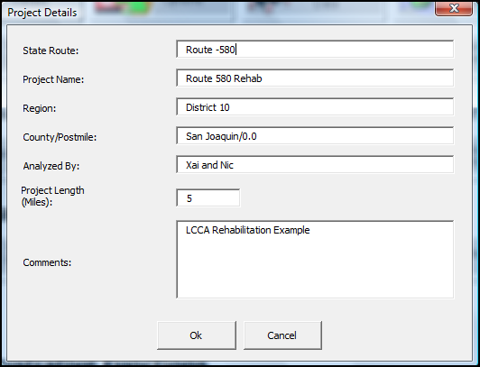

Enter project length in miles.

Figure 7. Project Details Window

Analysis Options

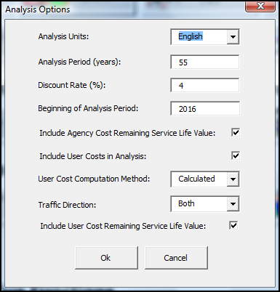

Caltrans uses English units.

See Table 1

Default value = **4%**

Begin Construction Year = **2016**

Default selection

Select **Both** if constructing in both directions

Default selection

Figure 8. Analysis Option Window

Comparing 20-yr Crack, Seat & Flexible Overlay, 40-yr concrete overlay (all lanes), and 40-yr lane replacement.

Table 2. LCCA Anaysis Periods (Table 2-1 in LCCA Procedure Manual)

|  |  |  |  |
| --- | --- | --- | --- |
| **Alternative Life** | **CAPM** | **20-Yr** | **More than 20 years** |
| **CAPM** | 20 years | 35 years | 55 years |
| **20-Yr** | 35 years | 35 years | 55 years |
| **More than 20 years** | 55 years | 55 years | 55 years |

Traffic Data

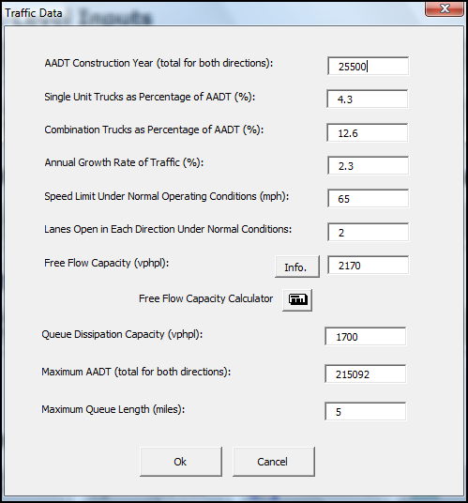

From Traffic Unit or Step 3B

Posted Speed Limit

2 Existing Lanes

See Table 3 Traffic Input Values

Note: Max AADT = (2 direction) x (2 lanes) x 53,773 = 215,092 Maximum AADT (total for both directions)

Figure 9. Traffic Data Window

The project is a multi-lane highway located on level terrain in an urban area. With the known information, use Table to get traffic input values.

Table 3. Traffic Input Values (1,2,3) (Tabel 3-1 in LCCA Procedure Manual)

Screen Shot of Traffic Input Values table from LCCA Manual.

Value of User Time

Use default values. Value of User Time is updated annually. Visit the LCCA website for the most current value.

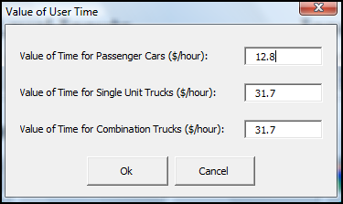

Default values

Figure 10. Values of User Time

Traffic Hourly Distribution

This project has weekday single peak.

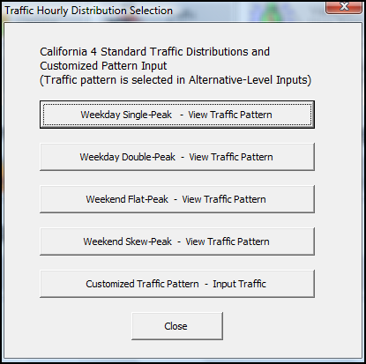

Traffic pattern for this project.

Figure 11. Traffic Hourly Distribution Selection Window

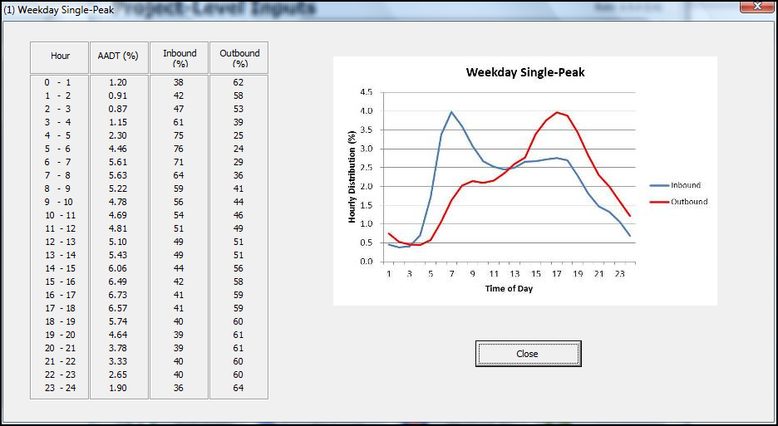

Figure 12. Weekday Single-Peak Window

Added Vehicle Time and Costs

Figure 13 shows the Default Values before escalating to year 2016.

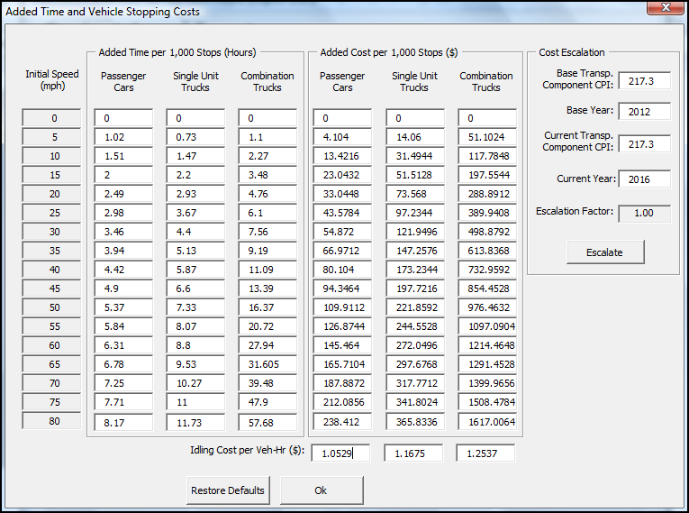

Figure 13. Added Time and Vehicle Stopping Cost Before Escalating Window

Table 4 shows the transportation Consumer Price Index (CPI), which is updated annually. For the latest CPI value, visit the LCCA website.

Table 4. Transportation Component Consumer Price Indexes

(Table 3-2 in LCCA Procedure Manual)

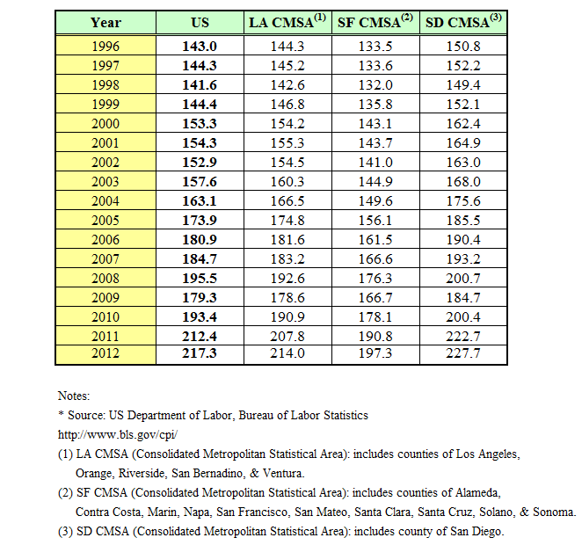

Use 217.3 for Current CPI for escalation.

Values shown are after escalation to construction year 2016.

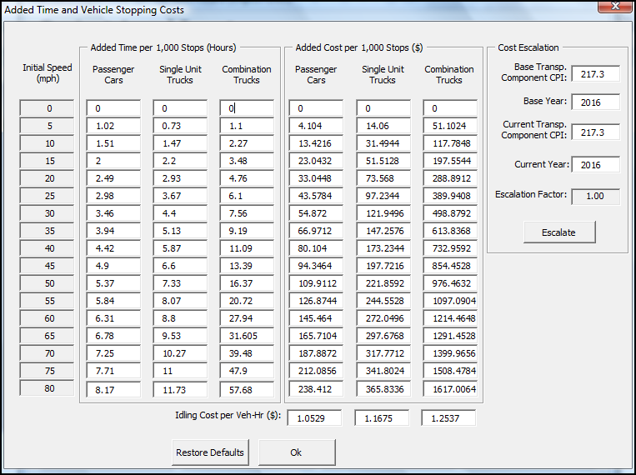

Current CPI value. See Table

Year of end construction.

Click Escalate

Note: Escalation factor shows “1.00” after escalation.

Figure 14. Added Time and Vehicle Stopping Cost after Escalating Window

M&R Sequence Selection

Maintenance Service Level: 1

Climate Region: Inland Valley

Project Type: Rehabilitation

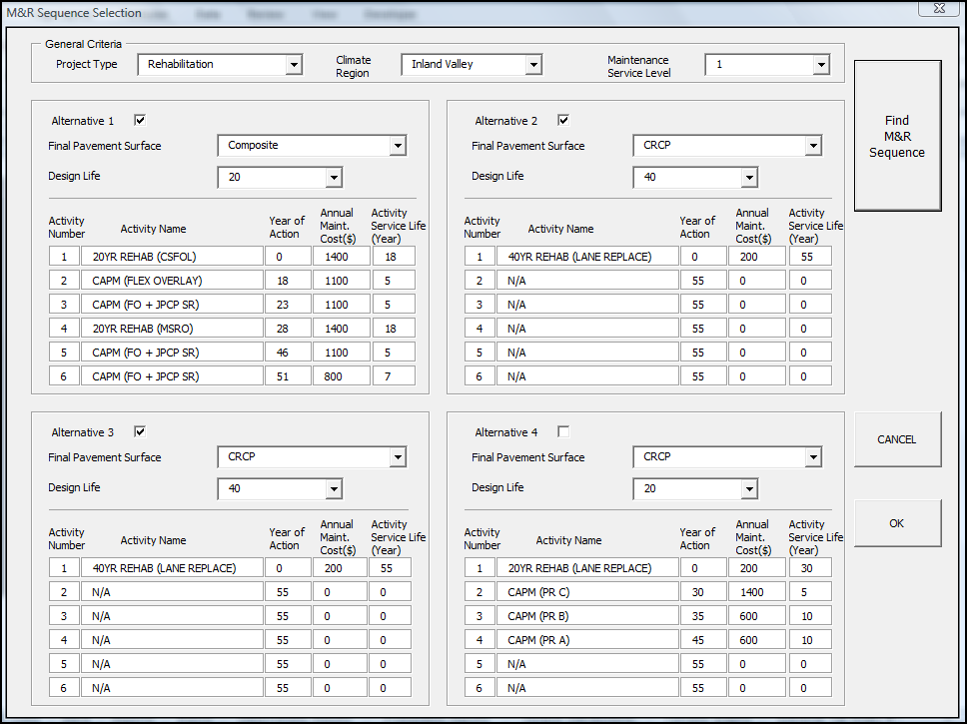

Note: For each alternative to be evaluated for comparison, a check mark must be clicked by the “Alternative “box.

Figure 15. M&R Sequence Selection Window

Specify the final pavement surface in Figure 15 given the three pavement alternatives:

1. 20-yr asphalt concrete crack, seat, and overlay (CSOL)
2. 40-year concrete overlay (CRCP) (all lanes)
3. 40-year lane replacement (CRCP) (outer 2 lanes)

**Alternative 1**

Alternative 1, Activity 1: 20YR REHAB (CSOL)

Initial construction cost estimate in $1000’s. See the engineer’s cost estimate in Table 1.

Some information is imported from M&R Sequence window.

Input Alternative Description

Imported from M&R Tables

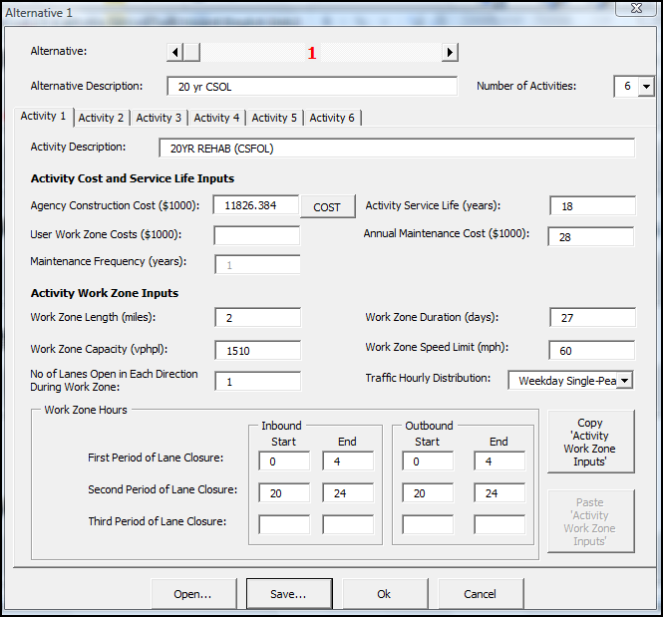

Imported from M&R Sequence.

Project length x # lanes in a direction x # of direction x Annual maintenance cost

5mi/lane x2 lane x 2 dir. x 1.4 = 28

Number of total lane closure days to construct project. Consult with Construction if necessary.

See Table 3  
Typi

This is a night time lane closure. Time is 0:00 to 24:00 hours.

One lane open during construction.

Typically 2 miles  
Typi

Default blank. *RealCost* to calculate

Pick the closest that match your traffic conditions

Typically 5 mph less than posted speed limit.

Figure 16. Alternative 1, Activity 1 Window

Work Zone Duration (day) Example:

Formula of WZD = Lane miles/PR

Where:

**WZD** = Work Zone Duration in days

**PR** = Productivity Rate in lane-miles per day

Lane-miles = 2 lanes/ dir. x 5miles x 2 dir. = 20 lane-miles

Productivity Rates can be found in Tables 3-4 to 3-7 in LCCA manual. (See Chapter 3, section 3.5.2 of the 2013 LCCA Procedures Manual)

Since the existing pavement is PCC (rigid pavement), use Table to determine productivity rate. Since the project type is rehabilitation with a final surface type of Composite, go to the Rehabilitation section and Flexible/Composite subsection; then choose Crack, Seat, & Flexible Overlay as the future M&R sequence. Subsequently, choose 20-yr for the pavement design life because the future M&R alternative’s design life is 20 years. Then choose Maintenance Service Level 1 since SR-580 is an arterial freeway. Since the implementation of the M&R alternative requires 8 hour closure daily, choose the productivity rate corresponding to the 8 to 12 hour closure column. The productivity rate is 0.75.

The logic for selecting productivity rate is shown below.

Existing PCC Rigid🡪Table 🡪Project Type: Rehabilitation🡪Final Surface Type: Flexible/Composite🡪CSOL in future M&R🡪20-yr. design life🡪MSL=1🡪12hr. closure 🡪 PR = 0.75

Table 5. Productivity Estimates of Typical Future Rehabilitation for Rigid and Composite Pavements (Table 3-6 in LCCA Manual)

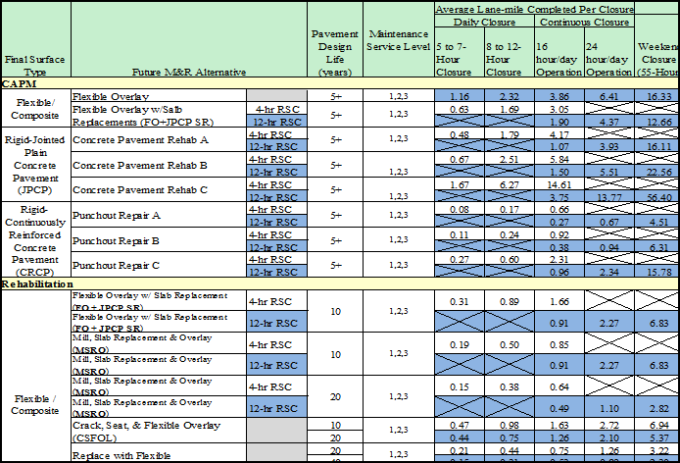

$$Work Zone Duration \left(days\right)=\frac{20 Lane-mile}{0.75}=26.66→27 days$$

Click on the ‘Copy Activity Work Zone Inputs’ to copy the inputs to paste on the next activity.

Agency Construction Cost

Input the initial cost estimate, from Table 1, of paving items in this version of *RealCost Version 2.5CA.* See Figure 17 for the completed window.



Figure 17. Completed Window of Alternative1, Activity 1

Alternative 1, Activity 2: CAPM (FLEX OVERLAY)

After the Alternative 1, Activity 1 inputs are completed, select the Alternative 1, Activity 2. All activities after Activity 1 need to use the cost estimate calculator in the software to calculate initial construction cost.

Clicks on the “COST” button shown in Figure 18 and Figure 19 will appear.

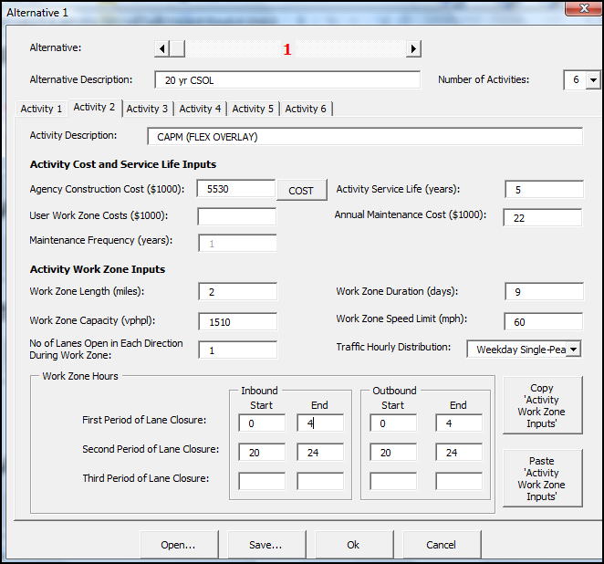

Construction cost estimate in $1000. Use cost estimate button. See below.

Figure 18. Alternative 1, Activity 2 Window

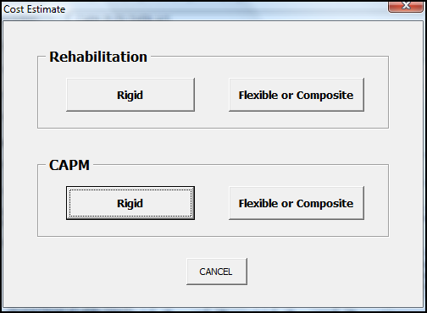

Figure 19. Cost Estimate Window

Since this activity is CAPM on composite pavement, use the CAPM, Flexible or Composite button in Figure 19. Then the “CAPM Flexible or Composite Pavement” window is activated as shown in Figure 20. The items that are shown in black font can be selected or inputted, and the items shown in gray font are either a program default value or the item is calculated by *RealCost Version 2.5CA*.

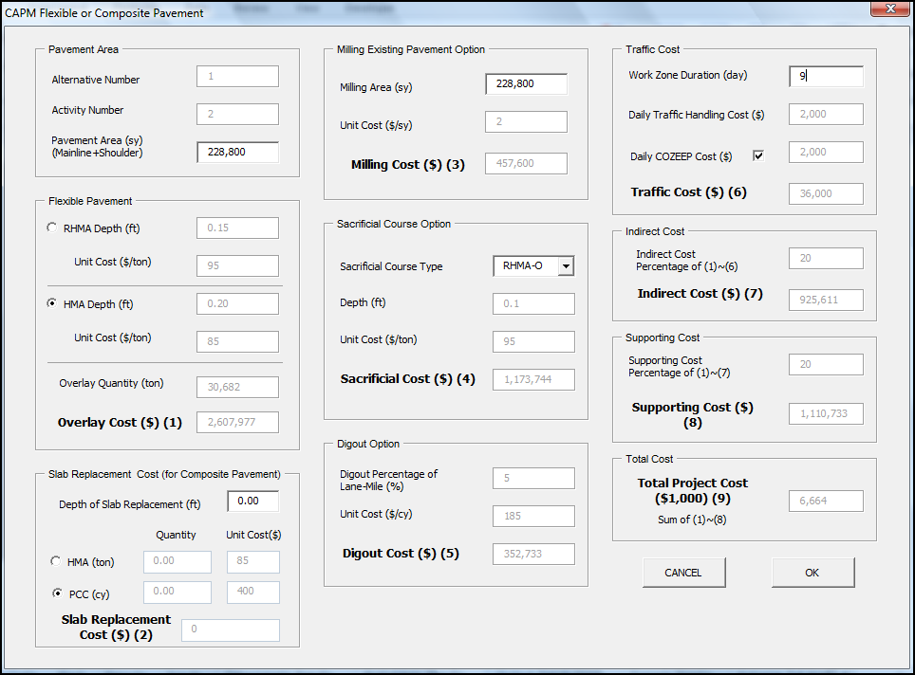

Specify Flex. Pave. Type. Also, select sacrificial course. This activity does not include slab replacement, so depth of slab replacement is 0.

Specify Pavement area and Milling Area. See calculations below.

Input Work Zone Duration. If applicable, select Daily COZEEP Cost.

Figure 20. CAPM Flexible or Composite Pavement Window

Pavement Area Example Calculation:

$$2 dir.\left[2 lane wide x \left(\frac{{12}^{'}}{lane width}\right)+\left(\frac{5^{'}}{Shoulder width}\right)+\left(\frac{{10}^{'}}{Shoulder width}\right)\right]\left[(5 mile project\right]\left[\frac{{5280}^{'}}{mile}\right]{\left[\frac{1yd}{3^{'}}\right]}^{2}=228800 {yd}^{2}$$

Milling Existing Pavement Option:

100% of the milling of existing pavement area was assumed.

After inputting the required information, click “OK” to transfer the calculated cost into the Agency Construction Cost in the Alternative 1, Activity 2 window, as shown in Figure 18.

Input the remaining required information into Alternative 1, Activity 2 window. A completed Alternative 1, Activity 2 window is shown in Figure 21.

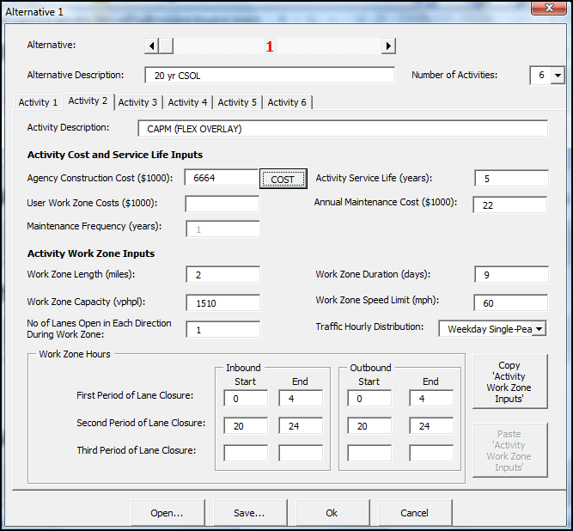

Figure 21. Completed Alternative 1, Activity 2 Window

When the Alternative 1, Activity 2 window is completed, select the “OK” button.

Alternative 1, Activity 3: CAPM (FO + JPCP + SR)

Click the “Cost” button to calculate the Agency Construction Cost via RealCost. Since the project is CAMP on composite, choose Flexible or Composite Button as show in Figure 19. Follow similar procedure as in Alternative 1, Activity 2, while updating the required information. A completed Alternative 1, Activity 3 is show in Figure 22.

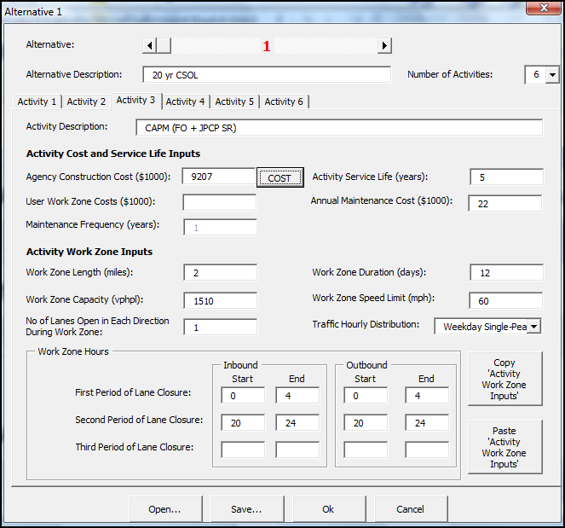

Figure 22. Completed Alternative 1, Activity 3 Window

Alternative 1, Activity 4: 20-yr REHAB (MSRO)

Click the “Cost” button to calculate the Agency Construction Cost via *RealCost*. Since the project is Rehab on composite, choose Flexible or Composite Button as show in Figure 19. The “Rehabilitation Flexible or Composite Pavement” window as shown in Figure 23 will appear.

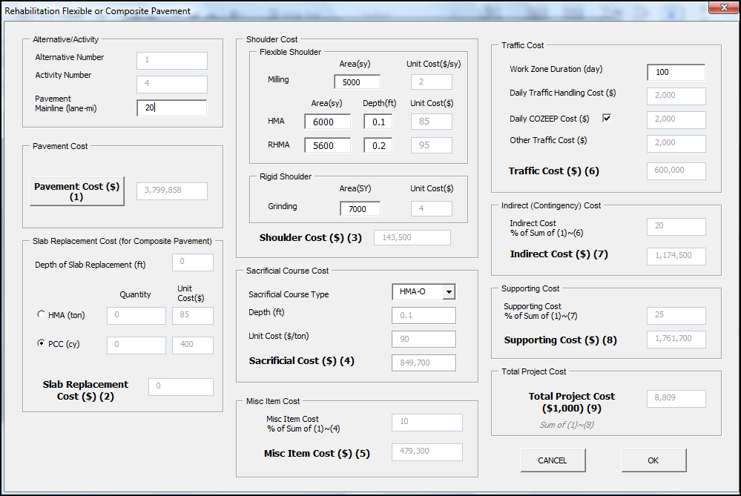

Click this button to calculate Pavement Cost.

Figure 23. Rehabilitation Flexible or Composite Pavement Window

After clicking the “Pavement Cost” button, a “Pavement Selection” window as shown in Figure 24 will appear.

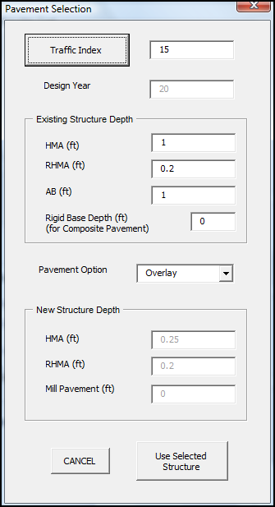

Click this button to estimate Traffic Index.

Figure 24. Pavement Selection Window

After clicking the “Traffic Index” button, a “Traffic Index (TI) Computation for Flexible Pavement” window will appear, as shown in Figure 25.

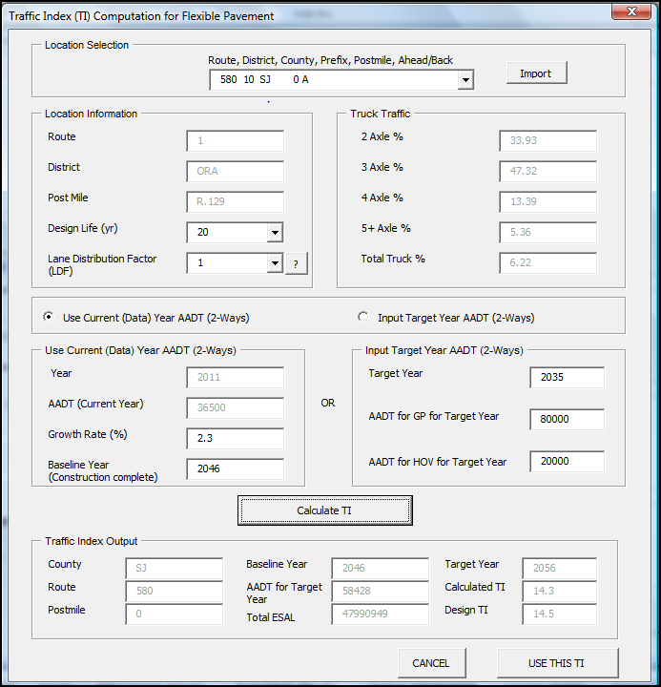

6. Click “Use This TI” to import the new TI

5. Click button to calculate TI.

2. Specify Design life and Lane Distribution Factor.

See example below

4. Specify Growth Rate and Baseline Year.

*See calculation below.

3. Select “Use Current (Data) Year AADT (2-ways)” if using current year AADT

1. Choose Project location from the drop-down menu, and then click the “Import” button.

Figure 25. Traffic Index (TI) Computation for Flexible Pavement Window

$$Baseline Year \left(Construction Complete\right)=2016\left(initial construction year\right)+20yr \left(Act.1\right)+5yr\left(Act. 2\right)+5\left(Act.3\right)=2046$$

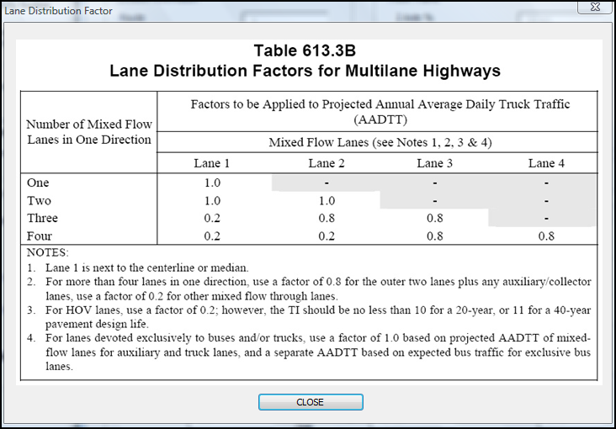

Figure 26. Lane Distribution Factors For Multilane Highways

After clicking the “Use This TI” button, a “Pavement Selection” window will appear, as shown in Figure 27.

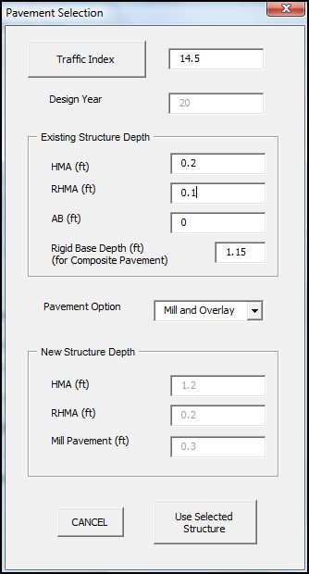

Value was obtained from TI Calculator

Use existing pavement structure and previous activity’s info.

Select “Mill and Overlay”

Click this button after calculating the new TI.

Figure 27. Pavement Selection Window

After clicking the “Use Selected Structure”, a “Rehab Flexible or Composite Pavement Cost” window will appear, as shown in Figure 28.

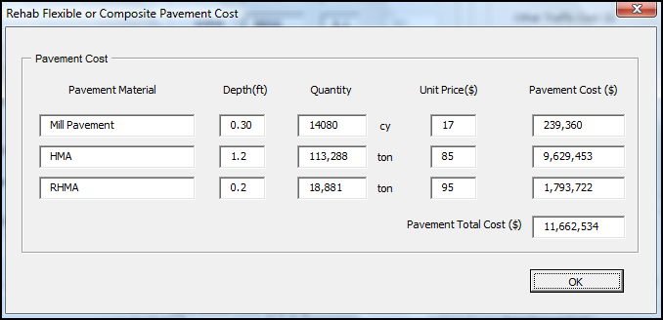

Click ok.

Figure 28. Rehab Flexible Or Composite Pavement Cost Window

A completed Rehabilitation Flexible or Composite Pavement window is shown in Figure 29.

For Flexible Shoulder: Specify Milling and HMA area. Also, specify the depth of HMA shoulder. It is not anticipated that RHMA will be replaced.

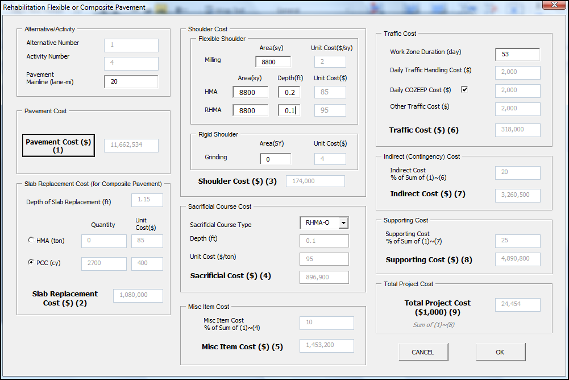

Click ok, which will take you back to the Alternative window.

Figure 29. Completed Rehabilitation Flexible or Composite Pavement Window

A Completed Alternative 1, Activity 4 is shown in Figure 30.

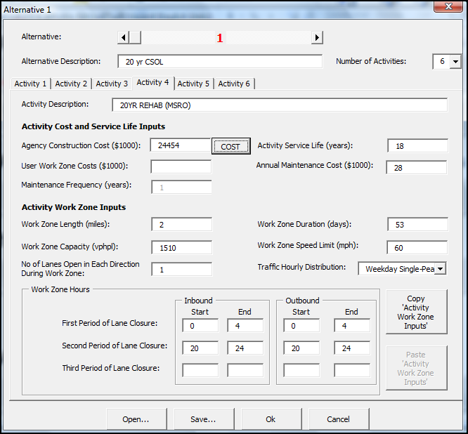

Figure 30. Completed Alternative 1, Activity 4 Window

Alternative 1, Activity 5: CAPM (FO + JPCP SR)

Click the “Cost” button to calculate the Agency Construction Cost via RealCost. Since the project is CAPM on composite, choose Flexible or Composite Button as show in Figure 19. The “CAPM Flexible or Composite Pavement” window as shown in Figure 31 will appear.

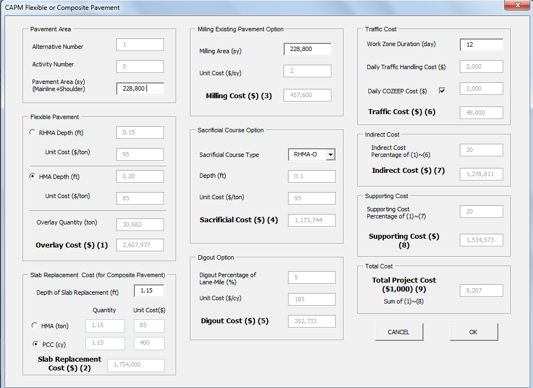

Figure 31. CAPM Flexible or Composite Pavement Window

Follow the procedure of previous activities to update and input the required information into the CAPM Flexible or Composite Pavement. After updating and inputting the required information, click “OK”.

A completed Alternative 1, Activity 5 is shown in Figure 32.

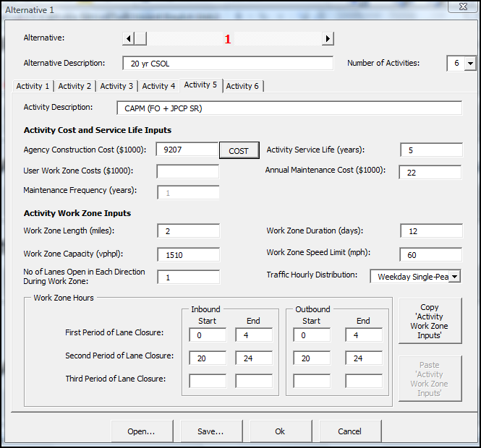

Figure 32. Completed Alternative 1, Activity 5 Window

Alternative 1, Activity 6: CAPM (FO + JPCP SR)

The procedure for this activity is the same for Alternative 1, Activity 5. Follow the same procedure in Alternative 1, Activity 5.

A completed Alternative 1, Activity 6 is shown in Figure 33.

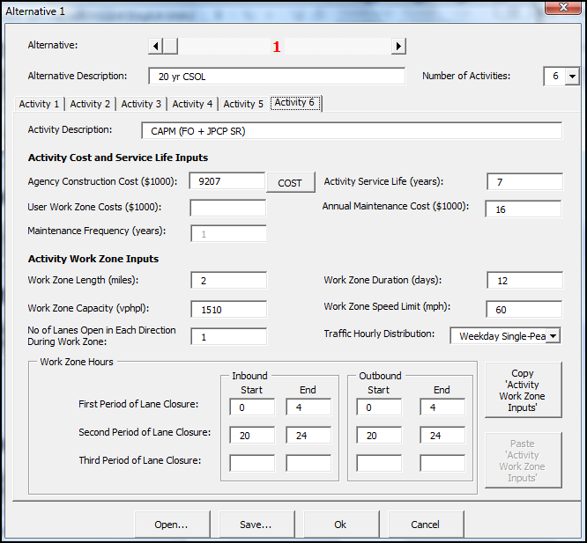

Figure 33. Completed Alternative 1, Activity 6 Window

**Alternative 2**

Alternative 2, Activity 1: 40-yr CRCP Concrete Overlay

A Completed Alternative 2, Activity 1 is shown in Figure 34. It is assumed that traffic will be detoured on temporary pavement during construction.

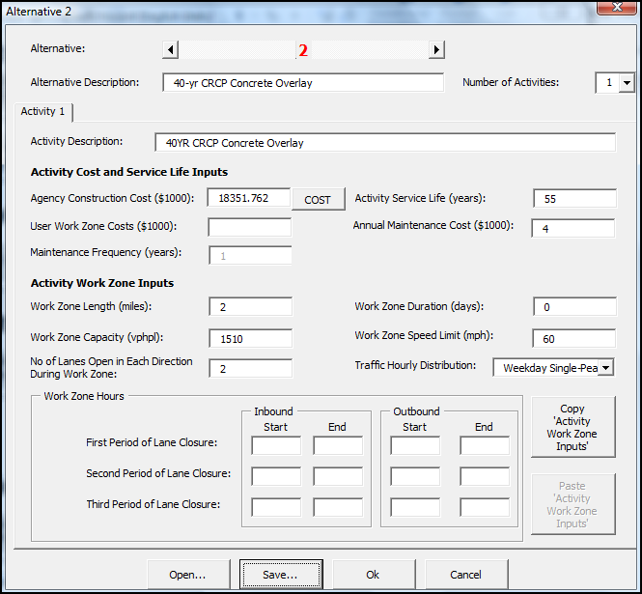

Use the Scroll Bar to select the Alternative Number

Figure 34. Completed Alternative 2, Activity 1 Window

Enter the required information into the Activity Cost and Service Life Inputs and Activity Work Zone Inputs.

**Alternative 3**

Alternative 3, Activity 1: 40-yr REHAB (LANE REPLACE)

Enter the required information into the Activity Cost and Service Life Inputs and Activity Work Zone Inputs. A completed Alternative 3, Activity 1 window is shown in Figure 35. It is assumed that traffic will be detoured on temporary pavement during construction.

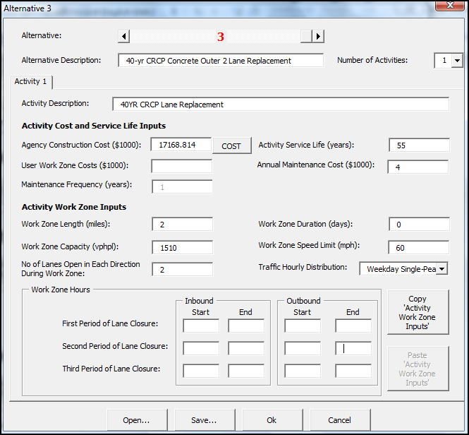

Figure 35. Completed Alternative 3, Activity 1 Window

Since this is the last activity of the last alternative, click the “OK”. It will return to the main RealCost switchboard.

Show Warnings

Click the “Show Warnings” button. A “Warnings” window, as shown Figure 36, will appear.

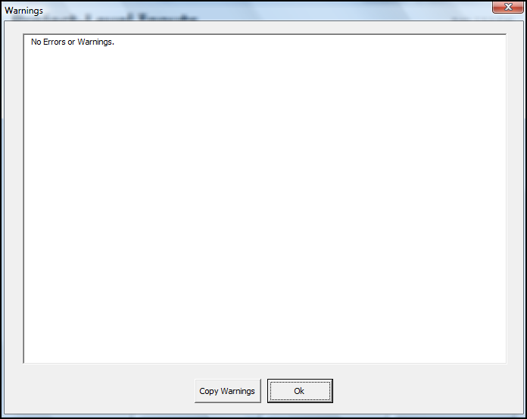

Figure 36. Warnings Window

Fix input errors and ensure warnings are acceptable; then click “OK”.

Deterministic Results

Click “Deterministic Results” button to see result. The Deterministic Results window is shown in Figure 37.

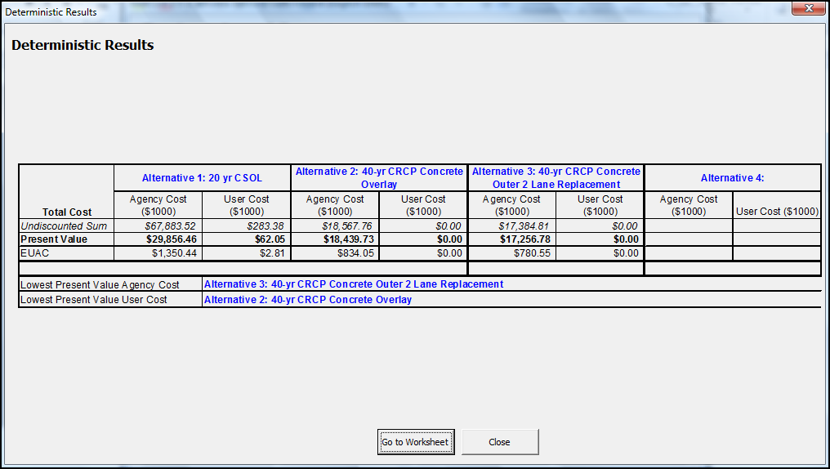

Figure 37. Deterministic Results

Click “Go to Worksheet” button to go to spreadsheets and see the results in detail.

Report

Click “Report” button to see *RealCost v2.5CA* Report. An example of the report for this analysis is shown in Figure 38.

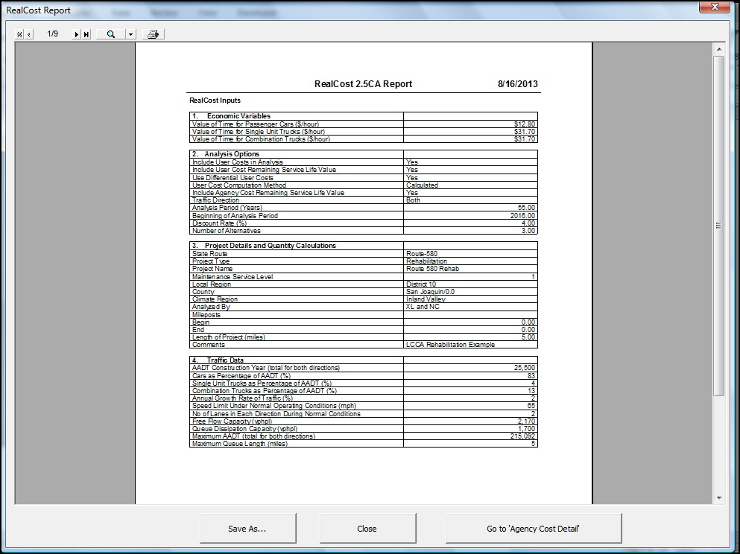

Figure 38. *RealCost v2.5CA* Report

**Step 5**

Conclusion

The pavement alternatives were analyzed with *RealCost v2.5CA* software. Alternative 3’s total life cycle cost and agency cost are the lowest among the three alternatives in the 55-year analysis period. Base on this analysis, it is concluded that Alternative 3, 40-year lane replacement (CRCP) (outer 2 lanes), is the recommended pavement alternative.

**Step 6**

Documentation

To document life-cycle costs in project documents follow the procedures in Appendix O-O of the Project Development Procedures Manual (PDPM). When the pavement alternative with the lowest life-cycle cost is not selected, the reasons must also be documented.

Also, submit your LCCA to HQ for data collection. Per PDPM Appendix O-O, a copy of the completed project initiation document, project report, or project scope summary report with life-cycle costs included shall be sent to:

Attn: HQ Program Advisor  
HQ Division of Maintenance, Pavement Program  
2389 Gateway Oaks, Suite 200, MS 91  
Sacramento, CA 95833

Or

lcca@dot.ca.gov

An alternative is to submit a *RealCost* LCCA Report.