Implementation and Guidance of 23 CFR 667 – Periodic Evaluation of Facilities Repeatedly Requiring Repair and Reconstruction Due to Emergency Events

INTRODUCTION:
Each State, acting through its department of transportation (State DOT), shall conduct statewide evaluations to determine if there are reasonable alternatives to roads, highways, and bridges that have required repair and reconstruction activities on two or more occasions due to emergency events and to determine if reasonable alternatives exist to address the root cause of recurring disaster damage requiring repeated repairs.
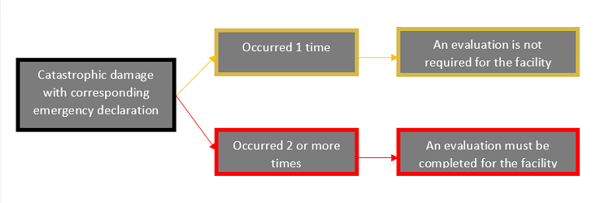

EVALUATION:
The periodic evaluations are performed in two steps. The State evaluation of emergency events and disaster damage sites from those emergency events, to identify locations of repeated disaster damage, is the first step.

In the first step the State evaluates all local agency reported and approved disaster damage from officially proclaimed disaster events. These locations are those same damages received and accepted as Emergency Relief (ER) program projects, in multiple ER eligible (e.g., FHWA accepted) disaster events. These identified repeated disaster damage locations are listed, with the list being updated regularly after every ER eligible, declared disaster. A minimum of once every four years, the entire evaluation list is reviewed and updated. The repeated disaster damage locations list is entitled the “Sites of Repeated Disaster Damage,” or SORDD table for short.

The second step is completed when the local agency evaluates it’s project to determine if their proposed federal-aid project: 1) has a site of repeated disaster damage located within their project limits and, if so, 2) they’ve considered reasonable alternatives to be included as part of their project that addresses the root cause of the repeated disaster damage. It is important to note, the CFR requirement is to consider reasonable alternatives and not a mandate to implement one or more of the alternatives.

IMPORTANT CONSIDERATIONS:

Non-Compliance
Projects that have not yet certified compliance with 23 CFR 667 shall not:
- Program the project’s RW and CON phases in the FTIP/FSTIP.
- Authorizing the project’s RW and CON phases of work.

Local Agencies are required to assure their project complies with the requirements of 23 CFR 667 by providing a copy of the completed 23 CFR 667 Resiliency Evaluation Certification Form. The Certification package shall include the 23 CFR 667 Resiliency Worksheet and Benefit-Cost Analysis, if these were used to complete the analysis for the certification.

Applicable To:
Roads, Highways, and Bridges. Defined in 23 U.S.C. 101(a)(11), a highway that is open to the public and eligible for financial assistance under title 23, U.S.C.; but excludes tribally owned and federally owned roads, highways, and bridges.

LOCAL AGENCY EVALUATION REQUIREMENT FOR PROJECTS:

Local Agency Three Step Procedure for Evaluation
A three-step procedure has been developed by the Division of Local Assistance to help agencies evaluate their projects and meet the 23 CFR 667 federal requirements on their federally funded projects. The steps are:
1. Evaluate
2. Document
3. Report

Evaluate
Local agency evaluation of the project comprises Identification of any sites of repeated disaster damage within their project limits and the Consideration of Alternatives, if one or more sites are found.

Identification
Identification is the process where the local agency checks to see whether there are any locations of repeated disaster damage within the limits of their fed-aid project. This is determined by comparing the project limits to the locations listed in the Sites of Repeated Disaster Damage (SORDD) Table.

Consideration of Alternatives
If there are no Sites of Repeated Disaster Damage listed on the SORDD table that fall within the limits of the local agency’s project, the local agency notes this on the 23 CFR 667 Resiliency Certification form by placing a check mark in the box next to the text “No sites were identified within the limits of this project.” The local agency then skips to the Certification signature line of the form, signs and completes the form.

If there are one or more repeated disaster damage sites from the SORDD table that fall within the limits of the local agency’s project, the local agency notes this on the 23 CFR 667 Resiliency Certification form by placing a check mark in the box next to the text “One or more site(s)… identified…” The local agency also lists the site(s) on the Sites of Repeated Disaster Damage table located on the 23 CFR 667 Resiliency Evaluation Certification form. The local agency then, as instructed on the form, completes the 23 CFR 667 Resiliency Worksheet form (including signature) and B-C Analysis, attaches the forms to the 23 CFR 667 Resiliency Evaluation Certification form. The 23 CFR 667 Resiliency Evaluation Certification form is then signed, and with the 23 CFR 667 Resiliency Worksheet form and the B-C Analysis attached to the Certification form. The local agency must take care to sign both the 23 CFR 667 Resiliency Evaluation Certification and the 23 CFR 667 Resiliency Worksheet.

Document
If one or more sites were identified in the SORDD table, the local agency shall complete the 23 CFR 667 Resiliency Evaluation Certification form, the 23 CFR 667 Resiliency Worksheet form, and the B-C Analysis. The forms, analysis, and other related documents, shall be arranged in the following order:
- 23 CFR 667 Resiliency Evaluation Certification form,
- 23 CFR 667 Resiliency Worksheet form, and
- the Benefit-Cost Analysis
- any other documentation pertaining to the analysis of the project for 23 CFR 667
These documents, when completed and combined, comprise the 23 CFR 667 Evaluation package and document compliance with 23 CFR 667 for the local agency’s federal-aid project.
If no sites were identified in the SORDD table, only the completed 23 CFR 667 Resiliency Evaluation Certification form is needed to document the project compliance.

Report
Once the Identification and Consideration of Alternatives, if required, are complete, the local agency sends a copy of the evaluation to the Caltrans DLA-OFP email box 23CFR667.Compliance@dot.ca.gov
. Caltrans gathers a copy of the local agency compliance to for use in measuring compliance with 23 CFR 667 and any short-term reporting to FHWA or other agencies.
It is important to note, the local agency is required to keep a copy of the 23 CFR 667 compliance documents in the local agency project folder. This documentation is expected to be in the project folder and may be required during Caltrans or FHWA audits of the project, to show compliance with 23 CFR 667. Non-compliance may result in FHWA sanctions, which could include loss of federal funding on the project.

ADDITIONAL RESOURCES:

- Q&A for 23 CFR 667 (Caltrans DLA)
- Fact Sheet – Outlining step by step requirements and certifications that local agency must follow.
- DLA 23 CFR 667 Website

*Last updated 03/26/2024

